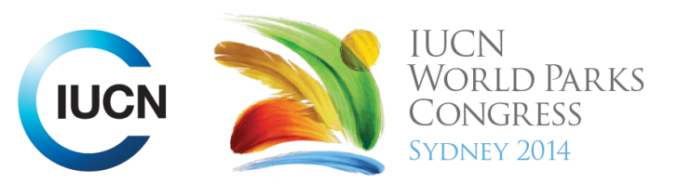

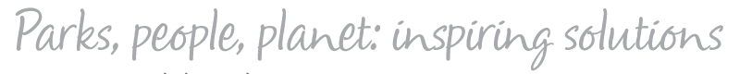

Please fill-in this word template, save it and email to:
WPCReports@iucn.org

Rapporteur’s report on session
Stream Number/WLD/Plenary:--- Congress---
Repporteur’s name: --- Jeff Thomas---
Session ID:---1020--- |  | Session Name: --- Our Pacific Voyage: Natural Solutions for Island Resilience.---
Summarize the session: Capture 1-3 main insights and findings of this session (including promising opportunities and inspiring solutions).
1. --- | The Mua Voyage. Different members of Pacific countries voyaged to Sydney on traditional sailing craft (Vaka) as part of the WPC to raise awareness and voice environmental issues on their islands, especially as related to climate change. It was done in the spirit of remembering the past (ancestors spreading across the Pacific) and stepping into the future---
2. --- | The Secretariat of the Pacific Regional Environment Programme (SPREP) has been charged by the governments and administrations of the Pacific region with the protection and sustainable development of the region's environment. Examples were given of projects SPREP supports with partners including governments, communities, local landholders and NGOs and other funding bodies. These were the Biodiversity survey of Vava’u Archipelago Tonga, Mt Vaea Restoration Samoa and PEEL (Pacific Emerging Environmental Leaders) in PNG. The biodiversity survey was the first step in a long process of establishing protected areas involving extensive consulations. SPREP is also establishing a Pacific Islands Protected Area Portal, which will be a location where all information related to PA management and issues will be able to be accessed. ---
3. --- | Click here to enter text.---
Related keywords
---Reaching Conservation Goals--- | ---Supporting Human Life--- | ---Respecting Indigenous and Traditional Knowledge and Culture---

Cross Cutting Themes
If the session was related to a Cross Cutting Theme, please give some information on what has been discussed.
---The biodiversity survey of the Vava’u Archipelago Tonga included Marine areas.---
Related cross cutting theme
---Marine---

Recommendations to the IUCN World Parks Congress
Capture any specific recommendation from this session for the Innovative Approaches documents / Promise of Sydney (along the line of policy changes, capacity development, financing, practice…)
 | It was recommended that: | Actors | Timeline
1. --- | The WPC support the Pacific Islands efforts to conserve their natural and cultural heritage, live sustainably and lobby in appropriate forums to address the impacts of climate change and resource over-exploitation--- | ---Click here to enter text.--- | ---Click here to enter text.---
2. --- | Click here to enter text.--- | ---Click here to enter text.--- | ---Click here to enter text.---
3. --- | Click here to enter text.--- | ---Click here to enter text.--- | ---Click here to enter text.---
Related keywords
---Choose an item.--- | ---Choose an item.--- | ---Choose an item.---

Information for the Communications - Team
Note any announcements/commitments or people/items of interests to media/communications. Please ensure to include any relevant contact information.
---Click here to enter text.---

