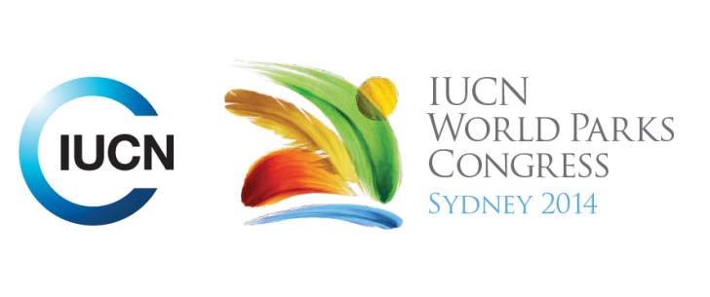



**Please fill-in this word template, save it and email to:**[**WPCReports@iucn.org**](mailto:WPCReports@iucn.org)

|  |  |  |
| --- | --- | --- |
| **Rapporteur’s report on session** | | |
| **Stream Number/WLD/Plenary:--- Congress---** | | |
| **Repporteur’s name: --- Jeff Thomas---** | | |
| **Session ID:---1069---** | | **Session Name: --- Protected Areas in South America-Natural solutions to global challenges---** |
| ***Summarize the session: Capture 1-3 main insights and findings of this session (including promising opportunities and inspiring solutions).*** | | |
| 1. **---** | **Effective management of natural areas is a key factor for natural based solutions. In South America, IUCN-Sur promotes sustainable management, restoration and conservation in order to maintain ecosystem’s health, diversity and functionality. In our Region, several examples of natural solutions are carried out Colombia: several indigenous organizations combined for the establishment of a National Park called “Indigenous Reserve Yaoige-Apaporis” due to the risk of mining activities. The protected area ensures legal status to the communities in order to avoid the extraction of minerals and promoted the creation of a “Sacred Sites System”. Peru: the Blue Cordillera National Park in Peru is working through an integral management model, including the participation of local communities, with the objective to stop illegal activities such as extraction of timber, hunting or fishing. Inside the Park a deforestation rate of 0% has been achieved. Landscape Reserve – IUCN promotes the Ecosystem Base Adaptation in order to use the ecosystems services provided by nature as part of a wide solution for adaptation to climate change. In Peru, the Landscape Reserve Noy Yauyos Cocha implements climate change tools through the management of local communities of water and native grasslands. Argentina – Whales: in the Argentinian Patagonia whale-watching activities bring more than one hundred thirty thousands of tourists per year increasing financial resources to local people and to the protected areas provincial system.It has strengthened the management of the Natural Reserve “Peninsula of Valdes” as a way to avoid the habitat degradation increased by the impact of human beings activities and the climate change. Ecuador – Highlands or Paramos: paramos are highland ecosystems located between three thousand and five thousand meters above sea level. In Ecuador, the Ecological Reserve “The Angel” guarantees the provision of water in the cities around its influence area. Conservation of Paramos is a key activity for the provision and water in Ecuador and active local groups for protection of the Paramo has been created..---** | |
| 2. **---** | **Several major challenges remain including the modeling of climate change impacts, understanding of the natural infrastructure of protected areas as way to reduce disasters, implementation of international agreements, increasing of the representation of coverage – for instance for coastal-marine area - among others.---** | |
| 3. **---** | **.---** | |

|  |  |  |
| --- | --- | --- |
| Related keywords | | |
| ---Responding to Climate Change--- | ---Improving Health and Well-Being--- | ---Reaching Conservation Goals--- |

| **Cross Cutting Themes** |
| --- |
| ***If the session was related to a Cross Cutting Theme, please give some information on what has been discussed.*** |
| **---**Click here to enter text.**---** |

|  |
| --- |
| Related cross cutting theme |
| ---Choose an item.--- |

| **Recommendations to the IUCN World Parks Congress** | | | |
| --- | --- | --- | --- |
| ***Capture any specific recommendation from this session for the Innovative Approaches documents / Promise of Sydney (along the line of policy changes, capacity development, financing, practice…)*** | | | |
|  | **It was recommended that:** | **Actors** | **Timeline** |
| 1. **---** | **South America can show to the world the need to integrate conservation and development, and one good example of this is the example of protected areas.---** | **---**Click here to enter text.**---** | **---**Click here to enter text.**---** |
| 2. **---** | Click here to enter text.**---** | **---**Click here to enter text.**---** | **---**Click here to enter text.**---** |
| 3. **---** | Click here to enter text.**---** | **---**Click here to enter text.**---** | **---**Click here to enter text.**---** |

|  |  |  |
| --- | --- | --- |
| Related keywords | | |
| ---Choose an item.--- | ---Choose an item.--- | ---Choose an item.--- |

| **Information for the Communications - Team** |
| --- |
| ***Note any announcements/commitments or people/items of interests to media/communications. Please ensure to include any relevant contact information.*** |
| **---**Click here to enter text.**---** |