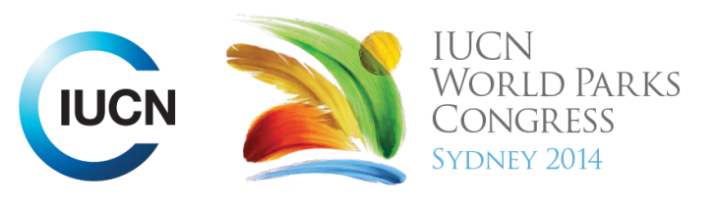

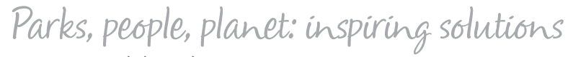

Please fill-in this word template, save it and email to:
WPCReports@iucn.org

Rapporteur’s report on session
Stream Number/WLD/Plenary:---Leader Dialogue---
Repporteur’s name: ---Camille---
Session ID:---1131--- |  | Session Name:---African Leader Dialogue---
Summarize the session: Capture 1-3 main insights and findings of this session (including promising opportunities and inspiring solutions).
1.--- | Africa should set up a promise around conservation of Park, not only for Africa, but for the whole world, based on their experience. This will guide future action in Africa. Africa has many success stories of conservation, reason for proud. Africa is amongst leader of conservation where live is in harmony with the nature, and source of inspiration for other continent. Africa is an underdeveloped continent, rich with natural resources that should rely on its leaders to bring change. Good management of NR will contribute to the development of Africa. African leaders should put conservation as a priority in national strategies and sit together for their own strategy Republic of Congo will work to improve management of existing PA. Namibia pledge to take care of wildlife against illegal exploitation, and to recognize the role of local collectivity and com in PA protection. There is no conservation without sustainable use. For Gabon, political will is key for conservation effort. No more time to complain, we need to act. Gabon is engaged for 23% of PA. For Mozambique, public-private partnership should be promoted. We should invest outside PA as well to build confidence and gain full engagement of local community---
2.--- | From different working groups some proposal came out for the Promise of Africa, drawn from presentations of different speakers: -Sharing park benefits to local communities and raising awareness on conservation; -National commitment to priorities conservation through community engagement education, regional cooperation and multi sectoral cooperation in national sustainable planning; Sustainable conservation as a pillar for all development plans (local, national, regional); Conservation needs to be part of integrated development planning; Conservation and enhancement of AP should be among the priorities of developing countries of Africa / all funds must integrate conservation and sustainable development; - Government should spearhead conservation investments; Financial mechanisms more accessible (REDD+, green funds); Funds need to be redirected to actual on the ground actions and 50% of these should go for community development to assure long terms sustainability and fairness in conservation; Political commitment in funding, affecting at least 0.5% of the national budget Protected Areas ;- Corporate social responsibilities; Local education (basic) and exposure to conservation practice; Integrate environmental education in schools curricula; Education and Involvement of Youth ( with a focus on urban youth ); management of PAs across border (landscape approach); - Invest in youth education; - Strengthening regional and international cooperation and partnership to fight against crime (wildlife crime); Build economic equality; - Encourage private investment in the development of AP; Promote public private partnership catalyzed by a strong public commitment ; -Shift conservation focus from species to people; Create a better world through the sustainable use of our natural resources; - Creating a forum for park management agencies in Africa; Conserve through the development of a well supported network of PAs in Africa---
3.--- | Click here to enter text.---
Related keywords
---Choose an item.--- | ---Choose an item.--- | ---Choose an item.---

Cross Cutting Themes
If the session was related to a Cross Cutting Theme, please give some information on what has been discussed.
---Click here to enter text.---
Related cross cutting theme
---Choose an item.---

Recommendations to the IUCN World Parks Congress
Capture any specific recommendation from this session for the Innovative Approaches documents / Promise of Sydney (along the line of policy changes, capacity development, financing, practice…)
 | It was recommended that: | Actors | Timeline
1.--- | Click here to enter text.--- | ---Click here to enter text.--- | ---Click here to enter text.---
2.--- | Click here to enter text.--- | ---Click here to enter text.--- | ---Click here to enter text.---
3.--- | Click here to enter text.--- | ---Click here to enter text.--- | ---Click here to enter text.---
Related keywords
---Choose an item.--- | ---Choose an item.--- | ---Choose an item.---

Information for the Communications - Team
Note any announcements/commitments or people/items of interests to media/communications. Please ensure to include any relevant contact information.
---Click here to enter text.---

