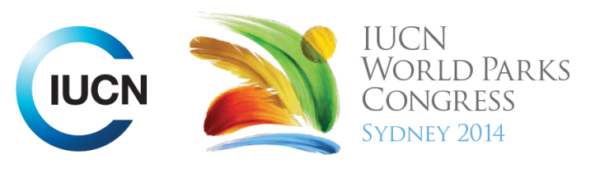

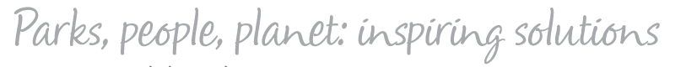

Please fill-in this word template, save it and email to:
WPCReports@iucn.org

Rapporteur’s report on session
Stream Number/WLD/Plenary:--- Plenary opening session afternoon---
Repporteur’s name: --- Lara Nassar and Jeff Thomas---
Session ID:---183--- |  | Session Name: --- Opening Parallel Plenary PEOPLE---
Summarize the session: Capture 1-3 main insights and findings of this session (including inspiring stories, promising opportunities and innovative solutions).
1. --- | During the past decade, much has been done on trying to reconnect people with nature. One of these components that have caused controversy; is technology. Protected area management in the past has been pushing away technological advances; however it has been thought today that technology can help reconnect people with nature. Urbanized people are not looking for systems to save them from technology, but to help integrate urbanised and technological life with nature. Protected area management today should think more about connecting people in urbanized areas to nature by utilizing this development shift happening today. To further engage the youth and the developed world, private sector involvement may help making this a reality, by maybe mobilizing funding towards better investments in that area. ---
2. --- | One of the most spoken about subjects in this congress; is youth engagement. It was greatly highlighted that better youth engagement and better participation of youth groups around the world and specially in developing countries, will awaken the desire communities have towards protecting and saving wild life, their desire to be more involved in taking community action and change future generation perceptions about wild life, protected areas and rural development. However, there is much challenge in making this a reality, little to no support towards institutional capacity in developing countries exist. Moreover, creating new protected areas are causing conflicts when no income alternatives are created for local communities around the area ---
3. --- | Changing perceptions around the globe about rural and urbanized areas should be one of the top priorities. Rural communities are usually embarrassed about their areas and urbanized communities are not engaged with nature for big misinterpreted ideas that protected parks and nature are for (lower class). It is thought that building better protected areas and parks, better managing it will create a combination of benefits that all community groups can benefit from. Income and social status should not be a reason communities around the world don’t benefit or are engaged with nature. (in developing countries, protected areas are not engaging local communities around it, and in developed countries some protected areas are not engaging urbanized communities) ---
Related keywords
---Improving Health and Well-Being--- | ---Inspiring a New Generation--- | ---Capacity Development---

Cross Cutting Themes
If the session was related to a Cross Cutting Theme, please give some information on what has been discussed.
---Click here to enter text.---
Related cross cutting theme
---Choose an item.---

Recommendations to the IUCN World Parks Congress
Capture any specific recommendation from this session for the Innovative Approaches documents / Promise of Sydney (along the line of policy changes, capacity development, financing, practice…)
 | It was recommended that: | Actors | Timeline
1. --- | Every effort must be made, by providing opportunities, to engage people, especially youth in connecting with nature. Many examples exist in the world but those that establish an emotional and support an emotional connection are strongest We can use people such as park rangers with inspiring stories about their work in protected areas to promote the values and benefits of conservation of nature --- | ---Click here to enter text.--- | ---Click here to enter text.---
2. --- | WE need to make use of social media and the digital world to promote and connect people with nature, ------ | ---Click here to enter text.--- | ---Click here to enter text.---
3. --- | People must be involved in the management of protected areas so they have the opportunities to obtain monetary and non monetary benefits to ensure long term sustainability of the protected areas--- | ---Click here to enter text.--- | ---Click here to enter text.---
Related keywords
---Reaching Conservation Goals--- | ---Choose an item.--- | ---Choose an item.---

Information for the Communications - Team
Note any announcements/commitments or people/items of interests to media/communications. Please ensure to include any relevant contact information.
---Click here to enter text.---

