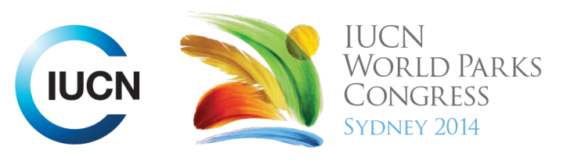

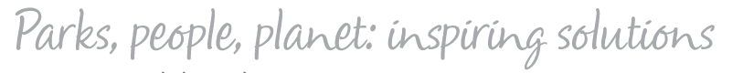

Please fill-in this word template, save it and email to:
WPCReports@iucn.org

Rapporteur’s report on session
Stream Number/WLD/Plenary:--- Plenary opening session afternoon---
Repporteur’s name: --- Lara Nassar---
Session ID:---199--- |  | Session Name: --- Opening Plenary: Afternoon Session (Part 1)---
Summarize the session: Capture 1-3 main insights and findings of this session (including inspiring stories, promising opportunities and innovative solutions).
1. --- | The importance of Biodiversity conservation is highlighted around main issues around the globe. Biodiversity conservation is an aim worldwide, continents have been mobilising resources inorder to fight the extinction of certain species, create better sustainably managed protected areas, fight the effects of climate change on wild life and protected areas alike and mostly find an answer towards the biggest dilemma countries around the world are facing today “Economic development Vs Biodiversity Conservation”. New approaches towards protected area management should focus on finding balance between economic development and biodiversity conservation. Protected area category declassification and/or revisit the whole concept of a protected area to try and include sustainable economic development ---
2. --- | There are many challenges facing countries today when taking protected areas management into consideration. There are many protected areas in developing countries which are virtually protected. They don’t have the tools and mechanisms necessary for proper monitoring and evaluation and there are many violations which can/or are not reported. Economic development priorities pose a great risk to certain protected areas around the world, where natural resources such as oil are found on protected area boundaries. The expansion or certain cities and towns also pose a threat towards ecosystem management and protected areas around the world. All of this is combined with the low capacity of communities to realise the benefits they can possess from protected areas ecosystem services. ---
3. --- | All the above being mentioned, its also great to finally see great outcomes around the globe. Protected areas have increased in number drastically over the past decade, funding towards better protected area management has increased, better youth involvement, a more integrated participatory approach is being used when considering policy formation, protected area and wild life protection. The private sector is being included in many initiatives which in turn increase national commitments. Increased renewable energy has been aimed for in many countries targeting decreased carbon emissions, and finally more youth involvement has been noticed. ---
Related keywords
---Reaching Conservation Goals--- | ---Improving Health and Well-Being--- | ---Capacity Development---

Cross Cutting Themes
If the session was related to a Cross Cutting Theme, please give some information on what has been discussed.
---Click here to enter text.---
Related cross cutting theme
---Choose an item.---

Recommendations to the IUCN World Parks Congress
Capture any specific recommendation from this session for the Innovative Approaches documents / Promise of Sydney (along the line of policy changes, capacity development, financing, practice…)
 | It was recommended that: | Actors | Timeline
1. --- | Appeal to present a resolution aiming at finding funding towards climate change effects on protected areas in developing countries --- | ---Click here to enter text.--- | ---Click here to enter text.---
2. --- | Click here to enter text.--- | ---Click here to enter text.--- | ---Click here to enter text.---
3. --- | Click here to enter text.--- | ---Click here to enter text.--- | ---Click here to enter text.---
Related keywords
---Reaching Conservation Goals--- | ---Choose an item.--- | ---Choose an item.---

Information for the Communications - Team
Note any announcements/commitments or people/items of interests to media/communications. Please ensure to include any relevant contact information.
---Click here to enter text.---

