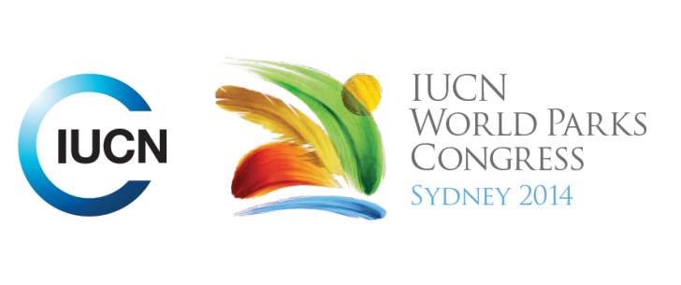



**Please fill-in this word template, save it and email to:**[**WPCReports@iucn.org**](mailto:WPCReports@iucn.org)

|  |  |  |
| --- | --- | --- |
| **Rapporteur’s report on session** | | |
| **Stream Number/WLD/Plenary:--- Stream 1---** | | |
| **Repporteur’s name: --- Sarah Titchen---** | | |
| **Session ID:---230---** | | **Session Name: --- Innovative Financial Mechanisms for Conservation and Protected Areas---** |
| ***Summarize the session: Capture 1-3 main insights and findings of this session (including promising opportunities and inspiring solutions).*** | | |
| 1. **---** | A diverse and evolving suite of sustainable financing mechanisms and instruments for Protected Area conservation were presented. These included a biodiversity offsets approach for gas pipelines in Myanmar, a proposal for a new type of green financial instrument called “Park Bonds” to fund conservation by offering a Triple-A credit rating to investors and a low coupon rate, a Green Fee as a proportion of Palau’s departure tax, the Brazilian Biodiversity Fund (Funbio) funded through compensation based on a mitigation hierarchy, the Mexican Fund for the Conservation of Nature (FMCN) and other examples of conservation trust funds.**---** | |
| 2. **---** | A number of new studies and publications were also presented. These included the Credit Suisse, WWF and McKinsey report “Conservation Finance. Moving beyond donor funding toward an investor-driven approach” and the Conservation Finance Alliance reports “Conservation Trust Funds and Projects Comparative Advantages” and “Practice Standards for Conservation Trust Funds” **---** | |
| 3. **---** | Click here to enter text.**---** | |

|  |  |  |
| --- | --- | --- |
| Related keywords | | |
| ---Reaching Conservation Goals--- | ---Choose an item.--- | ---Choose an item.--- |

| **Cross Cutting Themes** |
| --- |
| ***If the session was related to a Cross Cutting Theme, please give some information on what has been discussed.*** |
| **---**Click here to enter text.**---** |

|  |
| --- |
| Related cross cutting theme |
| ---Choose an item.--- |

| **Recommendations to the IUCN World Parks Congress** | | | |
| --- | --- | --- | --- |
| ***Capture any specific recommendation from this session for the Innovative Approaches documents / Promise of Sydney (along the line of policy changes, capacity development, financing, practice…)*** | | | |
|  | **It was recommended that:** | **Actors** | **Timeline** |
| 1. **---** | Click here to enter text.**---** | **---**Click here to enter text.**---** | **---**Click here to enter text.**---** |
| 2. **---** | Click here to enter text.**---** | **---**Click here to enter text.**---** | **---**Click here to enter text.**---** |
| 3. **---** | Click here to enter text.**---** | **---**Click here to enter text.**---** | **---**Click here to enter text.**---** |

|  |  |  |
| --- | --- | --- |
| Related keywords | | |
| ---Choose an item.--- | ---Choose an item.--- | ---Choose an item.--- |

| **Information for the Communications - Team** |
| --- |
| ***Note any announcements/commitments or people/items of interests to media/communications. Please ensure to include any relevant contact information.*** |
| **---**Click here to enter text.**---** |