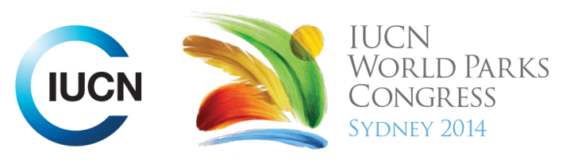



Please fill-in this word template, save it and email to:
WPCReports@iucn.org

Rapporteur’s report on session
Stream Number/WLD/Plenary:--- Stream 1---
Repporteur’s name: --- Natalie Lobartolo---
Session ID:---234--- |  | Session Name: --- Global Gap Analysis of Protected Area Coverage of Biodiversity---
Summarize the session: Capture 1-3 main insights and findings of this session (including promising opportunities and inspiring solutions).
1. --- | Different scientific analyses at the global scale show we need more than 17% of global areas to be protected. To achieve the aims, we need to not only go for 50/50 (or an increase form 17%), but also be more efficient in targeting PA expansion to include biodiversity values (must be quantitative and measurable). Projections found that although PA coverage may increase, biodiversity will eventually plateau or continue decreasing. Considerations should also be made to put biodiversity and species on equal terms with ecosystems (and ecosystem services). There seem to be two parallel arms to be considered when addressing the gaps in PA coverage: the gap between biodiversity and management needs to be bridged. Optimised visions and scenarios need to be developed regarding ecological representativity. ---
2. --- | Optimised visions and scenarios need to be developed regarding ecological representativity. Since 1990, PA coverage in the terrestrial environment has doubled, while marine and freshwater areas have not been given consideration (eg. 0.2% of high seas covered in PAs). We need global cooperation on protected area networks and coordination between countries. Combine global and national priorities to define goals and respond to challenges In terms of financing, even when there is a very good budget, sometimes you cannot protect the biodiversity.---
3. --- | Need to consider impacts of land use changes within and around PAs. The conservation of species outside of PAs also needs to be addressed. Cost benefit analyses of PAs should be carried out. There is much focus on the large cost of managmenet, staffing and review of plans and practise, however a large budget does not always result in the achieving biodiversity outcomes. Eg. Rhinocerous poaching issues in some countries still exist despite hefty budget availability. ---
Related keywords
---Choose an item.--- | ---Choose an item.--- | ---Choose an item.---

Cross Cutting Themes
If the session was related to a Cross Cutting Theme, please give some information on what has been discussed.
---Click here to enter text.---
Related cross cutting theme
---Choose an item.---

Recommendations to the IUCN World Parks Congress
Capture any specific recommendation from this session for the Innovative Approaches documents / Promise of Sydney (along the line of policy changes, capacity development, financing, practice…)
 | It was recommended that: | Actors | Timeline
1. --- | Quantify and communicate/draw attention to the economic benefits of PA Eg. The amount gained from tax from tourists visiting Australian protected areas is double the amount that the government provides in funding. --- | ---Click here to enter text.--- | ---Click here to enter text.---
2. --- | Biodiversity and species should be put on equal terms with ecosystem services and this should be done under a global context. Goals or recommendations to achieve this global cooperation should be set. We need to know exactly what and how much we want to conserve by determining acceptable, quantitative thresholds.--- | ---countries, governments, NGOS, all--- | ---Click here to enter text.---
3. --- | Policy or management approaches should be developed to address threatened species/conservation issues both inside and outside of PAs. This should be included in planning in response to land use changes and other global changes such as climate change.--- | ---Click here to enter text.--- | ---Click here to enter text.---
Related keywords
---Choose an item.--- | ---Choose an item.--- | ---Choose an item.---

Information for the Communications - Team
Note any announcements/commitments or people/items of interests to media/communications. Please ensure to include any relevant contact information.
---Click here to enter text.---

