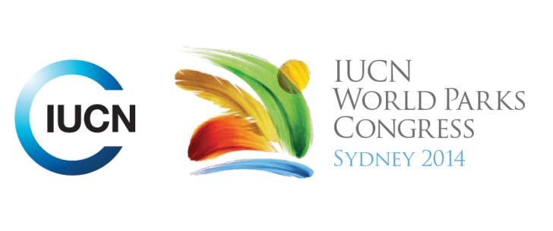



**Please fill-in this word template, save it and email to:**[**WPCReports@iucn.org**](mailto:WPCReports@iucn.org)

|  |  |  |
| --- | --- | --- |
| **Rapporteur’s report on session** | | |
| **Stream Number/WLD/Plenary:--- Stream 1---** | | |
| **Repporteur’s name: --- Natalie Lobartolo---** | | |
| **Session ID:---241---** | | **Session Name: --- National Experiences with MPA Network Development---** |
| ***Summarize the session: Capture 1-3 main insights and findings of this session (including promising opportunities and inspiring solutions).*** | | |
| 1. **---** | Learning from experience sharing in Marine PA development and management experiences is extremely valuable. In some countries, such as India, very little marine biological research has been carried out, and there is a need to identify biodiversity hotspots and valuable areas before MPAs can be developed, but this requires a lot of investment (both time and financial). In countries where research and investigation is more developed, some countries use strict biological data, whereas others also include broader scale biophysical data to have a better understanding of the whole system. In some cases, there is a lot of research occurring, but no conservation actions being put into place. In addition, some legislative and administrative frameworks do not allow for fast establishment of PAs, however given the status of many species, they do not have time to wait for us to gather data before taking action. In some cases, there is a lot of research occurring, but no conservation actions being put into place. **---** | |
| 2. **---** | Dealing with conflicts is one of the biggest challenges in MPA Network Development, especially in coastal areas. An example from Indonesia showed that 60% of dugongs were found outside MPAs, and fishing pressures were high in these areas. A leatherback turtle example was also given to demonstrate that conservation actions came in too late, resulting in loss of a whole population of nesting leatherback turtles, when before there were thousands annually. MPAs would have large positive impact in such cases. The discrepancies between federal and state/provincial priorities and governance frameworks and strategies can be very challenging in Federal countries. Many legislative and administrative frameworks do not allow for fast establishment of PAs, however given the status of many species, they do not have time to wait for us to gather data before taking action. **---** | |
| 3. **---** | The UNEP/MAP-GEF MedPartnership is an initiative which builds in the experience of different countries and improves coverage and management of PAs. It focuses on priority areas and uses technical assistance, training and capacity building. For example, more than 200 participants were trained (including stakeholder exchange, scientific diving, on-the-job training in field surveys and monitoring). The cooperation brought local scientists and graduates to undertake field training and provided technical teaching packages with guidelines and training materials. This was a great initiative to raise value of MPAs and create awareness. The network sustains development and enhances the values of nature and culture, addressing management to maintain balance between conservation and use of the area.**---** | |

|  |  |  |
| --- | --- | --- |
| Related keywords | | |
| ---Capacity Development--- | ---Reconciling Development Challenges--- | ---Enhancing Diversity and Quality of Governance--- |

| **Cross Cutting Themes** |
| --- |
| ***If the session was related to a Cross Cutting Theme, please give some information on what has been discussed.*** |
| **---**This session looked at MPA strategies, challenges and gaps. **---** |

|  |
| --- |
| Related cross cutting theme |
| ---Marine--- |

| **Recommendations to the IUCN World Parks Congress** | | | |
| --- | --- | --- | --- |
| ***Capture any specific recommendation from this session for the Innovative Approaches documents / Promise of Sydney (along the line of policy changes, capacity development, financing, practice…)*** | | | |
|  | **It was recommended that:** | **Actors** | **Timeline** |
| 1. **---** | Where possible, countries should adopt participatory science programmes to assist in filling gaps on available biodiversity and ecosystem data to aid in PA planning and management. **---** | **---**Click here to enter text.**---** | **---**Click here to enter text.**---** |
| 2. **---** | Build in experience of different countries and improve coverage and management- focus on priority areas – technical assistance, training and capacity building was undertaken to train more than 200 participants (stakeholder exchange, scientific diving, on-the-job training in field surveys and monitoring). Brought local scientists and graduates to undertake field training. Technical teaching packages with guidelines and training materials. Raise value of MPAs and create awareness – network sustains development and enhances values of nature and culture. Addressed management to maintain balance between conservation and use of the area.**---** | **---**Click here to enter text.**---** | **---**Click here to enter text.**---** |
| 3. **---** | In many countries, there are many gaps to conservation due to lack of research results. We need to continue improving the quality of biodiversity assessments. Stakeholders from multiple countries should unite to work together and share experiences and local stakeholders should be included from the very beginning. Once enough information is gathered to make a MPA decision, countries can look at establishing networks, but on average, this process is slow, taking around 10-15 years, and some conservation actions are urgent to save species. There is a need for more funding, enforcement and education. **---** | **---**Click here to enter text.**---** | **---**Click here to enter text.**---** |

|  |  |  |
| --- | --- | --- |
| Related keywords | | |
| ---Marine--- | ---Capacity Development--- | ---Enhancing Diversity and Quality of Governance--- |

| **Information for the Communications - Team** |
| --- |
| ***Note any announcements/commitments or people/items of interests to media/communications. Please ensure to include any relevant contact information.*** |
| **---There was an excellent example of communicating the value of MPAs to tourists given from Gwendalyn Sisior, who spoke about MPAs in Palau. I have a copy of the video on USB. There was also a great video presented from the FUndacion biodiversidad Representative, Sonia Castaneda---** |