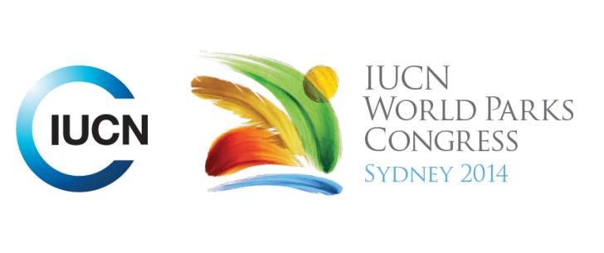



**Please fill-in this word template, save it and email to:**[**WPCReports@iucn.org**](mailto:WPCReports@iucn.org)

|  |  |  |
| --- | --- | --- |
| **Rapporteur’s report on session** | | |
| **Stream Number/WLD/Plenary:--- Stream 1---** | | |
| **Repporteur’s name: --- Sarah Titchen---** | | |
| **Session ID:---244---** | | **Session Name: --- Alliance for Zero Extinction – Saving the Most Critical Areas---** |
| ***Summarize the session: Capture 1-3 main insights and findings of this session (including promising opportunities and inspiring solutions).*** | | |
| 1. **---** | The Alliance for Zero Extinction (AZE), an alliance of 88 non-governmental biodiversity conservation organizations is working to address the extinction crisis. The AZE focusses on preventing species extinctions by identifying and safeguarding the places where species are evaluated as Endangered or Critically Endangered and are restricted to single remaining sites. A Brazilian Alliance for Zero Extinction (BAZE) is replicating AZEs work at a global level at the national level in Brazil. The focus of BAZEs work is in identifying and protecting the last refuges of CR and EN species in Brazil using public and private support.**---** | |
| 2. **---** | Recognizing that public PAs will not achieve Aichi Target 11 and that there is a lot of biodiversity to protect outside of public lands, examples of funding sources available for privately PAs were presented. The Dutch Postcode Lottery is an innovative pioneer that is funding projects in countries where land acquisition (purchase of lease) for conservation is possible, for example in Myanmar, Iran and Armenia. The focus is on achieving connectivity in fragmented landscapes that strengthen ecological networks and securing critical footholds for the survival of certain species. The Mohammad bin Zayed Fund for Species Conservation is providing small grants for on ground species-focussed projects focussing on supporting species that are endangered, poorly known or locally important.**---** | |
| 3. **---** | A number of case studies were presented. A Tree Kangaroo Conservation Program in Papua New Guinea has established partnerships with landowners, government and other stakeholders to build a community based conservation area recently recognized with a UNDP Equator Prize. The Amphibian Survival Alliance, is working to protect amphibians especially at AZE sites using a partnership approach to leverage resources. Sites of importance for critically endangered amphibians are being protected in Haiti with the establishment of Privately Protected Areas. It was noted that small cave invertebrates are often not protected and not red listed but could become a new focus of the AZE. Some members of the audience recalled the importance of protecting on large landscape.**---** | |

|  |  |  |
| --- | --- | --- |
| Related keywords | | |
| ---Reaching Conservation Goals--- | ---Choose an item.--- | ---Choose an item.--- |

| **Cross Cutting Themes** |
| --- |
| ***If the session was related to a Cross Cutting Theme, please give some information on what has been discussed.*** |
| **---**Click here to enter text.**---** |

|  |
| --- |
| Related cross cutting theme |
| ---Choose an item.--- |

| **Recommendations to the IUCN World Parks Congress** | | | |
| --- | --- | --- | --- |
| ***Capture any specific recommendation from this session for the Innovative Approaches documents / Promise of Sydney (along the line of policy changes, capacity development, financing, practice…)*** | | | |
|  | **It was recommended that:** | **Actors** | **Timeline** |
| 1. **---** | In addition to large landscapes the Promise of Sydney should concentrate on those areas designated under the Alliance for Zero Extinctions as well as other key sites for highly endangered or threated species and confined to small ranges. **---** | **---**Click here to enter text.**---** | **---**Click here to enter text.**---** |
| 2. **---** | Click here to enter text.**---** | **---**Click here to enter text.**---** | **---**Click here to enter text.**---** |
| 3. **---** | Click here to enter text.**---** | **---**Click here to enter text.**---** | **---**Click here to enter text.**---** |

|  |  |  |
| --- | --- | --- |
| Related keywords | | |
| ---Choose an item.--- | ---Choose an item.--- | ---Choose an item.--- |

| **Information for the Communications - Team** |
| --- |
| ***Note any announcements/commitments or people/items of interests to media/communications. Please ensure to include any relevant contact information.*** |
| **---The highly prestigious 2014 UNDP Equator Prize was won by the Tree Kangaroo Conservation Program in Papua New Guinea – the presenter is Daniel Solomon Okena. He and several other members of this team are at the Congress. Contact Daniel on mobile +675 472 7856 or his US based colleague Lisa Dabek is also at the Congress Lisa.dabek@zoo.org---** |