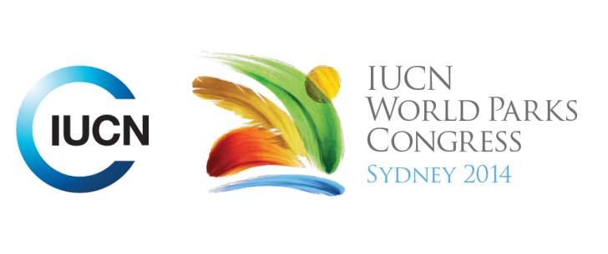



**Please fill-in this word template, save it and email to:**[**WPCReports@iucn.org**](mailto:WPCReports@iucn.org)

|  |  |  |
| --- | --- | --- |
| **Rapporteur’s report on session** | | |
| **Stream Number/WLD/Plenary:--- Stream 1---** | | |
| **Repporteur’s name: --- Natalie Lobartolo---** | | |
| **Session ID:---248---** | | **Session Name: --- Inspiring Hope: Preotected Area Restoration---** |
| ***Summarize the session: Capture 1-3 main insights and findings of this session (including promising opportunities and inspiring solutions).*** | | |
| 1. **---** | This session looked at restoration efforts to connect protected areas at a landscape scale. 4 key learnings: 1. must have a conceptual model to know if, when and how to intervene, 2. Harness and exploit modern technology 3. Long term resourcing solutions 4. Social partnerships and strong relationships with the community is the only way to achieve long term results. **---** | |
| 2. **---** | Many key species are often outside of PA networks and this needs to be addressed. Research showed that trees in protected areas can be restored via protection, without specific or active restoration efforts. In Indonesia, there were new licenses created to manage forests for conservation purposes and enforce a logging moratorium BUT if the timber is not cut, it is a challenge to finance the activities of the forest. Ecosystem Restoration Concessions were introduced – not just for the sake of biodiversity, but for the sake of the people who use and depend on forest resources. These experiences showed that policy reform is possible, even in developing countries. **---** | |
| 3. **---** | In Mexico, passive tillage was used to maintain floristic structure and composition. The processes maintain the carbon and water cycles in the desert and improve resilience to climate change. Examples were given of recovery programs that were launched, funded by local communities (PES: Payment for Ecosystem Services). In Sangako, Senegal, Community Created and Managed MPAs are being restored starting with first level herbivores, up to large trophic predators. Only 5 years after the fishing ban, the fish assembly was already characterized by high level tropic level, predatory marine species. In Tasmania, Invasive Rabbit Management Strategies include regulatory, staffing, strategy, comms/awareness, logistics, procurement, dog training and peer review. Successful results are already being seen. The planning phase was incredibly important, but a key success factor was the level of government commitment and funding, allowing to proceed with contracting and actions. These kind of activities need dedicated staff. **---** | |

|  |  |  |
| --- | --- | --- |
| Related keywords | | |
| ---Choose an item.--- | ---Choose an item.--- | ---Choose an item.--- |

| **Cross Cutting Themes** |
| --- |
| ***If the session was related to a Cross Cutting Theme, please give some information on what has been discussed.*** |
| **---**World Heritage Sites mentioned: Springbrook, Cumberland, Macquaries Island, Tasmania**---** |

|  |
| --- |
| Related cross cutting theme |
| ---World Heritage--- |

| **Recommendations to the IUCN World Parks Congress** | | | |
| --- | --- | --- | --- |
| ***Capture any specific recommendation from this session for the Innovative Approaches documents / Promise of Sydney (along the line of policy changes, capacity development, financing, practice…)*** | | | |
|  | **It was recommended that:** | **Actors** | **Timeline** |
| 1. **---** | Look for practical solutions: adaptive management. Eg. using fire, cut the problems into small pieces (start small and build), get the community involved from the very beginning – create a sense of ownership and stories to tell. **---** | **---**managers**---** | **---**Click here to enter text.**---** |
| 2. **---** | Awe has the capacity to change the way we think: We need to rekindle people’s passion for nature. The mutual benefits of voluntourism should be recognised and valued. **---** | **---**countries, NGOs, civil society, governments**---** | **---**Click here to enter text.**---** |
| 3. **---** | Involve communities in conservation efforts and managent, seek and source dedicated staff who don’t just do their job well, but genuinely care about what they do.**---** | **---**Click here to enter text.**---** | **---**Click here to enter text.**---** |

|  |  |  |
| --- | --- | --- |
| Related keywords | | |
| ---Choose an item.--- | ---Choose an item.--- | ---Choose an item.--- |

| **Information for the Communications - Team** |
| --- |
| ***Note any announcements/commitments or people/items of interests to media/communications. Please ensure to include any relevant contact information.*** |
| **---Springbrook Rescue** <https://springbrookrescue.org.au/>. Low impact rainforest retreat for conservation: [http://www.lyrebirdspringbrook.com.au/index.html**-**](http://www.lyrebirdspringbrook.com.au/index.html-) **Forests of Hope:** <http://www.birdlife.org/asia/programmes/forests-hope-asia> Book about Cumberland Plains: Contact Jonathan Sanders **---** |