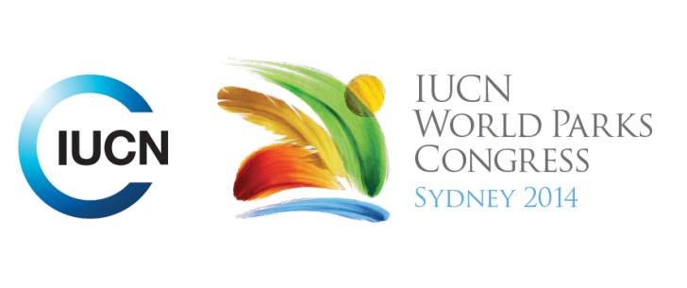



**Please fill-in this word template, save it and email to:**[**WPCReports@iucn.org**](mailto:WPCReports@iucn.org)

|  |  |  |
| --- | --- | --- |
| **Rapporteur’s report on session** | | |
| **Stream Number/WLD/Plenary:--- 2---** | | |
| **Repporteur’s name: --- Jacqui Doyle---** | | |
| **Session ID:---280---** | | **Session Name: --- Guidelines for Sustainability and ecosystem based climate change adaptation in the coastal zone---** |
| ***Summarize the session: Capture 1-3 main insights and findings of this session (including promising opportunities and inspiring solutions).*** | | |
| 1. **---** | Coastlines are very diverse and dynamic thus require multiple types and scales of interventions. Spatial planning and zoning are important starting points. Nature-based solutions need to be much more widely promoted as they can provide multiple benefits for adaptation, mitigation and disaster risk reduction. It was suggested that all adaptation projects should be screened for their impacts on ecosystems and livelihoods. Greater support is required for research to understand climate change impacts on species and ecosystems. We need to understand the limits to adaptation, for example due to changing distribution. It was suggested research be focused on a select number of ‘champion’ species to assist in communicating climate changes to the public. As marine protected areas are areas of last resort for many species, effective management in the face of climate change will require ensuring connectivity between marine protected areas across large seascapes. Transboundary collaboration will become increasingly important. **---** | |
| 2. **---** | Salt marshes are an important component of the ecosystem in Kouchibouguac, Canada, as they contain many traditional medicinal plants for the nearby First Nations. These plant populations are under threat when storm surges occur. Under the projected scenarios of sea level rise coupled with storm surges, many of these sites may not recover, leading to loss of plant populations. Some of the proposed measures that may be useful for disaster risk reduction include linking weather forecast (for storms) with harvest and monitoring periods in order to avoid risks to people as well as relocation of some populations. Some of these measures are also adaptation strategies that the park with the community can discuss. In NZ, dune restoration projects are assisting in the protection of cities, such as Christchurch against coastal hazards. Disaster risk reduction is viewed as a useful addition to biodiversity protection strategies, due to the focus on shorter duration high intensity events. The challenge is to design a whole of ecosystem approach that is inclusive of the ecological system and the community. Protected Areas can offer DRR benefits for coastal margins, noting however that coastal PA themselves are vulnerable to sea level rise. **---** | |
| 3. **---** | Sea level rise is a serious problem for many coastal national parks. A range of actions are being taken – for example roads and infrastructure are being moved, elevated or alternative access developed in light of climate forecasts. Other activities include restoring coastal ecosystems, plantings and restoring hydrology (Everglades). Dredged material is being used to raise elevation of landscape, offset erosion problems and sea level rise impacts, attenuate salt water intrusion and protect natural and cultural resources. The objective of some restoration activities, such as beach nourishment, is the protection of critical infrastructure. It was suggested that this type of restoration should be limited, particularly in national parks, as it can have negative impacts on the environment. There will be increasing pressure to undertake restoration projects to protect infrastructure and coastal communities, and that the impacts on the natural environment should be considered. **---** | |

|  |  |  |
| --- | --- | --- |
| Related keywords | | |
| ---Responding to Climate Change--- | ---Marine--- | ---Choose an item.--- |

| **Cross Cutting Themes** |
| --- |
| ***If the session was related to a Cross Cutting Theme, please give some information on what has been discussed.*** |
| **---**This session discussed climate change impacts on the coastal**---** |

|  |
| --- |
| Related cross cutting theme |
| ---Marine--- |

| **Recommendations to the IUCN World Parks Congress** | | | |
| --- | --- | --- | --- |
| ***Capture any specific recommendation from this session for the Innovative Approaches documents / Promise of Sydney (along the line of policy changes, capacity development, financing, practice…)*** | | | |
|  | **It was recommended that:** | **Actors** | **Timeline** |
| 1. **---** | More research is required to understand (i)climate change impacts on species and ecosystems and (ii) the limits to adaptation, for example due to changing distribution. It was suggested research be focused on a select number of ‘champion’ species to assist in communicating climate changes to the public.**---** | **---**Click here to enter text.**---** | **---**Click here to enter text.**---** |
| 2. **---** | It was suggested that all adaptation projects should be screened for their impacts on ecosystems and livelihoods.**---** | **---**Click here to enter text.**---** | **---**Click here to enter text.**---** |
| 3. **---** | Nature-based solutions need to be much more widely promoted as they can provide multiple benefits for adaptation, mitigation and disaster risk reduction.**---** | **---**Click here to enter text.**---** | **---**Click here to enter text.**---** |

|  |  |  |
| --- | --- | --- |
| Related keywords | | |
| ---Choose an item.--- | ---Choose an item.--- | ---Choose an item.--- |

| **Information for the Communications - Team** |
| --- |
| ***Note any announcements/commitments or people/items of interests to media/communications. Please ensure to include any relevant contact information.*** |
| **---**Click here to enter text.**---** |