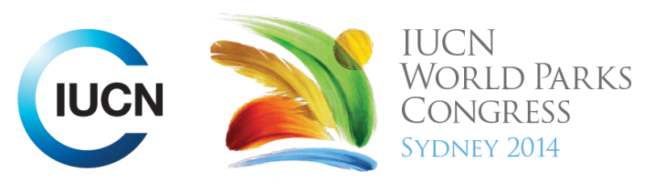

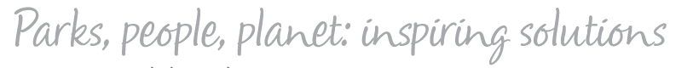

Please fill-in this word template, save it and email to:
WPCReports@iucn.org

Rapporteur’s report on session
Stream Number/WLD/Plenary:--- Click here to enter text.---
Repporteur’s name: --- Melissa Marin---
Session ID:---281--- |  | Session Name: --- Perceptions and expectations for protected areas under climate change---
Summarize the session: Capture 1-3 main insights and findings of this session (including promising opportunities and inspiring solutions).
1. --- | This session is focused on a survey of conservation scientists, protected areas managers and policy makers tied with the "Global Warming's Six Americas". The main results are that adaptation strategies are under-resources; in Australia although the people understand the physical impacts of Climate Change, they have few information on the socio-economic impacts; in the long term, manager under climate change will become more engineers than ecologists or environmental analysts; specifically for the Unite Stated of America, public perceptions of climate change are not simply grouped into "believers" and "sceptics", they are divided into 4 different perceptions and 75% of them are in the middle; almost 50% of people thinks climate change is happening because human actions and 38% thinks it is because natural fluctuation in earth’s temperature; knowledge, values and rules are still seen as a barrier to climate change adaption strategies; and finally, climate change is a lower social concern issue.---
2. --- | Protected Areas are being considered as a climate change adaptation strategy and represents a great opportunity to talk on this issue. ---
3. --- | Evidence that myths of nature as not static, but fluctuate over time. There are 4 different environmental worldviews: 1. Hierarchical (the environment can be managed). 2. Fatalistic (we can’t control environment). 3. Individualistic (the technology will solve the environmental problems). 4. Efalitarian (we can protect the environment only if there are large changes in human and society behaviour). Climate change is not one of the main social concerns. ---
Related keywords
---Responding to Climate Change--- | ---Choose an item.--- | ---Choose an item.---

Cross Cutting Themes
If the session was related to a Cross Cutting Theme, please give some information on what has been discussed.
---Click here to enter text.---
Related cross cutting theme
---Choose an item.---

Recommendations to the IUCN World Parks Congress
Capture any specific recommendation from this session for the Innovative Approaches documents / Promise of Sydney (along the line of policy changes, capacity development, financing, practice…)
 | It was recommended that: | Actors | Timeline
1. --- | Considering that what you manage today won’t be what you manage tomorrow, is extremely urgent moving from preserve and protect approaches to ones focused on facilitate changes, and from specific species approaches to ecosystem function approaches. --- | ---Click here to enter text.--- | ---Click here to enter text.---
2. --- | National Parks needs urgently a National Policy on Climate Change--- | ---Click here to enter text.--- | ---Click here to enter text.---
3. --- | Click here to enter text.--- | ---Click here to enter text.--- | ---Click here to enter text.---
Related keywords
---Responding to Climate Change--- | ---Choose an item.--- | ---Choose an item.---

Information for the Communications - Team
Note any announcements/commitments or people/items of interests to media/communications. Please ensure to include any relevant contact information.
---www.surveymonkey.com/s/WorldParkCongress---

