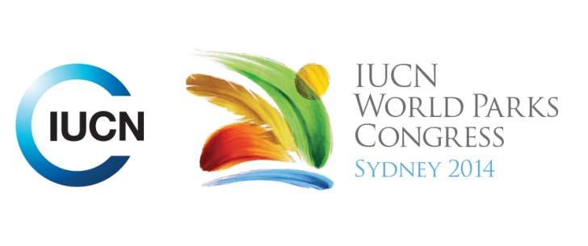



**Please fill-in this word template, save it and email to:**[**WPCReports@iucn.org**](mailto:WPCReports@iucn.org)

|  |  |  |
| --- | --- | --- |
| **Rapporteur’s report on session** | | |
| **Stream Number/WLD/Plenary:--- Responding to climate change---** | | |
| **Repporteur’s name: --- Roberto Valera---** | | |
| **Session ID:---288---** | | **Session Name: --- --- A Polar Journey Part 2: The effectiveness of protected areas in the high north and the deep south---** |
| ***Summarize the session: Capture 1-3 main insights and findings of this session (including promising opportunities and inspiring solutions).*** | | |
| 1. **---** | Research and specific studies conducted in the Polar Regions have established the effectiveness of PA’s and MPA’s. PA’s assist in the preservation of polar wildlife and ecosystems. It was found that PA’s have been effective in helping to maintain level of oxygen, organic matter, minimise erosion and the expansion of ecosystem, waterways and water quality. **-- ----** | |
| 2. **---** | Other advantages of establishing PA’s has been related to the archaeological findings, i.e it was established that permafrost in the arctic region of Greenland helped to preserve the remains of ancient cultures who inhabited these regions.**---** | |
| 3. **---** | Initials steps include: to support an integrated stewardship, ensure open and transparent process, to protect shared marine areas applying common principles and to establish methods to evaluate significant and potential threatened sites. **---** | |

|  |  |  |
| --- | --- | --- |
| Related keywords | | |
| ---Responding to Climate Change--- | ---Choose an item.--- | ---Choose an item.--- |

| **Cross Cutting Themes** |
| --- |
| ***If the session was related to a Cross Cutting Theme, please give some information on what has been discussed.*** |
| **---**Climate Change is threatening existence of specific species such as Polar Bears, whales of different types, and other marine and other endemic species. The need to declare the Polar Regions as World Heritage**---** |

|  |
| --- |
| Related cross cutting theme |
| ---Marine--- |

| **Recommendations to the IUCN World Parks Congress** | | | |
| --- | --- | --- | --- |
| ***Capture any specific recommendation from this session for the Innovative Approaches documents / Promise of Sydney (along the line of policy changes, capacity development, financing, practice…)*** | | | |
|  | **It was recommended that:** | **Actors** | **Timeline** |
| 1. **---** | Develop common tools and to support an integrated systems to protect shared MPA’s. Respect the existing natives rights and activities. **---** | **---**Click here to enter text.**---** | **---**Click here to enter text.**---** |
| 2. **---** | The objective is to have at least 10% of coastal and marine areas declared as PA’s by 2020 **---** | **---**Click here to enter text.**---** | **---**2020**---** |
| 3. **---** | Click here to enter text.**---** | **---**Click here to enter text.**---** | **---**Click here to enter text.**---** |

|  |  |  |
| --- | --- | --- |
| Related keywords | | |
| ---Choose an item.--- | ---Choose an item.--- | ---Choose an item.--- |

| **Information for the Communications - Team** |
| --- |
| ***Note any announcements/commitments or people/items of interests to media/communications. Please ensure to include any relevant contact information.*** |
| **---**Click here to enter text.**---** |