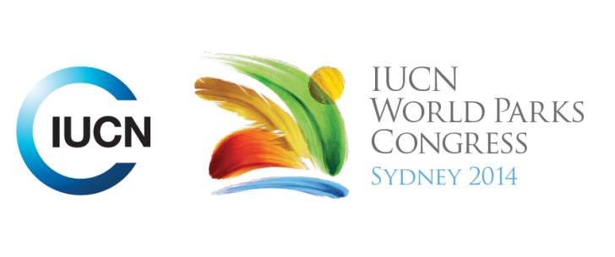

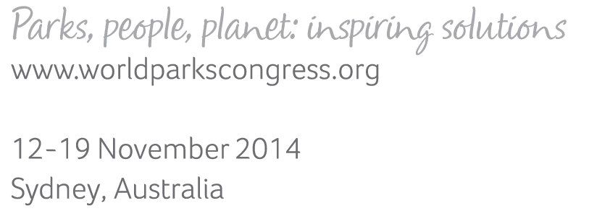

**Please fill-in this word template, save it and email to:**[**WPCReports@iucn.org**](mailto:WPCReports@iucn.org)

|  |  |  |
| --- | --- | --- |
| **Rapporteur’s report on session** | | |
| **Stream Number/WLD/Plenary:--- 2 Responding to Climate Change---** | | |
| **Repporteur’s name: --- Robert Valera---** | | |
| **Session ID:---300---** | | **Session Name: --- Adaptation Frameworks: key characteristics of climate-smart conservation---** |
| ***Summarize the session: Capture 1-3 main insights and findings of this session (including inspiring stories, promising opportunities and innovative solutions).*** | | |
| 1. **---** | Scientists are in accord when it come to the existence of a crisis and that Climate Change there is the need to reconsider goals and objectives and to integrate strategies and approaches. The various adaptation Frameworks have to be integrated and common goals defined. Introduction of an Adaptation Checklist to facilitate assessment of situations and to plan for the future. The planning process needs to include elements such as: Strategic Planning with flexible parameters and realistic targets, Assessment of the capacity and resources available, Monitoring the development of the plan, Reflection and engagement of decision makers and social groups. **---** | |
| 2. **---** | Developing a solution is accepting that a problem does exist. We need to respond to Climate Change by mitigating the causes. This is an immediate action and short term goal. Adaptation is a long term planning objective. Given the different frameworks being discussed it is important to link the “dots” and establish common practices to mitigate Climate Change. **---** | |
| 3. **---** | “Go away from the idea of Business as usual” Governments need to introduce Acts to have a mandate to act on Climate Change**---** | |

|  |  |  |
| --- | --- | --- |
| Related keywords | | |
| ---Responding to Climate Change--- | ---Choose an item.--- | ---Choose an item.--- |

| **Cross Cutting Themes** |
| --- |
| ***If the session was related to a Cross Cutting Theme, please give some information on what has been discussed.*** |
| **---**I**---** |

|  |
| --- |
| Related cross cutting theme |
| ---Choose an item.--- |

| **Recommendations to the IUCN World Parks Congress** | | | |
| --- | --- | --- | --- |
| ***Capture any specific recommendation from this session for the Innovative Approaches documents / Promise of Sydney (along the line of policy changes, capacity development, financing, practice…)*** | | | |
|  | **It was recommended that:** | **Actors** | **Timeline** |
| 1. **---** | To learn and have a say in the IUCN Best Practice Guide for Protected Areas Climate Adaptation. **---** | **---** **---** | **---**Expected June 2016**---** |
| 2. **---** | Click here to enter text.**---** | **---**Click here to enter text.**---** | **---**Click here to enter text.**---** |
| 3. **---** | Click here to enter text.**---** | **---**Click here to enter text.**---** | **---**Click here to enter text.**---** |

|  |  |  |
| --- | --- | --- |
| Related keywords | | |
| ---Responding to Climate Change--- | ---Choose an item.--- | ---Choose an item.--- |

| **Information for the Communications - Team** |
| --- |
| ***Note any announcements/commitments or people/items of interests to media/communications. Please ensure to include any relevant contact information.*** |
| **---New Climate Economy report 16th Sept 2014---** |