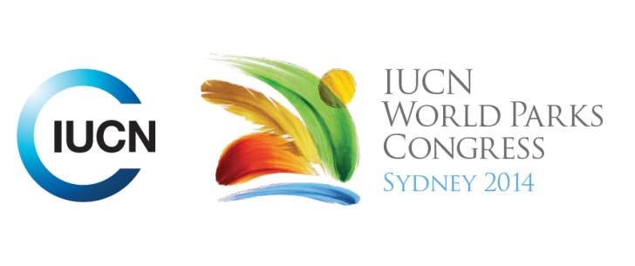



**Please fill-in this word template, save it and email to:**[**WPCReports@iucn.org**](mailto:WPCReports@iucn.org)

|  |  |  |
| --- | --- | --- |
| **Rapporteur’s report on session** | | |
| **Stream Number/WLD/Plenary:--- 3---** | | |
| **Repporteur’s name: --- Barbara Webster---** | | |
| **Session ID:---328---** | | **Session Name: --- Green justice: the right to nature---** |
| ***Summarize the session: Capture 1-3 main insights and findings of this session (including promising opportunities and inspiring solutions).*** | | |
| 1. **---** | Human Rights Law has developed without concentration on the question of the Right to Nature (a clean, healthy, safe environment). The 1948 Human Rights Declaration and 1966 Covenants do not mention the environment. There are several ways to approach this – from the top-down (global and national legislation) and from the bottom-up (community/local initiative). Over 100 countries now have a right to a healthy environment in their constitutions. These articles can be used by the Courts to focus on aspects of environmental degradation. There has also been a call for inclusion of the ‘Right to Nature and a Healthy Environment’ in the Convention of the Rights of the Child. In cities across the world there has been a community-led movement to create recreation areas in underprivileged communities by rehabilitating ‘brownfield’ sites. Communities that have access to parks are far healthier: for every $1 spent on creating bike and walking trails there is a $3 saving in direct medical costs. New York has implemented a $130 million community parks initiative and 60 community groups are now working to reconnect to the Bronx River through restoration efforts and rehabilitation. Beavers have returned to the Hudson River. **---** | |
| 2. **---** | How the Rights of Nature are reflected in International and National conventions - Respect for nature and its inherent value is embedded in the 1982 World Charter for Nature and the 1992 Convention on Biological Diversity is conscious of the intrinsic value of biodiversity. But how is the Earth Charter, founded on a respect for nature, implemented in civil society? Both Bolivia and Ecuador have specific rights of nature in their constitutions. However, these rights need legislation and court cases to bring them into practice. In one case in the Philippines, the fundamental human right to a healthy environment was used in judgement related to halting logging licences. In the existing legal system, the earth is treated as a commodity (from medieval times) and there are no limits on consumption or growth. This fundamental basis of law needs to change to a more ecocentric view. In Australia, they are working from grass roots up - not trying to change the constitution, but using civil disobedience and asserting rights locally through local government. **---** | |
| 3. **---** | The English language in law does not describe the relationship between nature and people very well. In New Zealand they have included Maori language in the legislation to better reflect the true meaning and aspiration of the laws. The courts now have to consider these Maori terms and get advice on their meaning. The judiciary is now undertaking training on Maori language. For example: Maori cosmology – “Beneath the herbs and the plants are the writings of the ancestors” (translation) must now be taken into account in natural resource legislation. This is new language because the relationship is a guardianship relationship – not transactional or proprietary as in existing English Law derived from Medieval times. Another way of returning control of land and nature is by recognising natural feature as tribal ancestors, or making a natural feature a legal ‘person’ including holding title to land. Co-governance sees Guardians appointed to speak for the feature (eg a river) on a majority-Indigenous Board of Management. The key guiding principle is “I am the river, the river is me” The health and wellbeing of the river is intrinsically linked to the health and wellbeing of the people.**---** | |

|  |  |  |
| --- | --- | --- |
| Related keywords | | |
| ---Enhancing Diversity and Quality of Governance--- | ---Choose an item.--- | ---Choose an item.--- |

| **Cross Cutting Themes** |
| --- |
| ***If the session was related to a Cross Cutting Theme, please give some information on what has been discussed.*** |
| **---**Click here to enter text.**---** |

|  |
| --- |
| Related cross cutting theme |
| ---Choose an item.--- |

| **Recommendations to the IUCN World Parks Congress** | | | |
| --- | --- | --- | --- |
| ***Capture any specific recommendation from this session for the Innovative Approaches documents / Promise of Sydney (along the line of policy changes, capacity development, financing, practice…)*** | | | |
|  | **It was recommended that:** | **Actors** | **Timeline** |
| 1. **---** | A call for the inclusion of the Right to Nature and a Healthy Environment in the Convention of the Rights of the Child**---** | **---**Click here to enter text.**---** | **---**Click here to enter text.**---** |
| 2. **---** | Click here to enter text.**---** | **---**Click here to enter text.**---** | **---**Click here to enter text.**---** |
| 3. **---** | Click here to enter text.**---** | **---**Click here to enter text.**---** | **---**Click here to enter text.**---** |

|  |  |  |
| --- | --- | --- |
| Related keywords | | |
| ---Inspiring a New Generation--- | ---Choose an item.--- | ---Choose an item.--- |

| **Information for the Communications - Team** |
| --- |
| ***Note any announcements/commitments or people/items of interests to media/communications. Please ensure to include any relevant contact information.*** |
| **---**Click here to enter text.**---** |