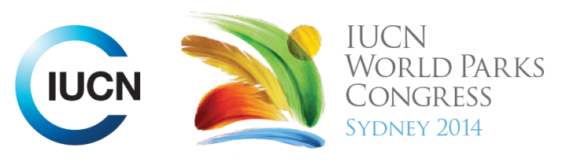

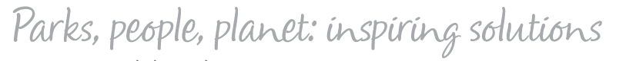

Please fill-in this word template, save it and email to:
WPCReports@iucn.org

Rapporteur’s report on session
Stream Number/WLD/Plenary:--- 3---
Repporteur’s name: --- Émilie Sasseville---
Session ID:---341--- |  | Session Name: --- Indigenous and local community perspectives on nature and well-being---
Summarize the session: Capture 1-3 main insights and findings of this session (including promising opportunities and inspiring solutions).
1. --- | Health is more than the absence of illness, and has more than a physical dimension. Not only biological but also environmental, social, cultural and spiritual factors can influence physical health. Industrialized societies can learn from Indigenous perceptions on health and wellbeing (from indigenous communities from all around the world) to reconsiderate their own vision of health and wellbeing. Indigenous communities have needs and deficits, and they also have assets and expertise. The definition of well-being for indigenous and riverine peoples of the Amazon, for example, is more integrated than merely dependent on economic factors. They still maintain strong belief systems and have imbued their homelands with symbolic meaning; these beliefs have helped them manage natural resource use sustainably.---
2. --- | Planning proposal to manage parks, reserves and Indigenous Protected Areas as broader landscapes can be a way to increase health and wellbeing. Caring for country, shared knowledge systems and learning, capacity development for communities, sustainable development and education, growth of nature based tourism, economic development and prosperity are all wellbeing outcomes of planning in Victorian parks. It is important to connect community plans to national values. Common planning approach/planning language at a community level allows regional scale aggregation retaining community identity. Regional scale aggregation is essential to link community priorities and national conservation values. Holistic planning for healthy country needs to incorporate cultural health with natural health. Holistic planning framework allows communities to be pro-active in development research priorities.---
3. --- | Click here to enter text.---
Related keywords
---Improving Health and Well-Being--- | ---Respecting Indigenous and Traditional Knowledge and Culture--- | ---Choose an item.---

Cross Cutting Themes
If the session was related to a Cross Cutting Theme, please give some information on what has been discussed.
---Click here to enter text.---
Related cross cutting theme
---Choose an item.---

Recommendations to the IUCN World Parks Congress
Capture any specific recommendation from this session for the Innovative Approaches documents / Promise of Sydney (along the line of policy changes, capacity development, financing, practice…)
 | It was recommended that: | Actors | Timeline
1. --- | ---- | ------- | -------
2. --- | Click here to enter text.--- | ---Click here to enter text.--- | ---Click here to enter text.---
3. --- | Click here to enter text.--- | ---Click here to enter text.--- | ---Click here to enter text.---
Related keywords
---Choose an item.--- | ---Choose an item.--- | ---Choose an item.---

Information for the Communications - Team
Note any announcements/commitments or people/items of interests to media/communications. Please ensure to include any relevant contact information.
---Click here to enter text.---

