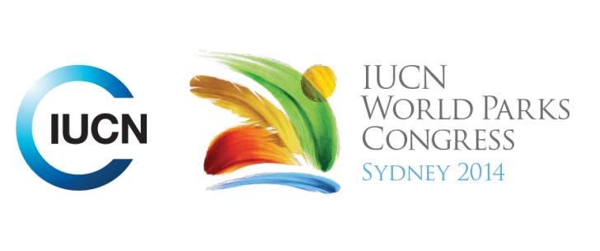

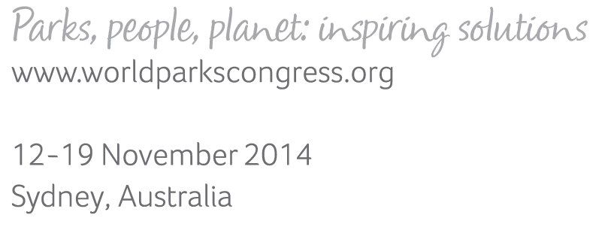

**Please fill-in this word template, save it and email to:**[**WPCReports@iucn.org**](mailto:WPCReports@iucn.org)

|  |  |  |
| --- | --- | --- |
| **Rapporteur’s report on session** | | |
| **Stream Number/WLD/Plenary:--- Stream 3---** | | |
| **Repporteur’s name: --- Michelle Coll---** | | |
| **Session ID:---345---** | | **Session Name: --- Inspriging business solutions---** |
| ***Summarize the session: Capture 1-3 main insights and findings of this session (including promising opportunities and inspiring solutions).*** | | |
| 1. **---** | Business plays an important role in showing leadership that supports healthy parks and healthy people. This is demonstrated through the HP earth insights with Conservation International initiative which is combining big data and biodiversity outcomes. This initiative involves understanding early warning systems for threatened species and at risk ecosystems in tropical forests by using IT to better track changes by measuring and monitoring data across tropical sites. CI is using HP technology with Tablets in the field, centralising data and using IT to communicate results of monitoring. This work is transforming the way science is being done by reducing the time for analysis, understanding and communication of data. Goes beyond monitoring and measuring – images communicated can connect people with nature. In relation to urban areas, there is possibility for partnerships with health, IT and parks sector in relation to wearable products that can provide information on activities in parks. **---** | |
| 2. **---** | Parks can make a difference to business. In the US, a partnership developed between the US National Parks and the Delaware North company working in Yosemite NP. The company purchased assets for the NPS, provides catering services, transportation services, interpretive tours, recycling and accommodation. The company also applies simple measurements to activities in parks such as calories used in walking on trails which raises the awareness of the benefits of parks to the users. The company took the business that it learnt from the park, incorporated in into its business model and now operates globally in national parks and World Heritage Areas.**---** | |
| 3. **---** | **---** | |

|  |  |  |
| --- | --- | --- |
| Related keywords | | |
| ---Improving Health and Well-Being--- | ---Choose an item.--- | ---Choose an item.--- |

| **Cross Cutting Themes** |
| --- |
| ***If the session was related to a Cross Cutting Theme, please give some information on what has been discussed.*** |
| **---**Click here to enter text.**---** |

|  |
| --- |
| Related cross cutting theme |
| ---Choose an item.--- |

| **Recommendations to the IUCN World Parks Congress** | | | |
| --- | --- | --- | --- |
| ***Capture any specific recommendation from this session for the Innovative Approaches documents / Promise of Sydney (along the line of policy changes, capacity development, financing, practice…)*** | | | |
|  | **It was recommended that:** | **Actors** | **Timeline** |
| 1. **---** | Click here to enter text.**---** | **---**Click here to enter text.**---** | **---**Click here to enter text.**---** |
| 2. **---** | Click here to enter text.**---** | **---**Click here to enter text.**---** | **---**Click here to enter text.**---** |
| 3. **---** | Click here to enter text.**---** | **---**Click here to enter text.**---** | **---**Click here to enter text.**---** |

|  |  |  |
| --- | --- | --- |
| Related keywords | | |
| ---Choose an item.--- | ---Choose an item.--- | ---Choose an item.--- |

| **Information for the Communications - Team** |
| --- |
| ***Note any announcements/commitments or people/items of interests to media/communications. Please ensure to include any relevant contact information.*** |
| **---**Click here to enter text.**---** |