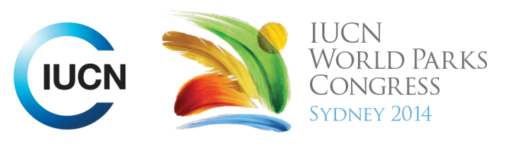

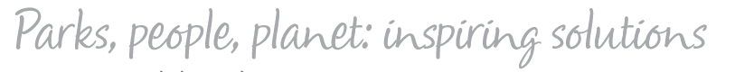

Please fill-in this word template, save it and email to:
WPCReports@iucn.org

Rapporteur’s report on session
Stream Number/WLD/Plenary:--- Stream 3---
Repporteur’s name: --- Michelle Coll---
Session ID:---355--- |  | Session Name: --- Responding to the effects of climate change on communities, parks and protected areas---
Summarize the session: Capture 1-3 main insights and findings of this session (including promising opportunities and inspiring solutions).
1. --- | The impact of climate change on humans is felt through changes in ecosystems and biodiversity. Protected Areas are part of the answer as they help with disaster mitigation and help us adapt to changing conditions. About 40% of the world’s forests are located in protected areas or community conserved areas. Old growth forests are more valuable in storing carbon then new fast growing forests. Therefore the large trees are especially valuable in mitigating climate change. Action priorities for the future include: invest in enhancing the management of Protected Areas, explore possibilities for connectivity of Protected Areas, improve understanding of the relationship between biodiversity, development and ecosystem services and tap into emerging sources of funds such as REDD+. ---
2. --- | There are both risks and opportunities that climate change poses to public health. For example, climate change will lead to an increase in extreme events such as heat waves which will place pressure on the health system, however there is opportunity to consider the health benefits of cleaner energy in offsetting carbon emissions costs – for example - taking cars off roads will not only reduce carbon emissions, but also increase physical activity of people. Cities could be designed for alternative transportation. Another example is greenspace and mental health. Eating a high meat diet is very energy intensive - less meat would also have health benefits. ---
3. --- | Now is the time to actively engage with technology when addressing emergencies. Change in society is already happening and people want to be connected and use technology such as social media in emergency situations. Eg: during the Vic fires, people were linked together via facebook. There is a challenge for telecommunications and parks in building connectivity in remote areas. There will be 30 billion devices connected by 2020 – therefore what are the opportunities to connect with people and get info out to the community and make a difference in public safety. The notion of being unplugged in nature will be overridden with societies need to be informed by technology and park managers will need to provide this service. ---
Related keywords
---Improving Health and Well-Being--- | ---Choose an item.--- | ---Choose an item.---

Cross Cutting Themes
If the session was related to a Cross Cutting Theme, please give some information on what has been discussed.
---Click here to enter text.---
Related cross cutting theme
---Choose an item.---

Recommendations to the IUCN World Parks Congress
Capture any specific recommendation from this session for the Innovative Approaches documents / Promise of Sydney (along the line of policy changes, capacity development, financing, practice…)
 | It was recommended that: | Actors | Timeline
1. --- | Click here to enter text.--- | ---Click here to enter text.--- | ---Click here to enter text.---
2. --- | Click here to enter text.--- | ---Click here to enter text.--- | ---Click here to enter text.---
3. --- | Click here to enter text.--- | ---Click here to enter text.--- | ---Click here to enter text.---
Related keywords
---Choose an item.--- | ---Choose an item.--- | ---Choose an item.---

Information for the Communications - Team
Note any announcements/commitments or people/items of interests to media/communications. Please ensure to include any relevant contact information.
---Click here to enter text.---

