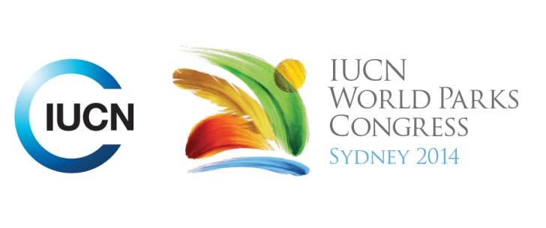



**Please fill-in this word template, save it and email to:**[**WPCReports@iucn.org**](mailto:WPCReports@iucn.org)

|  |  |  |
| --- | --- | --- |
| **Rapporteur’s report on session** | | |
| **Stream Number/WLD/Plenary:--- Stream 4---** | | |
| **Repporteur’s name: --- Anshuman Saikia---** | | |
| **Session ID:---364---** | | **Session Name: --- Nature-based solutions for disasters: a new horizon for protected areas---** |
| ***Summarize the session: Capture 1-3 main insights and findings of this session (including promising opportunities and inspiring solutions).*** | | |
| 1. **---** | A major insight was on the need for PA managers and practitioners to not just focus on engaging with the DRR practitioners and planners but to actively seek engagement with the humanitarian and aid development sector. A number of IUCN members such as Wetlands International have experience of working with the IFRC, Caritas and other humanitarian organisations from which PA managers can learn. There was also a good suggestion that IUCN should try and engage with the UNOCHA given it is responsible for coordinating humanitarian assistance. It was emphasised that the engagement was to be made in the context of the entire DRM cycle and try and work with them to integrated EBDRR into their strategies. This would imply the draft manual to include a section related to integrating PA considerations into the humanitarian agencies practices, plans and operations **---** | |
| 2. **---** | A second insight was that to recognise that all PAs do not have DRR benefits and are not able to support DRR objectives. It was pointed out through examples of Kruger National Park in South Africa, bushfires in Australia and another in the Philippines that PAs can also be sources of disasters. Hence it is imperative to integrate DRR considerations into the management of the PAs which will enable in reducing the ability of PAs to compound disaster damage. This in a way reaffirmed the proposed recommendation of building capacity of PA managers to understand DRR and also the other specific recommendation on fostering risk perception as well as communicating risk better. **---** | |
| 3. **---** | A third insight was to recognise that EBDRR is not just limited to protected areas and goes beyond protected areas to refer to the role of nature in reducing DRR. It was agreed that the spatial approaches such as landscape and seascape approaches are important and the boundaries of these areas either might be corresponding to the PAs or much beyond the current areal extent which emphasises the need to revisit the current delimitation of PAs. It was raised that the links between water, PAs and DRR need to be clearly articulated given 90% of major disasters in the last century have been water related ones. It was also pointed out that the definition of these larger areas is consistent with Aichi Target 11 description which clearly refers to areas of importance of biodiversity connected with wider landscapes and seascapes. **---** | |

|  |  |  |
| --- | --- | --- |
| Related keywords | | |
| ---Supporting Human Life--- | ---Responding to Climate Change--- | ---Reconciling Development Challenges--- |

| **Cross Cutting Themes** |
| --- |
| ***If the session was related to a Cross Cutting Theme, please give some information on what has been discussed.*** |
| **---**Click here to enter text.**---** |

|  |
| --- |
| Related cross cutting theme |
| ---Choose an item.--- |

| **Recommendations to the IUCN World Parks Congress** | | | |
| --- | --- | --- | --- |
| ***Capture any specific recommendation from this session for the Innovative Approaches documents / Promise of Sydney (along the line of policy changes, capacity development, financing, practice…)*** | | | |
|  | **It was recommended that:** | **Actors** | **Timeline** |
| 1. **---** | PA managers and practitioners need to engage with the humantarian organisations that are responsible for emergency relief and rescue**---** | **---**Click here to enter text.**---** | **---**Click here to enter text.**---** |
| 2. **---** | Click here to enter text.**---** | **---**Click here to enter text.**---** | **---**Click here to enter text.**---** |
| 3. **---** | Click here to enter text.**---** | **---**Click here to enter text.**---** | **---**Click here to enter text.**---** |

|  |  |  |
| --- | --- | --- |
| Related keywords | | |
| ---Choose an item.--- | ---Choose an item.--- | ---Choose an item.--- |

| **Information for the Communications - Team** |
| --- |
| ***Note any announcements/commitments or people/items of interests to media/communications. Please ensure to include any relevant contact information.*** |
| **---**Click here to enter text.**---** |