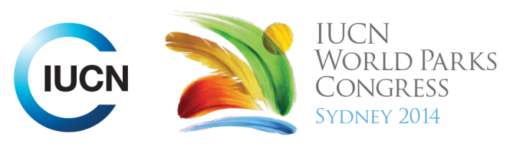



Please fill-in this word template, save it and email to:
WPCReports@iucn.org

Rapporteur’s report on session
Stream Number/WLD/Plenary:--- Stream 4---
Repporteur’s name: --- Rachel Miller---
Session ID:---391--- |  | Session Name: --- Protected areas and sustainable hunting and fishing.---
Summarize the session: Capture 1-3 main insights and findings of this session (including inspiring stories, promising opportunities and innovative solutions).
1. --- | Should some fishing/hunting be allowed in some or all IUCN PAs for local communities and why? Namibia case study says yes, where hunting is considered conservation and good wildlife management. Community based resource management of wildlife in Namibia allows people to hunt science-based quotas in PAs, providing food/livelihood and money from trophy hunting. They have taken ownership of wildlife management, no longer is wildlife the government’s, it’s theirs, so they except living with wildlife, reducing human/wildlife conflict. Namibia has seen a steady increase in lion and rhino populations since allowing hunting in PAs, due to good governance, community ownership and law enforcement. ---
2. --- | How can hunting/fishing provide income for local people and for protected areas? In the Rio Negro, Brazil tetra fish are sustainably collected by the local people for the aquarium trade. The locals make a good income, and have a very strong environmental stewardship of the natural environment which is essential to fish production and essential to their livelihoods. In Finland people pay to hunt and fish in protected areas and also volunteer to do wildlife monitoring and habitat restoration. Hunters and gatherers can earn a livelihood while providing valuable monitoring of the ecosystem, species and populations for PA managers. ---
3. --- | Positive and negative impacts of hunting/fishing and in protected areas. Hunting and fishing can be unsustainable, therefore must be managed strictly and be based on scientific data. Laws that are too restricted on hunting can lead too high population that can damage other natural resources and services. Complete restriction of hunting can lead to poaching (eg. Finland mynx). Hunting and fishing can negative impact non-target species and habitat, thus a need for sustainable hunting methods, hunting/fishing zones, appropriate seasons. Hunting/fishing in PAs can cause conflict with other users of PAs eg. Disturbing mushroom and berry pickers in Finland. Hunting/fishing can be positive economically if user pays (eg. Finland and trophy hunting in Namibia). Provide income to local communities. Can increase well-being of people – getting back to nature. Allowing sustainable – non-destructive fishing practices and fish sanctuaries in the Sierra Madre of the Philippines, has improved freshwater fish stocks and helped protect the critically-endangered Philippine crocodile ---
Related keywords
---Improving Health and Well-Being--- | ---Reaching Conservation Goals--- | ---Enhancing Diversity and Quality of Governance---

Cross Cutting Themes
If the session was related to a Cross Cutting Theme, please give some information on what has been discussed.
---None---
Related cross cutting theme
---Choose an item.---

Recommendations to the IUCN World Parks Congress
Capture any specific recommendation from this session for the Innovative Approaches documents / Promise of Sydney (along the line of policy changes, capacity development, financing, practice…)
 | It was recommended that: | Actors | Timeline
1. --- | Click here to enter text.--- | ---Click here to enter text.--- | ---Click here to enter text.---
2. --- | Click here to enter text.--- | ---Click here to enter text.--- | ---Click here to enter text.---
3. --- | Click here to enter text.--- | ---Click here to enter text.--- | ---Click here to enter text.---
Related keywords
---Choose an item.--- | ---Choose an item.--- | ---Choose an item.---

Information for the Communications - Team
Note any announcements/commitments or people/items of interests to media/communications. Please ensure to include any relevant contact information.
---Mabuwaya Foundation Philippines – Helping protect the critically endangered Philipine crocodile through sustainable/non-destructive fishing practices.---

