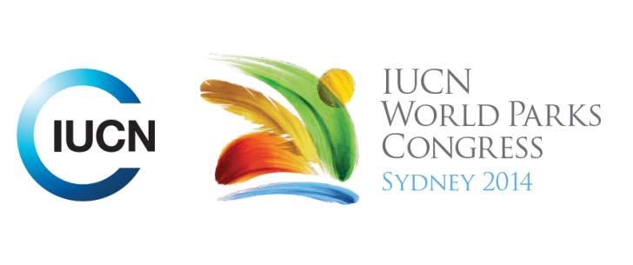

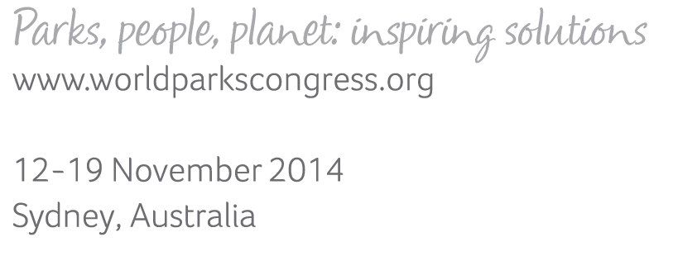

**Please fill-in this word template, save it and email to:**[**WPCReports@iucn.org**](mailto:WPCReports@iucn.org)

|  |  |  |
| --- | --- | --- |
| **Rapporteur’s report on session** | | |
| **Stream Number/WLD/Plenary:--- stream 5---** | | |
| **Repporteur’s name: --- Moumini Savadogo---** | | |
| **Session ID:---416---** | | **Session Name: --- Conservation and peacebuilding: tools and practice---** |
| ***Summarize the session: Capture 1-3 main insights and findings of this session (including promising opportunities and inspiring solutions).*** | | |
| 1. **---** | Conflicts mostly natural resources-related. While the impacts of conflicts on protected areas are well documented and known, the role of conservation in peace building is the great opportunity not yet entirely explored. For the full exploitation of this opportunity is to understand the scope and unpack the concept as well as its recognition by the conservation community. Environmental peace building can be defined as an opportunity to use **active cooperation over environmental issues**, natural resource management and protected areas to foster **frameworks for collaboration at local, regional, national and international levels** between all stakeholders including governments, corporations, NGOs and local communities that creates **benefits for all stakeholders**, builds **peace and stability at all levels**, increases **ecosystem resilience and sustainability**, and contributes to increased **human well-being (Todd Walters).** It includes peacemaking, conflict prevention and effective peace building. It must take into account Ecosystem Perspective, positive Peace not just Negative Peace, collaborative Framework, community Participation / Benefits, Sustainable Livelihoods, Address Root Causes, Soft Issue for Negotiation in International Affairs**---** | |
| 2. **---** | A number of case studies were presented as success stories in different countries in East, West and central Africa,the Amazon, Bolivia and Timor Laos where conflict sensitive conservation approaches and tools have been experimented and or scaled-up. The concerned types of conflicts were diverse including armed conflicts, inter-community conflicts, land-related conflicts, mining, pastoralism and human-wildlife conflicts. The responsive use of participatory tools is effective for creating a collaborative decision making and benefit sharing among the different stakeholders. The results are peacemaking, conflict prevention and peace building depending on the type, the level and the acuity of the conflict. These case studies were presented by the IISD, the Wildlife conservation society, conservation international and national partners. The lessons learnt from these cases can be applied in private (case of the concessions), national and transboundary parks and demonstrate clearly that environmental peace building can be inspiring solutions by increasing positive incentives for conservation and sustainable co-management of natural resources.**---** | |
| 3. **---** | Click here to enter text.**---** | |

|  |  |  |
| --- | --- | --- |
| Related keywords | | |
| ---New Social Compact--- | ---Reaching Conservation Goals--- | ---Supporting Human Life--- |

| **Cross Cutting Themes** |
| --- |
| ***If the session was related to a Cross Cutting Theme, please give some information on what has been discussed.*** |
| **---**None**---** |

|  |
| --- |
| Related cross cutting theme |
| ---World Heritage--- |

| **Recommendations to the IUCN World Parks Congress** | | | |
| --- | --- | --- | --- |
| ***Capture any specific recommendation from this session for the Innovative Approaches documents / Promise of Sydney (along the line of policy changes, capacity development, financing, practice…)*** | | | |
|  | **It was recommended that:** | **Actors** | **Timeline** |
| 1. **---** | Click here to enter text.**---** | **---**Click here to enter text.**---** | **---**Click here to enter text.**---** |
| 2. **---** | Click here to enter text.**---** | **---**Click here to enter text.**---** | **---**Click here to enter text.**---** |
| 3. **---** | Click here to enter text.**---** | **---**Click here to enter text.**---** | **---**Click here to enter text.**---** |

|  |  |  |
| --- | --- | --- |
| Related keywords | | |
| ---Reaching Conservation Goals--- | ---Responding to Climate Change--- | ---Supporting Human Life--- |

| **Information for the Communications - Team** |
| --- |
| ***Note any announcements/commitments or people/items of interests to media/communications. Please ensure to include any relevant contact information.*** |
| **---OK---** |