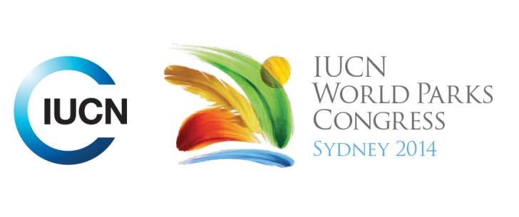

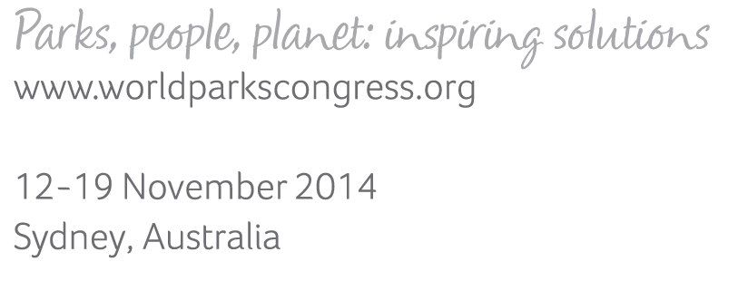

**Please fill-in this word template, save it and email to:**[**WPCReports@iucn.org**](mailto:WPCReports@iucn.org)

|  |  |  |
| --- | --- | --- |
| **Rapporteur’s report on session** | | |
| **Stream Number/WLD/Plenary:--- Stream 5---** | | |
| **Repporteur’s name: --- Moumini Savadogo---** | | |
| **Session ID:---423---** | | **Session Name: --- Good to the last drop: protected areas, forests and water---** |
| ***Summarize the session: Capture 1-3 main insights and findings of this session (including promising opportunities and inspiring solutions).*** | | |
| 1. **---** | The sound use of the payment of ecosystem services is a promising solution for public-private partnership in water sector. Pilots experiments have were presented for discussion: The Nairobi Water funds as a source water protection Strategy: Conservation with social, economic and environment impact (public-private partnership to protect watersheds) for people and wildlife; a project started in 2012 and targeting 15 millions $ target endowment, to be launch by march 2015 and expecting to sustain 1 million ha of land by working with 5 million people. The ecological infrastructure project of Durban (South Africa) where the concept of PES has been translated as ecological infrastructure for the purpose of comprehensive communication with decision makers. The ongoing process of setting a Payment for watershed services (PWS) in Mbé Watershed as a pilot site for PES in Gabon and Central Africa. There is real potential for this approach to mobilize water companies, communities and other relevant stakeholders in joint incentive effort to protect watersheds against sedimentation, floods and pollutions and thereby provide to cities enough and safer water.**---** | |
| 2. **---** | The public-private partnership is not always a success. An experience of failure in Ghana illustrates how it is important to have a good knowledge of the context and the decision making processes in such approach.**---** | |
| 3. **---** | Click here to enter text.**---** | |

|  |  |  |
| --- | --- | --- |
| Related keywords | | |
| ---Reconciling Development Challenges--- | ---Reaching Conservation Goals--- | ---Improving Health and Well-Being--- |

| **Cross Cutting Themes** |
| --- |
| ***If the session was related to a Cross Cutting Theme, please give some information on what has been discussed.*** |
| **---**Click here to enter text.**---** |

|  |
| --- |
| Related cross cutting theme |
| ---Choose an item.--- |

| **Recommendations to the IUCN World Parks Congress** | | | |
| --- | --- | --- | --- |
| ***Capture any specific recommendation from this session for the Innovative Approaches documents / Promise of Sydney (along the line of policy changes, capacity development, financing, practice…)*** | | | |
|  | **It was recommended that:** | **Actors** | **Timeline** |
| 1. **---** | Click here to enter text.**---** | **---**Click here to enter text.**---** | **---**Click here to enter text.**---** |
| 2. **---** | Click here to enter text.**---** | **---**Click here to enter text.**---** | **---**Click here to enter text.**---** |
| 3. **---** | Click here to enter text.**---** | **---**Click here to enter text.**---** | **---**Click here to enter text.**---** |

|  |  |  |
| --- | --- | --- |
| Related keywords | | |
| ---Choose an item.--- | ---Choose an item.--- | ---Choose an item.--- |

| **Information for the Communications - Team** |
| --- |
| ***Note any announcements/commitments or people/items of interests to media/communications. Please ensure to include any relevant contact information.*** |
| **---**Click here to enter text.**---** |