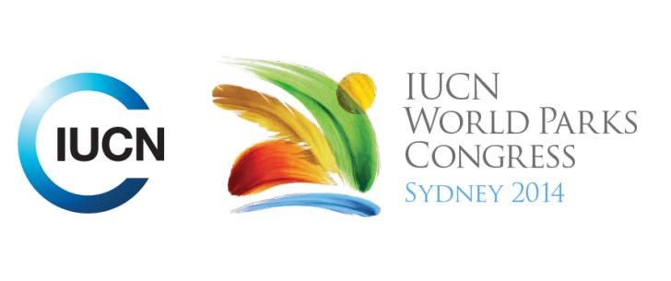



**Please fill-in this word template, save it and email to:**[**WPCReports@iucn.org**](mailto:WPCReports@iucn.org)

|  |  |  |
| --- | --- | --- |
| **Rapporteur’s report on session** | | |
| **Stream Number/WLD/Plenary:--- 5---** | | |
| **Repporteur’s name: --- David Andrew---** | | |
| **Session ID:---429---** | | **Session Name: --- --- Good for business: solutions through sustainable sourcing---** |
| ***Summarize the session: Capture 1-3 main insights and findings of this session (including promising opportunities and inspiring solutions).*** | | |
| 1. **---** | This session looked at 6 presentations with the underpinning question of: ‘How do different initiatives reinforce protecting PAs and how could they do better? Examples included Sediment and fertiliser runoff in the Great barrier Reef; Sustainable forestry for pulp milling in Indonesia; How a multinational fashion house insists on a sustainable supply chain; Capacity building in Zambia; Growth of sustainable fisheries in SW Madagascar; and the Amazon challenge. Key themes that emerged were: the importance of local knowledge and commitment; Consideration of local needs and income; Markets that care and that want change; Financial support; Partnerships; Leadership within companies; and Monitoring and evaluation. **---** | |
| 2. **---** | Inspirational: By implementing Indigenous Protected Areas in Brazilian Amazonia the PA area increased dramatically and deforestation decreased by nearly 80 % in 10 years; Amazonia experienced Brazil’s highest economic growth in those 10 years (2004-2014); a key element of this was direct intervention in the supply chain for cattle ranching and sugar cane cropping, e.g. sugar cane can now be grown only in landscapes that have already been modified. **---** | |
| 3. **---** | Inspirational: Sustainable fisheries in SW Madagascar; overfishing has led to fishery collapse; local re-education and voluntary compliance by locals (e.g. a 3-month closed season to allow octopus stocks to recover) has improved productivity and attracted a sympathetic market in Europe. This initiative has expanded to include sea cucumber cultivation for the China market and growing seaweed, with a dramatic net increase in local income relative to the national average. **---** | |

|  |  |  |
| --- | --- | --- |
| Related keywords | | |
| ---Supporting Human Life--- | ---Capacity Development--- | ---Improving Health and Well-Being--- |

| **Cross Cutting Themes** |
| --- |
| ***If the session was related to a Cross Cutting Theme, please give some information on what has been discussed.*** |
| **---**No cross-cutting themes**---** |

|  |
| --- |
| Related cross cutting theme |
| ---Choose an item.--- |

| **Recommendations to the IUCN World Parks Congress** | | | |
| --- | --- | --- | --- |
| ***Capture any specific recommendation from this session for the Innovative Approaches documents / Promise of Sydney (along the line of policy changes, capacity development, financing, practice…)*** | | | |
|  | **It was recommended that:** | **Actors** | **Timeline** |
| 1. **---** | Click here to enter text.**---** | **---**Click here to enter text.**---** | **---**Click here to enter text.**---** |
| 2. **---** | Click here to enter text.**---** | **---**Click here to enter text.**---** | **---**Click here to enter text.**---** |
| 3. **---** | Click here to enter text.**---** | **---**Click here to enter text.**---** | **---**Click here to enter text.**---** |

|  |  |  |
| --- | --- | --- |
| Related keywords | | |
| ---Choose an item.--- | ---Choose an item.--- | ---Choose an item.--- |

| **Information for the Communications - Team** |
| --- |
| ***Note any announcements/commitments or people/items of interests to media/communications. Please ensure to include any relevant contact information.*** |
| **---**Click here to enter text.**---** |