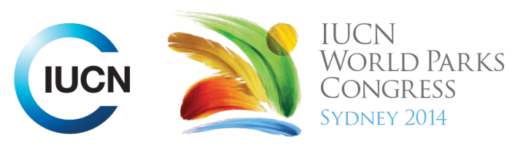



Please fill-in this word template, save it and email to:
WPCReports@iucn.org

Rapporteur’s report on session
Stream Number/WLD/Plenary:--- 5---
Repporteur’s name: --- David Andrew---
Session ID:---430--- |  | Session Name: --- Food for thought: minimizing impacts and maximizing benefits of sustasinable agriculture (Part 1) ---
Summarize the session: Capture 1-3 main insights and findings of this session (including promising opportunities and inspiring solutions).
1. --- | This session presented a series of case studies showing how various agricultural practices could be improved to move towards sustainability, to enhance landscapes and provide ecosystem services, and to complement existing PAs. Examples included Shade-grown Coffee in Africa, Sustainable Cattle-ranching in Colombia, Ibis Rice in Cambodia and Leveraging Sectoral Investments in India. Underpinning discussions was the principle that if you care about parks then you have to care about agriculture (mining gets more attention even though its footprint is not nearly as large). A large percentage of biodiversity is outside PAs, or uses surrounding agricultural land for foraging, migration etc; and PAs are under constant pressure from encroaching agriculture, therefore agriculture must be compatible with PAs. ---
2. --- | Important principles to emerge included ‘What happens in PAs depends to a large extent on what happens in agricultural land surrounding them’; and ‘Expensive agriculture shouldn’t be the price of cheap conservation’ (i.e. we shouldn’t rely on subsidising boutique products as an incentive to conserving biodiversity); and we could aim for a ‘norm shift’, i.e. products should be labelled as ‘wildlife-unfriendly’ or ‘made with dangerous chemicals’. ---
3. --- | A particularly inspiring example was the Ibis Rice project in Cambodia. The core range of two highly endangered bird species, including the Giant ibis, coincides with prime rice-growing land in Cambodia, where villagers are extremely poor and have been subject to protracted war. Through re-education and incentives villagers have been encouraged to tolerate the birds’ presence, and given access to marketing expertise to make Ibis Rice a prestigious, sought-after product. A negative corollary of this has been pushing back against chemical companies who also offer incentives to the farmers. ---
Related keywords
---Supporting Human Life--- | ---Reconciling Development Challenges--- | ---Capacity Development---

Cross Cutting Themes
If the session was related to a Cross Cutting Theme, please give some information on what has been discussed.
---There were no cross-cutting themes---
Related cross cutting theme
---Choose an item.---

Recommendations to the IUCN World Parks Congress
Capture any specific recommendation from this session for the Innovative Approaches documents / Promise of Sydney (along the line of policy changes, capacity development, financing, practice…)
 | It was recommended that: | Actors | Timeline
1. --- | Click here to enter text.--- | ---Click here to enter text.--- | ---Click here to enter text.---
2. --- | Click here to enter text.--- | ---Click here to enter text.--- | ---Click here to enter text.---
3. --- | Click here to enter text.--- | ---Click here to enter text.--- | ---Click here to enter text.---
Related keywords
---Choose an item.--- | ---Choose an item.--- | ---Choose an item.---

Information for the Communications - Team
Note any announcements/commitments or people/items of interests to media/communications. Please ensure to include any relevant contact information.
---Click here to enter text.---

