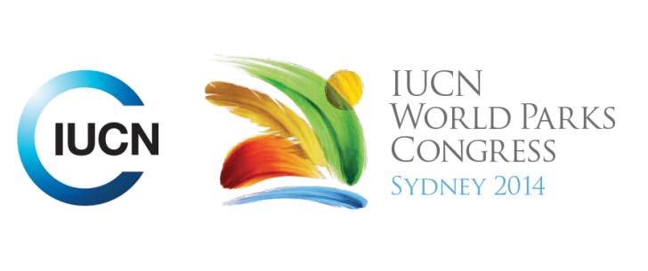

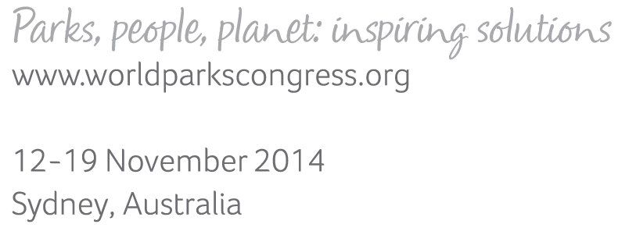

**Please fill-in this word template, save it and email to:**[**WPCReports@iucn.org**](mailto:WPCReports@iucn.org)

|  |  |  |
| --- | --- | --- |
| **Rapporteur’s report on session** | | |
| **Stream Number/WLD/Plenary:--- 5---** | | |
| **Repporteur’s name: --- Gillian Duggin ---** | | |
| **Session ID:---439---** | | **Session Name: --- Mobilising financial resources for protected areas (part 2) ---** |
| ***Summarize the session: Capture 1-3 main insights and findings of this session (including promising opportunities and inspiring solutions).*** | | |
| 1. **---** | This session was a workshop continuing the discussion on mobilising financial resources for protected areas. Discussions focused on revenue streams from PAs , including questions and comments on different approaches taken by countries to charging for access to PAs, payments for services, and offsets. The session also presented a framework for identifying financing for PA systems, providing a general process for assessing PA financing and including a broad overview of the range of options across government, donors and trust funds, site based fees and private sector/markets. It presented some tools that could be used to identify PA funding mechanisms eg. The Biodiversity Financial Initiative (BIOFIN), which can be translated to PA systems, the UNDP Financial Sustainability Scorecard, and business planning methods. The session reinforced the need for identifying value of PAs to leverage investment, and to consider creative and innovative financing options. **---** | |
| 2. **---** | Click here to enter text.**---** | |
| 3. **---** | Click here to enter text.**---** | |

|  |  |  |
| --- | --- | --- |
| Related keywords | | |
| ---Choose an item.--- | ---Choose an item.--- | ---Choose an item.--- |

| **Cross Cutting Themes** |
| --- |
| ***If the session was related to a Cross Cutting Theme, please give some information on what has been discussed.*** |
| **---**Click here to enter text.**---** |

|  |
| --- |
| Related cross cutting theme |
| ---Choose an item.--- |

| **Recommendations to the IUCN World Parks Congress** | | | |
| --- | --- | --- | --- |
| ***Capture any specific recommendation from this session for the Innovative Approaches documents / Promise of Sydney (along the line of policy changes, capacity development, financing, practice…)*** | | | |
|  | **It was recommended that:** | **Actors** | **Timeline** |
| 1. **---** | Click here to enter text.**---** | **---**Click here to enter text.**---** | **---**Click here to enter text.**---** |
| 2. **---** | Click here to enter text.**---** | **---**Click here to enter text.**---** | **---**Click here to enter text.**---** |
| 3. **---** | Click here to enter text.**---** | **---**Click here to enter text.**---** | **---**Click here to enter text.**---** |

|  |  |  |
| --- | --- | --- |
| Related keywords | | |
| ---Choose an item.--- | ---Choose an item.--- | ---Choose an item.--- |

| **Information for the Communications - Team** |
| --- |
| ***Note any announcements/commitments or people/items of interests to media/communications. Please ensure to include any relevant contact information.*** |
| **---**Click here to enter text.**---** |