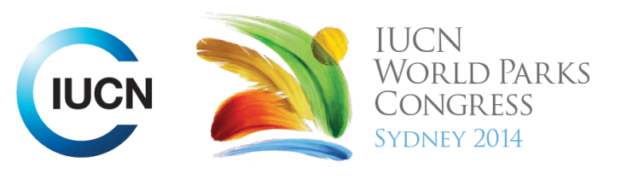



Please fill-in this word template, save it and email to:
WPCReports@iucn.org

Rapporteur’s report on session
Stream Number/WLD/Plenary:--- 5---
Repporteur’s name: --- Gillian Duggin ---
Session ID:---446--- |  | Session Name: --- Protected areas and Sustainable Development Goals part 1---
Summarize the session: Capture 1-3 main insights and findings of this session (including promising opportunities and inspiring solutions).
1. --- | To deliver on linking protected areas with sustainable development, the value of PAs to deliver on these goals must firstly be recognised. Investment must then be made to achieve these goals. PAs must also be integrated into sustainable development goals, to ensure their relevance. The session provided eight stories on how PAs can contribute to sustainable development, in particular emphasising food and water security, disaster risk reduction and jobs and livelihoods. All case studies discussed in the session demonstrated how PAs must be situated within the broader landscape to support sustainable development goals.---
2. --- | The session particularly emphasised that PAs are an efficient, affordable and durable means of delivering sustainable development. For example in Bhutan, ecosystem services are valued at $US15.5 billion per year; about 5 times the GDP of $3.5 billion per year. It was also emphasised that the costs of investing in PAs is much less than the benefits ecosystem services and biodiversity provide. For example, the Philippines has recognised this, after a devastating typhoon in 2009 caused an estimate of $4.8billion in damages due to massive flooding in metropolitan Manila, loss of life and damage to property. In response, the river basin in the region has been declared a protected area and rehabilitation of forests is underway, to restore absorptive capacity of the catchment. Uganda has also recognised this through the multiple benefits it receives from tourism in its PAs and flow on effects such as infrastructure and community development [keyword- human well-being stream]---
3. --- | The session provided examples of countries integrating PAs into national development plans and policies. Rather than GDP, Bhutan has based its development around ‘Gross National Happiness,’ which integrates environmental conservation as one of four core pillars. 42.71% of the country is under the protected area system and PAs support many key aspects of its development. Malaysia is also integrating biodiversity directly in its national development planning, through its 2020 Vision. Solutions that Malaysia has identified include enhancing the management of its PAs through economic instruments, such as performance based funding, Biodiversity Finance Initiative, in addition to building a sound business case for increasing investment in the management of ecosystems and biodiversity through a bottom up approach. It is also focusing on creating linkages for PAs, and enhancing public knowledge about and appreciation of biodiversity, including through a new branding campaign. The Egree Foundation in India is also integrating biodiversity and protected areas into regional level productive sector plans in the Bay of Bengal---
Related keywords
---Choose an item.--- | ---Choose an item.--- | ---Choose an item.---

Cross Cutting Themes
If the session was related to a Cross Cutting Theme, please give some information on what has been discussed.
---Click here to enter text.---
Related cross cutting theme
---Choose an item.---

Recommendations to the IUCN World Parks Congress
Capture any specific recommendation from this session for the Innovative Approaches documents / Promise of Sydney (along the line of policy changes, capacity development, financing, practice…)
 | It was recommended that: | Actors | Timeline
1. --- | PAs need to be viewed as elements in the overall landscape to recognise their sustainable and significant contribution to economic development--- | ---Click here to enter text.--- | ---Click here to enter text.---
2. --- | Governments need to trace and understand existing linkages between values, economic policies, PA management systems and incentives for community involvement in sustainable development and landscape management--- | ---Click here to enter text.--- | ---Click here to enter text.---
3. --- | Click here to enter text.--- | ---Click here to enter text.--- | ---Click here to enter text.---
Related keywords
---Choose an item.--- | ---Choose an item.--- | ---Choose an item.---

Information for the Communications - Team
Note any announcements/commitments or people/items of interests to media/communications. Please ensure to include any relevant contact information.
---Click here to enter text.---

