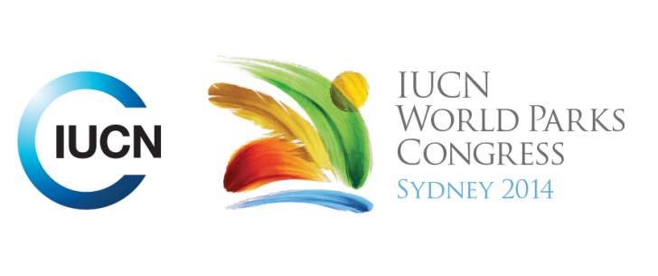

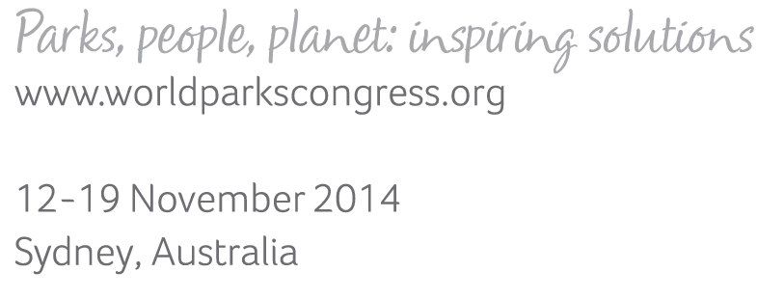

**Please fill-in this word template, save it and email to:   
[WPCReports@iucn.org](mailto:WPCReports@iucn.org)**

|  |  |  |
| --- | --- | --- |
| **Rapporteur’s report on session** | | |
| **Stream Number/WLD/Plenary:---** Click here to enter text.**---** | | |
| **Repporteur’s name: --- Salome Begeladze---** | | |
| **Session ID:---449---** | | **Session Name: --- Governance for the Conservation of Nature---** |
| ***Summarize the session: Capture 1-3 main insights and findings of this session (including promising opportunities and inspiring solutions).*** | | |
| 1. **---** | The session introduced the concepts, terms and definitions of Governance in historical perspective that has been and is essential for conserving nature and achieving the CBD Aichi Targets for Biodiversity and pointed out the importance of understanding history to have a sense of the future; understanding the responsibility to maintain culturally appropriate governance; understanding that the Governance is a process and can improve. Governance by government, shared, private and by indigenous and local communities, require informed, legitimate and fair decision making supported by legal systems. The session stressed out the importance of Governance quality, vitality and diversity in conservation of nature. The governance diversity is crucial for conservation because it helps extend coverage of protected areas and achieve conservation targets beyond the Aichi Targets. IUCN proposed governance quality (“good governance”) that respects “agreed principles” (legitimacy and voice, direction, performance, accountability, fairness and rights) should be linked to governance equity and governance effectiveness, procedural rights (access to justice, information) and natural rights (to decisions, to action). By governance vitality we mean integration and connectivity (abundant and meaningful interactions in a systemic way with diverse actors); adaptability (learning from experience); wisdom (aware of traditional knowledge, values); Innovation and Creativity as well as Empowerment. Governance is emerging common language. National legal frameworks need to incorporate these principles, plus diverse tools for implementation of conservation goals in protected areas and protected area systems. The panellist expressed gratitude to IUCN and CBD providing the guidance, which complexity should not scare anyone. Governance can be understood, can be dealt with, can be improved, and can help us in fundamental ways to properly respond to change. **---** | |
| 2. **---** | Indigenous community have challenged governance framework, arguing that their customary lows and traditions have to be recognized. Legal system must incorporate the traditional and customary systems, providing the mechanisms for participation of different stakeholder, access to justice, enforce accountability of decision makers and allow share governance and management. ICCAs are more than conservation they are matter for collective right and responsibilities. Indigenous community has been managing and protecting the nature, they have the knowledge and capacity but they are not allowed to govern their environment. Important to consider the future we want for ICCA. ICCAs call for recognition of their collective rights and responsibilities to land and natural resources and for recognition of their capacity to conserve them. **---** | |
| 3. **---** | ."Celebrating Governance!" - Countries were called on stage to share their examples of the governance that have been leading the way in improving governance for the conservation for nature. Namibia had greatest wildlife recovery story to tell. Since the government has legally allowed the community management of resources, it has seen success story. Started as small project in 1992 has extended to 82 conservation projects that has created jobs and generated income but also created wildlife benefit. As a result lion, cheetah, elephant and rhino populations have significantly increased. What others can learn from Nigeria is that communities better can manage their resources when they are empowered and allowed. Madagascar exemplified how government has increased management categories from 3 to 6 since Durban vision and is hoping to cover all protected areas categories in 2014. Government representative gave the explanation how did it happen - after 2003 Durban vision, the national commission in charge of protected areas set up the system for developing new code adaptation providing recognition to all main IUCN categories and government types and creating joint governance system with local communities (Fokolonola). The local community played important role in conservation, have created national networks to take action together, effectively and rapidly to ensure community governance is fully recognized. Increased conservation coverage by communities (Fokolonola) has become important actor in conservation of nature and culture. From Madagascar the lesson can be learned that everyone must play role in conservation and for that effective and equitable governance is crucial.**---** | |

|  |  |  |
| --- | --- | --- |
| Related keywords | | |
| ---Enhancing Diversity and Quality of Governance--- | ---Choose an item.--- | ---Choose an item.--- |

| **Cross Cutting Themes** |
| --- |
| ***If the session was related to a Cross Cutting Theme, please give some information on what has been discussed.*** |
| **---**Click here to enter text.**---** |

|  |
| --- |
| Related cross cutting theme |
| ---Choose an item.--- |

| **Recommendations to the IUCN World Parks Congress** | | | |
| --- | --- | --- | --- |
| ***Capture any specific recommendation from this session for the Innovative Approaches documents / Promise of Sydney (along the line of policy changes, capacity development, financing, practice…)*** | | | |
|  | **It was recommended that:** | **Actors** | **Timeline** |
| 1. **---** | Click here to enter text.**---** | **---**Click here to enter text.**---** | **---**Click here to enter text.**---** |
| 2. **---** | Click here to enter text.**---** | **---**Click here to enter text.**---** | **---**Click here to enter text.**---** |
| 3. **---** | Click here to enter text.**---** | **---**Click here to enter text.**---** | **---**Click here to enter text.**---** |

|  |  |  |
| --- | --- | --- |
| Related keywords | | |
| ---Choose an item.--- | ---Choose an item.--- | ---Choose an item.--- |

| **Information for the Communications - Team** |
| --- |
| ***Note any announcements/commitments or people/items of interests to media/communications. Please ensure to include any relevant contact information.*** |
| **---ICCAs: indigenous man called for reconsideration of economic models that are imposing death, destruction and depravation of indigenous peoples; Call for no-go areas agreement;** **CBD releasing French and Spanish guides for governance in protected areas; Nordic campaign against state forestry authority due to threats to community and environment (by Norwegian presenter who heads a village of 300 people under threat from developments) – announced during session.---** |