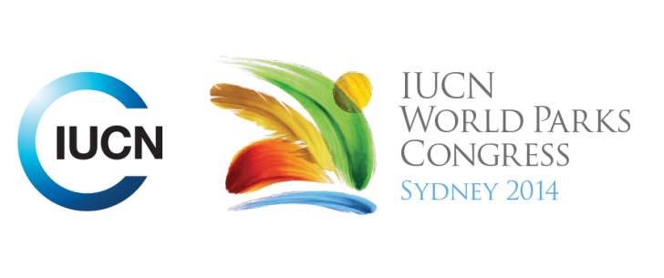



**Please fill-in this word template, save it and email to:**[**WPCReports@iucn.org**](mailto:WPCReports@iucn.org)

|  |  |  |
| --- | --- | --- |
| **Rapporteur’s report on session** | | |
| **Stream Number/WLD/Plenary:--- 6---** | | |
| **Repporteur’s name: --- Robert Deves---** | | |
| **Session ID:---454---** | | **Session Name: --- Achieving Aichi Target 11 – Governance and the Law---** |
| ***Summarize the session: Capture 1-3 main insights and findings of this session (including promising opportunities and inspiring solutions).*** | | |
| 1. **---** | STREAM 1, 6: Overview of governance and law and its role for protected areas. Law is an essential underpinning and support tool for achieving Aichi Target 11 goals and ensuring equitable and effective conservation of important terrestrial and marine areas over the long term. Both statutory and customary law (and their mutual recognition and interplay) affect governance of all types of conserved and protected areas. They interrelate with their objectives and categories, the range of initiatives that may be needed to protect biodiversity and ecosystem services, the variety of players that may be involved, and the broader economic and community well-being goals that need to be advanced. Governance includes aspects of quality and diversity.**---** | |
| 2. **---** | STREAM 1, 6, 7: Presentations we given about different approaches in a variety of contexts and countries. The key ideas behind these included the importance of impartial auditing schemes in assessing compliance with established protected areas (Brazil), the importance of non-regression principles especially during periods of financial crisis or change of government (Greece/Australia), the benefits offered by incorporating indigenous customary law into statutory law (including challenges such as passage of the law and apprehension of communities in codeifying their law) (the Phillippines), the importance of diversity, integrity and accountability in shared governance (Australia), and devolution/democratizing national parks mananagement (france) for improved PA cover and management. Madagascar, in particular, has tripled its PAs since Durban by developing its legal framework and developing plans and tools.**---** | |
| 3. **---** | STREAM 1, 6 7: The presentations brought up recurring threats to good governance, management and the achievement of Aichi targets. These included that natural capital can be sacrificed for immediate and unclear growth targets (especially during trying economic and social times) (Greece), the need for capacity development and coordination between government agencies and non government actors to move forward and address challenges (Madagascar), different opinions on shared management (Australia booderee national park). Governments ignoring courts or using special legislation in breach of non-regression principles (USA, Australia), and challenges associated with ICCAs in the phillipines (locals having to get government permit to sustainably manage or harvest their own village forests).**---** | |

|  |  |  |
| --- | --- | --- |
| Related keywords | | |
| ---Choose an item.--- | ---Choose an item.--- | ---Choose an item.--- |

| **Cross Cutting Themes** |
| --- |
| ***If the session was related to a Cross Cutting Theme, please give some information on what has been discussed.*** |
| **---**World Heritage/ Marine. Session not tagged, but there was a presentation of the customary land ownership and management framework in the Solomon Islands. The Solomon Islands includes sites of potential world heritage significance and have specific ‘ridge to reef’ challenges to integrate terrestrial and marine PA governance. The EDO has been developing capacity for indigenous communities to apply for ICCAs. ICCA framework includes non-negotiable prohibitions on fishing seasons and includes penalties for terrestrial activities which impact marine areas. **---** |

|  |
| --- |
| Related cross cutting theme |
| ---Choose an item.--- |

| **Recommendations to the IUCN World Parks Congress** | | | |
| --- | --- | --- | --- |
| ***Capture any specific recommendation from this session for the Innovative Approaches documents / Promise of Sydney (along the line of policy changes, capacity development, financing, practice…)*** | | | |
|  | **It was recommended that:** | **Actors** | **Timeline** |
| 1. **---** | Recognize the key role of statutory and customary law for ensuring good governance principles in decision-making about protected areas, for recognizing and supporting diverse governance types, and for helping build governance vitality.**------** | **---**none given for all**---** | **---**none given for all**---** |
| 2. **---** | Develop and strengthen legal frameworksgoverning national protected area systems and associated conservation areas to meet biodiversity goals, promote connectivity, and ensure governance quality, diversity, and vitality, taking advantage of the latest IUCN guidance in this area, and national experience.**---** | **---**Click here to enter text.**---** | **---**Click here to enter text.**---** |
| 3. **---** | Highlight the important international (global and regional) treaties with obligations and policy commitments with respect to protected areas and governance that need to be taken into account and applied in national protected area-related laws, policies, and programmes**---** | **---**Click here to enter text.**---** | **---**Click here to enter text.**---** |

|  |  |  |
| --- | --- | --- |
| Related keywords | | |
| ---Choose an item.--- | ---Choose an item.--- | ---Choose an item.--- |

| **Information for the Communications - Team** |
| --- |
| ***Note any announcements/commitments or people/items of interests to media/communications. Please ensure to include any relevant contact information.*** |
| **---Brazils Supreme Auditing Institution announced that 12 Latin American SAIs have completed audits of 980 Protected Areas….**  **Madagascar has tripled its number of protected areas since Durben by developing its plans, legal framework and tools---** |