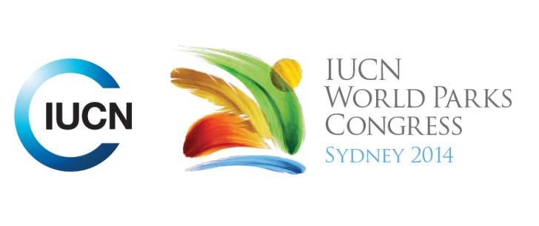

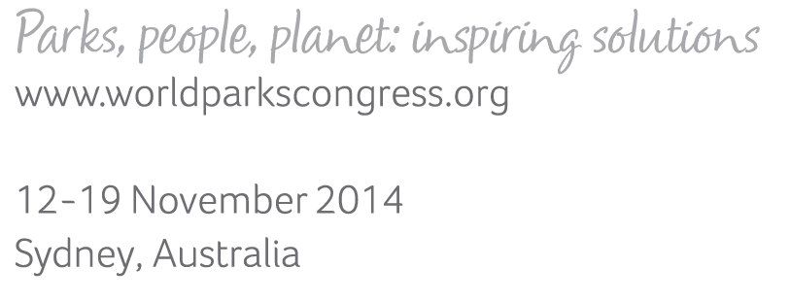

**Please fill-in this word template, save it and email to:**[**WPCReports@iucn.org**](mailto:WPCReports@iucn.org)

|  |  |  |
| --- | --- | --- |
| **Rapporteur’s report on session** | | |
| **Stream Number/WLD/Plenary:--- 6---** | | |
| **Repporteur’s name: --- Salome Begeladze---** | | |
| **Session ID:---468---** | | **Session Name: --- Governance of the high seas---** |
| ***Summarize the session: Capture 1-3 main insights and findings of this session (including promising opportunities and inspiring solutions).*** | | |
| 1. **---** | Session addressed the global challenges and solutions governing high sea areas and key messages for improving the quality and vitality of global high seas governance. Protecting high seas is the common interest for future generations and it has many values including cultural heritage value. The identified threats to high seas are unsustainable fishing, pollution, climate change, new emerging industries (seabed mining). The second major challenge is lack of comprehensive framework of governing the high seas; need to get oceans higher at the political agenda. Treaties governing high seas has not implemented as an agreement. What happens to high seas is that he fragmented numerous regulatory and international overlapping mandates exist and there is no harmonizing structure, framework that doesn’t provide any legal aspects. Some gaps in legal framework are – no coordinating mechanisms for establishment, monitoring and enforcement, no regulation for new and emerging uses. Lack of financing mechanisms has also been addressed – moving away from traditional approach to finance marine protected areas and engaging public and private sector, mix-use ocean infrastructure in private public partnerships, facilitate impact investments are needed to balance the gaps between need for funding and amount of financial support provided. Cultivating political will is needed and can be done by framing the issue (need to make connections in subsistence thoughts), getting the science right (conveyed in message well), diversifying the political dialogues (don’t think about the fisheries only but also other biodiversity benefits and general global benefits).**---** | |
| 2. **---** | The session covered the lessons learned from regional experiences and the ways it has strengthen global commitments, engaged scientists and civil society in governing high seas. Some main lessons included that it must involve the engagement of champions and leaders – for example – the country champions have been important to build political capital in support of marine protection(Southern Oceans), Engaging scientists and publishing science (Sargasso Sea); a strong body of science and the best available science; and geopolitics approach have played a big role in achieving consensus (Southern Oceans); Identifying the challenges such as multiple stakeholders, different governance approaches, geopolitical implications, coordination challenges (Costa Rica)are also critical. A new UN implementing agreement to protect the biodiversity of the high seas should have new framework - a mechanism - that enables no-take marine reserves; include language regarding review and reporting requirements; consensus-based decision making and the political capital to do so. The weaknesses - the only voluntary measures in place for deep sea fishing and limited capacity for developing governance (South West Indian Ocean) and strength - growing knowledge base for action provided by a number of prominent projects were also identified (South West Indian Ocean).**---** | |
| 3. **---** | Session focused on inspiring solutions by addressing the elements of implementing agreement from Science, Legal and Management perspectives. Management focused on – need to have coordinated efforts, linking the regional organization and states, management based on transparency and accountability, integration science, developing technology and capacity, financial mechanisms focused on balance between private sector, voluntary contributions and mandatory state contributions. Establish regional management organizations through the implementing agreement that enables equitable and effective governance. Science – Marine Protected Areas (MPAs) - dynamic processes on conserving them overtime, necessity to have provision in legal framework to have access to scientific data, as well as information sharing with public, cooperation non biding provisions becoming legally binding within newly proposed legal document. **---** | |

|  |  |  |
| --- | --- | --- |
| Related keywords | | |
| ---Enhancing Diversity and Quality of Governance--- | ---Marine--- | ---World Heritage--- |

| **Cross Cutting Themes** |
| --- |
| ***If the session was related to a Cross Cutting Theme, please give some information on what has been discussed.*** |
| **---**Governance in marine areas beyond national jurisdiction has been discussed with list of challenges and opportunities that calls for the effective global legal framework and mechanisms to enhance governance quality, equity and accountability. Attention to conserve areas with ecological and biological significance in the Ross Sea, Southern Ocean, the Sargasso Sea, the Costa Rica Dome**---** |

|  |
| --- |
| Related cross cutting theme |
| ---Marine--- |

| **Recommendations to the IUCN World Parks Congress** | | | |
| --- | --- | --- | --- |
| ***Capture any specific recommendation from this session for the Innovative Approaches documents / Promise of Sydney (along the line of policy changes, capacity development, financing, practice…)*** | | | |
|  | **It was recommended that:** | **Actors** | **Timeline** |
| 1. **---** | UN AD Hoc group tasked by UN general assembly to develop a multilateral instrument/implementing agreement to protect the world’s ocean beyond national jurisdiction (including area based management tools, environment impact assessments, capacity building and technology transfer).**---** | **---**UN AD Hoc Group**---** | **---**September 2015**---** |
| 2. **---** | Click here to enter text.**---** | **---**Click here to enter text.**---** | **---**Click here to enter text.**---** |
| 3. **---** | Click here to enter text.**---** | **---**Click here to enter text.**---** | **---**Click here to enter text.**---** |

|  |  |  |
| --- | --- | --- |
| Related keywords | | |
| ---Marine--- | ---Enhancing Diversity and Quality of Governance--- | ---Choose an item.--- |

| **Information for the Communications - Team** |
| --- |
| ***Note any announcements/commitments or people/items of interests to media/communications. Please ensure to include any relevant contact information.*** |
| **---“Before exploiting this planet better to explore it” by Sylvia Earle, SEAlliance/Mission Blue. -“Ocean doesn’t divide us it connect us” by Aulani Wilhem, NOAA.---** |