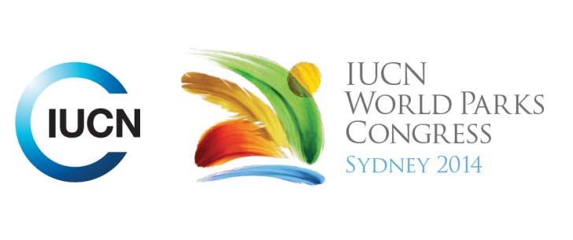



**Please fill-in this word template, save it and email to:**[**WPCReports@iucn.org**](mailto:WPCReports@iucn.org)

|  |  |  |
| --- | --- | --- |
| **Rapporteur’s report on session** | | |
| **Stream Number/WLD/Plenary:--- Stream 6---** | | |
| **Repporteur’s name: --- Gregor Manson---** | | |
| **Session ID:---469---** | | **Session Name: --- Governance Sustainable use of Wild Resources and Combating Wildlife Crime ---** |
| ***Summarize the session: Capture 1-3 main insights and findings of this session (including promising opportunities and inspiring solutions).*** | | |
| 1. **---** | **Strengthening community compliance (through local ownership) has reduced wildlife crime and improved local economic and conservation outcomes** - How has community strengthening of compliance approaches impacted wildlife resources use, is it equitable and what are the outcomes on illegal use? - *Northern Peru* –fish and wildlife control by community – established legal framework in 2009 – management wildlife for food -locals agree when and where can use wildlife to prevent illegal trade – *Ghana* locals locked out and made criminal – CREMAs balance livelihood strategies, broadening economic , mobilise collective action – *Namibia* reduce poachers by enforcement is now transferring to generating community stewards (through 1996 new laws community can manage wildlife) - wildlife is now seen as a valuable land use - *Central India* loss of resources and legal income since 1996 – is conflict with government forestry – the FRA 2008 forest rights brought in and locals can claim land - 2013 vision process allows locals to agree what to do with the area – locals want to protect land and defend their rights – micro planning led to collaboration and development *Uganda Kenya and south Sudan*  joint intelligence, patrols, partnership other agencies -  *Costa Rica*  - SSF with new rights negotiated outcomes and benefits are proven - k**---** | |
| 2. **---** | **Common property principles that lead to community sustainable use include** - clearly defined boundaries; community social coherence; appropriate sustainable harvesting rules; participatory collective choice; locally driven rule development and enforcement; social norms favour collaboration, reciprocity and trust; perceived likelihood of a fair outcome; ability to share experiences within and with other community groups – in *Brazil* Participatory Management models - have two models in conflict – need to value local knowledge – before 2002 more local power – post 2002 national processes take over and new balance is developing that will require land regularisation, decentralise power legislation that supports the decentralization of power – move from co management to community management - k **---** | |
| 3. **---** | **There is an urgency to respond to reduce poaching to protect critical species survival in some areas - noting that we may have time not wait for community based conservation to deliver and we need to reply in the short term on key enforcement intervention** - Where organise crime becomes involved there is a new risk that usually will require high police resources - Where coastal development is rapid communities struggle manage resources and are overcome - k**---** | |

|  |  |  |
| --- | --- | --- |
| Related keywords | | |
| ---Improving Health and Well-Being--- | ---Reaching Conservation Goals--- | ---Choose an item.--- |

| **Cross Cutting Themes** |
| --- |
| ***If the session was related to a Cross Cutting Theme, please give some information on what has been discussed.*** |
| **---**Click here to enter text.**---** |

|  |
| --- |
| Related cross cutting theme |
| ---Choose an item.--- |

| **Recommendations to the IUCN World Parks Congress** | | | |
| --- | --- | --- | --- |
| ***Capture any specific recommendation from this session for the Innovative Approaches documents / Promise of Sydney (along the line of policy changes, capacity development, financing, practice…)*** | | | |
|  | **It was recommended that:** | **Actors** | **Timeline** |
| 1. **---** | Click here to enter text.**---** | **---**Click here to enter text.**---** | **---**Click here to enter text.**---** |
| 2. **---** | Click here to enter text.**---** | **---**Click here to enter text.**---** | **---**Click here to enter text.**---** |
| 3. **---** | Click here to enter text.**---** | **---**Click here to enter text.**---** | **---**Click here to enter text.**---** |

|  |  |  |
| --- | --- | --- |
| Related keywords | | |
| ---Choose an item.--- | ---Choose an item.--- | ---Choose an item.--- |

| **Information for the Communications - Team** |
| --- |
| ***Note any announcements/commitments or people/items of interests to media/communications. Please ensure to include any relevant contact information.*** |
| **---**Click here to enter text.**---** |