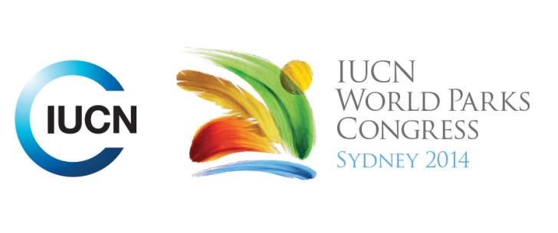

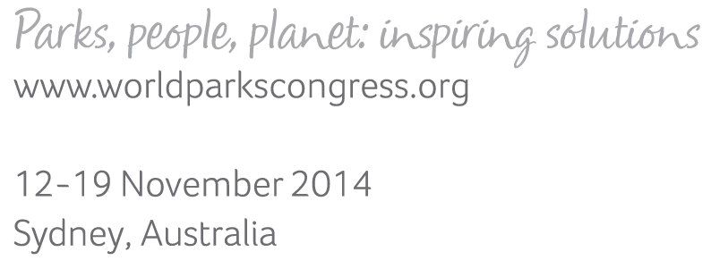

**Please fill-in this word template, save it and email to:**[**WPCReports@iucn.org**](mailto:WPCReports@iucn.org)

|  |  |  |
| --- | --- | --- |
| **Rapporteur’s report on session** | | |
| **Stream Number/WLD/Plenary:--- Stream 6---** | | |
| **Repporteur’s name: --- Gregor Manson---** | | |
| **Session ID:---479---** | | **Session Name: --- Governace of Transboundary Areas Part 1---** |
| ***Summarize the session: Capture 1-3 main insights and findings of this session (including promising opportunities and inspiring solutions).*** | | |
| 1. **---** | **An overview of Trans Boundary Conservation Governance Key Principles and Concepts in the new WCPA Trans Boundary Guideline (to be published) 2015** - looks at power and responsibilities and stakeholder participation and describes the types of conservation governance as government, private, indigenous and shared - trans boundary refers to national and sub national zones and has informal and formal arrangements – there is no single model however they **define key character elements as: right leadership , right people, clarifying purpose, level of authority and accountability, learning, decision making, adaptive management and financing and outlines types of leadership including pioneers/sponsors/thought makers/networkers/stewards/facilitators.** Financing focuses on back office and on ground support – current identified obstacles include; lack of public understanding of resources, lack of compelling stories, trust and capacity to integrate together with the challenge to move from project thinking to long term sustainable funding k**---** | |
| 2. **---** | **Key examples (Waterton/Glacier, SADC, Himalaya, EUROPARC, Coral Triangle, Columbia) demonstrate successful application of key Trans Boundary Governance principles using different approaches to achieve improved long term conservation management in complex ecological and tenure environments.** *Waterton/Glacier Peace Park* ‘ roundtable at top of the continent’ - connecting social and ecological fields - scaling up and scaling out to manage – how does it work?: annual gathering, governance based on culture/community/conservation – process of facilitation to move from awareness to action in an adaptive management approach – *Southern Africa* (SADC TFCAs) - documented plan for governance and implementation - key feature is in establishing the feasibility of approaches before action and having the ability to measure outcomes that is critical to sell the benefits to all actors to maintain their engagement – *Himalayan* (ICIMOD*)* – landscape approach to inform stakeholders for discussion – outcomes are focused towards economic and ecological sustainability – key achievement include conceptual acceptance of landscape approach , reconciling conservation and development - *Europarc* – criteria for effective measurement, active certification and verification, new TransParcNet – *Coral Triangle* –complex biodiversity, bathometry, species proximity – challenges ecosystem management and management fatigue for new activities.- *Colombia/Peru/Ecuador* Mayo river - biome for focus – water shed focus - seven indigenous tribes – promoting new social governance schemes. K **---** | |
| 3. **---** | Click here to enter text.**---** | |

|  |  |  |
| --- | --- | --- |
| Related keywords | | |
| ---Marine--- | ---Choose an item.--- | ---Choose an item.--- |

| **Cross Cutting Themes** |
| --- |
| ***If the session was related to a Cross Cutting Theme, please give some information on what has been discussed.*** |
| **---**Click here to enter text.**---** |

|  |
| --- |
| Related cross cutting theme |
| ---Choose an item.--- |

| **Recommendations to the IUCN World Parks Congress** | | | |
| --- | --- | --- | --- |
| ***Capture any specific recommendation from this session for the Innovative Approaches documents / Promise of Sydney (along the line of policy changes, capacity development, financing, practice…)*** | | | |
|  | **It was recommended that:** | **Actors** | **Timeline** |
| 1. **---** | Click here to enter text.**---** | **---**Click here to enter text.**---** | **---**Click here to enter text.**---** |
| 2. **---** | Click here to enter text.**---** | **---**Click here to enter text.**---** | **---**Click here to enter text.**---** |
| 3. **---** | Click here to enter text.**---** | **---**Click here to enter text.**---** | **---**Click here to enter text.**---** |

|  |  |  |
| --- | --- | --- |
| Related keywords | | |
| ---Choose an item.--- | ---Choose an item.--- | ---Choose an item.--- |

| **Information for the Communications - Team** |
| --- |
| ***Note any announcements/commitments or people/items of interests to media/communications. Please ensure to include any relevant contact information.*** |
| **---**Click here to enter text.**---** |