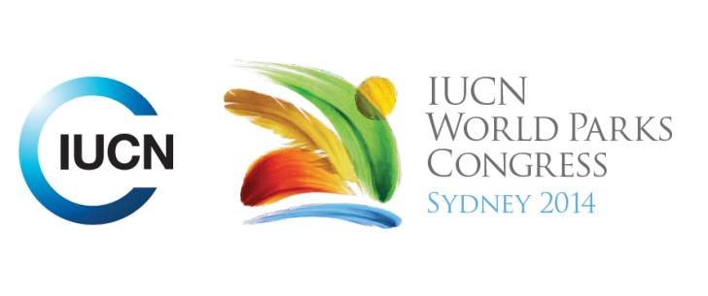

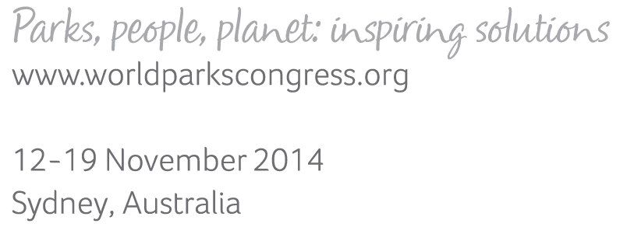

**Please fill-in this word template, save it and email to:**[**WPCReports@iucn.org**](mailto:WPCReports@iucn.org)

|  |  |  |
| --- | --- | --- |
| **Rapporteur’s report on session** | | |
| **Stream Number/WLD/Plenary:--- 6---** | | |
| **Repporteur’s name: --- Robert Deves---** | | |
| **Session ID:---481---** | | **Session Name: --- Robert Deves---** |
| ***Summarize the session: Capture 1-3 main insights and findings of this session (including promising opportunities and inspiring solutions).*** | | |
| 1. **---** | **Biodiversity is not being conserved in the current global approach and conservation in isolation is not a sustainable proposition.** ICCAs offer holistic and transformative frameworks of wellbeing and how they are integrated with the diverse range of legal and governance frameworks is important. ICCAs face many challenges: recognition of tenure/rights/governance structures; lack of capacity/capability; dependence on external stakeholders (e.g. for funding); lack of transparency and authority within their own framework (including to external stakeholders). Joint management can exist in name only and ICCAs have limited decision making capacity. While there are examples of flexible top down frameworks, generally they are rigid and require buy in from communities, while bottom up approaches in non-supportive frameworks require time, money and effort by communities. STREAM 3,5,6,7**---** | |
| 2. **---** | **There is an incredible diversity of ICCAs, languages and groups yet there are common objectives and goals.** This includes ensuring traditional and contemporary governance systems are explicitly and clearly integrated. Collective action can take place by forming networks of supportive groups to enable policy and legal environments which support community led change and provide for capacity development. Donors can support communities by aligning their commitments to the community led conservation goals and minimizing the use of intermediaries (who have their own process and agenda and don’t empower local communities). Communities themselves need to consider and realize the opportunities offered by progress and continue to find innovative ways to engage and inspire their members. STREAM 3,5,6,7**---** | |
| 3. **---** | **ICCAs and indigenous paradigms offer a holistic approach that can be practiced by everyone world wide;** they offer solutions to present and future challenges.Indigenous values and experience do not separate conservation with other values like livelihood, spirituality and society and, as such, can contribute towards our understanding of sustainable development. Non-monetized exhanges and re-localisations are examples. Countries like France have governance frameworks which effectively combine bottom up and top down decision making. Visionary and inspiring comments: ‘let us indigenize the world’ and ‘remember the difference between the government and the state: the state belongs to the people and we have the right to organize, put forward ideas and create new paradigms’ (Alejandro, Peru). STREAM 3,5,6,7.**---** | |

|  |  |  |
| --- | --- | --- |
| Related keywords | | |
| ---Choose an item.--- | ---Choose an item.--- | ---Choose an item.--- |

| **Cross Cutting Themes** |
| --- |
| ***If the session was related to a Cross Cutting Theme, please give some information on what has been discussed.*** |
| **---**Theme 4 on Governance and social compact in that well-being across the landscape entails collaboration and agreement on rights and responsibilities, direct democracy, accountability, and other aspects of governance. Capacity development to empower and support local and indigenous communities was also discussed. (SOCIAL COMPACT, CAPACITY DEVELOPMENT). **---** |

|  |
| --- |
| Related cross cutting theme |
| ---Choose an item.--- |

| **Recommendations to the IUCN World Parks Congress** | | | |
| --- | --- | --- | --- |
| ***Capture any specific recommendation from this session for the Innovative Approaches documents / Promise of Sydney (along the line of policy changes, capacity development, financing, practice…)*** | | | |
|  | **It was recommended that:** | **Actors** | **Timeline** |
| 1. **---** | The need to recognise diverse governance types of protected areas and conservation measures, to enhance conservation, sustainable livelihoods, equity and well-being across large landscapes.**---** | **---**Click here to enter text.**---** | **---**Click here to enter text.**---** |
| 2. **---** | The need to alter and bring in policies and programmes at national and global levels, to enable the search for extending such approaches across all landscapes.**---** | **---**Click here to enter text.**---** | **---**Click here to enter text.**---** |
| 3. **---** | The need to think outside the ‘protected areas versus development areas’ box and move towards genuine sustainable and equitable use across the landscape.**---** | **---**Click here to enter text.**---** | **---**Click here to enter text.**---** |

|  |  |  |
| --- | --- | --- |
| Related keywords | | |
| ---Choose an item.--- | ---Choose an item.--- | ---Choose an item.--- |

| **Information for the Communications - Team** |
| --- |
| ***Note any announcements/commitments or people/items of interests to media/communications. Please ensure to include any relevant contact information.*** |
| **---**Click here to enter text.**---** |