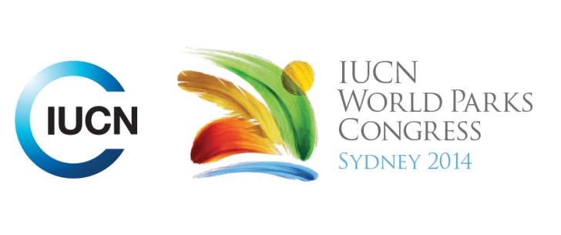



**Please fill-in this word template, save it and email to:**[**WPCReports@iucn.org**](mailto:WPCReports@iucn.org)

|  |  |  |
| --- | --- | --- |
| **Rapporteur’s report on session** | | |
| **Stream Number/WLD/Plenary:--- 6---** | | |
| **Repporteur’s name: --- Salome Begeladze---** | | |
| **Session ID:---486---** | | **Session Name: --- Inspiring solutions better governed seascapes as models for sustainable living---** |
| ***Summarize the session: Capture 1-3 main insights and findings of this session (including promising opportunities and inspiring solutions).*** | | |
| 1. **---** | Diverse experiences on sustainable solutions in marine and coastal environments, drawing the lessons from traditional, indigenous and local models of governance and implement inspiring solutions for sustainable use of resources in Marine Protected Areas (MPAs). Participatory design and shared governance - Despite the historical context of top down planning, Cambodia has been able, through establishing the mechanism that broke the historical context, to move towards the participatory joint government. Cambodia in process of establishing its first large MPA. Consultation mechanism that brought many stakeholders and engaged various sectors – including the community fisheries, civil society, private sector, local and national government. Three mechanisms developed: zoning consultations; community fisheries support (combination of training communities, increasing capacity of their engagement and involvement in management); establishment of a technical working group (advising management committee, increasing local awareness).**---** | |
| 2. **---** | How to deal with conflict between large and small-scale fisheries. Cases dealing with MPAs exemplified the community driven management (Fiji and Taiwan) and participatory process. Madagascar –multi-stakeholder approach of government and management to conservation – when the government had little capacity to enforce small scale fishing, the community management was only approach to manage small scale fisheries. Mediterranean Road Map (participatory process) – creating model that can achieve the commitments already existing instead of creating new commitments. The Road Map looks at different commitment of CBD, EU and the actors and actions that can contribute to the implementation. Strategic objectives include establishing: an ecological network of MPAs which is representative and connected and has an effective, efficient and sustainable management and good governance; develop a Mediterranean MPAs governance integrated with other sectors, promoting the benefit sharing; support financial resources to establish and maintain a network of effectively managed MPAs.**---** | |
| 3. **---** | Incorporating marginalized population and people who do not have land claims, how they can be part of the management – Iran example – try to incorporate the entire community, bringing back collective idea, individual benefits are within the community context, identify the group in the history of customary institutional governance (tribal, village councils, village older) – these approach is much more cohesive. Cambodia – tourism has potential to overwhelm the MPAs, need for tourism capacity integration in management planning for MPAs. When you integrate the traditional and modern methods of management, look also at traditional methods that have excluded women from the participation.**---** | |

|  |  |  |
| --- | --- | --- |
| Related keywords | | |
| ---Enhancing Diversity and Quality of Governance--- | ---Marine--- | ---Respecting Indigenous and Traditional Knowledge and Culture--- |

| **Cross Cutting Themes** |
| --- |
| ***If the session was related to a Cross Cutting Theme, please give some information on what has been discussed.*** |
| **---**Click here to enter text.**---** |

|  |
| --- |
| Related cross cutting theme |
| ---Choose an item.--- |

| **Recommendations to the IUCN World Parks Congress** | | | |
| --- | --- | --- | --- |
| ***Capture any specific recommendation from this session for the Innovative Approaches documents / Promise of Sydney (along the line of policy changes, capacity development, financing, practice…)*** | | | |
|  | **It was recommended that:** | **Actors** | **Timeline** |
| 1. **---** | Mandate from Barcelona Convention to establish 2020 Road Map for Marine Protected Areas**---** | **---**COP**---** | **---**COP21 2015**---** |
| 2. **---** | Click here to enter text.**---** | **---**Click here to enter text.**---** | **---**Click here to enter text.**---** |
| 3. **---** | Click here to enter text.**---** | **---**Click here to enter text.**---** | **---**Click here to enter text.**---** |

|  |  |  |
| --- | --- | --- |
| Related keywords | | |
| ---Choose an item.--- | ---Choose an item.--- | ---Choose an item.--- |

| **Information for the Communications - Team** |
| --- |
| ***Note any announcements/commitments or people/items of interests to media/communications. Please ensure to include any relevant contact information.*** |
| **---Mandate from Barcelona convention - 2020 Road Map to be established by next COP 2015.---** |