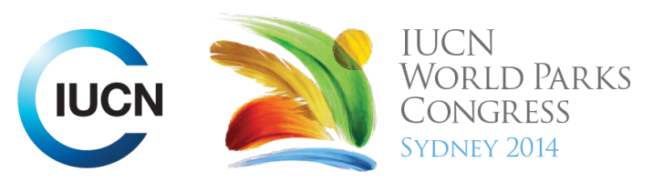



Please fill-in this word template, save it and email to:
WPCReports@iucn.org

Rapporteur’s report on session
Stream Number/WLD/Plenary:--- 7---
Repporteur’s name: --- Naomi Dwyer---
Session ID:---494--- |  | Session Name: --- African Indigenous Peoples' knowledge, culture, values and livelihoods: transforming protected areas from within---
Summarize the session: Capture 1-3 main insights and findings of this session (including promising opportunities and inspiring solutions).
1. --- | Bwabwata Territory National Park in Namibia spans multiple regions and is home to about 5,500 people and 6,000 elephants. They are the only park in Nambia where people live in the park and gain concessions of 50% of the financial benefits from trophy hunting which is allowed under ‘integrated [co-]management. The indigenous people are not allowed to hunt traditionally on their land. It is where people and animals live, thousands of plants germinate, local medicines are collected, and biodiversity and cultural tourism occur. The park is thriving because of the people, not in spite of them. Therefore the rights of the people and their livelihoods is the priority in managing the park. Officials from across ‘official borders’ from Angola are working with Nambian government to learn how people living within protected area of Bwabwata (a landscape that extends across the official border) bring a range of conservation and livelihoods benefits to managing the protected area better---
2. --- | Western science is working with the indigenous owner’s traditional ecological knowledge eg. aerial mapping combined with ground-truthing and traditional ecological knowledge gives better information for protected area management. Buffalo and wildlife numbers are improving due to traditional practices being used in park management. However their ability to benefit fully from this economic opportunity may hampered by banning the importation of wild animal parts/trophies (lion, elephant etc) into other countries. There is the argument that this is effectively trade sanctions against the people who have the market share of those items and who live with and use those animal for their livelihoods---
3. --- | There is a movement to encourage traditional owners and communities to fight for the right to continue to manage their lands traditionally rather than the right to their ownership of their lands. The benefits of traditional land management become evident more quickly than the process of land rights claims, and the evidence can then provide a better claim to sovereign rights over traditional lands.---
Related keywords
---Supporting Human Life--- | ---Choose an item.--- | ---Choose an item.---

Cross Cutting Themes
If the session was related to a Cross Cutting Theme, please give some information on what has been discussed.
---Click here to enter text.---
Related cross cutting theme
---Choose an item.---

Recommendations to the IUCN World Parks Congress
Capture any specific recommendation from this session for the Innovative Approaches documents / Promise of Sydney (along the line of policy changes, capacity development, financing, practice…)
 | It was recommended that: | Actors | Timeline
1. --- | The protection of species and the natural environment should not come at the cost of the people who are part of a natural environment ie identifying that while an elephant is important, the cost of its preservation may be too high when compared with its impact on livelihoods (where it may destroy a years worth of crops for example) --- | ---National governments--- | ---Click here to enter text.---
2. --- | Re-visit the banning of animal trophy imports (lion skins, elephant ivory) because - while it may deter poaching – it removes an economic benefit to communities which have the market share of those industries. --- | ---Australian Governments and other government which ban animal imports--- | ---Click here to enter text.---
3. --- | Click here to enter text.--- | ---Click here to enter text.--- | ---Click here to enter text.---
Related keywords
---Supporting Human Life--- | ---Choose an item.--- | ---Choose an item.---

Information for the Communications - Team
Note any announcements/commitments or people/items of interests to media/communications. Please ensure to include any relevant contact information.
---Click here to enter text.---

.

.

