**\**

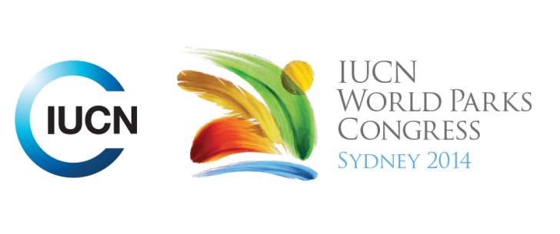

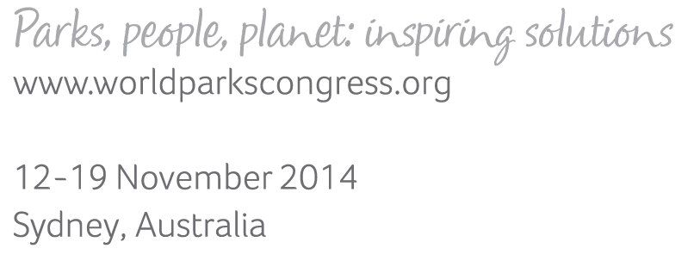

**Please fill-in this word template, save it and email to:**[**WPCReports@iucn.org**](mailto:WPCReports@iucn.org)

|  |  |  |
| --- | --- | --- |
| **Rapporteur’s report on session** | | |
| **Stream Number/WLD/Plenary:--- 7---** | | |
| **Repporteur’s name: --- Naomi Dwyer---** | | |
| **Session ID:---496---** | | **Session Name: --- Indigenous sustainable uses and rights in marine protected areas---** |
| ***Summarize the session: Capture 1-3 main insights and findings of this session (including promising opportunities and inspiring solutions).*** | | |
| 1. **---** | The Great Barrier Reef Marine Park Authority (GBRMPA) has developed a Traditional Use of Marine Resources Agreement (TUMRA) program to support traditional use in the Great Barrier Reef Marine Park. The TUMRA is a legislatively supported management framework that formally recognises traditional lore and custom and identifies clear obligations for all parties. Traditional Owners are supported to maintain a living marine culture. A blend of traditional ecological knowledge and contemporary land and sea management delivers multiple benefits for biodiversity and cultural conservation. Compliance officers in the GBRMPA work with traditional owners to increase their capability to manage their country and provide training to address illegal activities that threaten their cultural and natural heritage values. Benefits include better education about traditional rights and traditional use, training and education in compliance for traditional owners and more active participation in sea country the management. **---** | |
| 2. **---** | The Dhimurru Indigenous Protected Area was developed in the absence of any legal framework covering protected areas for sea country. They developed a plan using the IUCN protected areas definition where it was traditionally used to define ‘land’ and applied it to sea country. They developed a collaborative, traditional-owner led plan of management for their country and had it endorsed by the Australia Federal Government. It is the first IPA in Australia to include both terrestrial and marine areas. The commitments, authorities and capacities of the collaborating organisations will be brought together to achieve the shared goals of the IPA through a voluntary governance and management partnership. **---** | |
| 3. **---** | Partnerships and shared responsibility in development of TUMRA has given traditional owners the opportunity to revive cultural activities, provide education and employment, undertake research and monitoring, to have their voices heard and participate in decision making activities. Traditional owners should take the lead in planning and have their role as custodians acknowledged and recognised and have governments in fitting with Indigenous needs and roles rather than the other way around.**---** | |

|  |  |  |
| --- | --- | --- |
| Related keywords | | |
| ---World Heritage--- | ---Marine--- | ---Choose an item.--- |

| **Cross Cutting Themes** |
| --- |
| ***If the session was related to a Cross Cutting Theme, please give some information on what has been discussed.*** |
| **---**Indigenous traditional use and management agreements on marine areas are delivering benefits to traditional owners and the GBR.**---** |

|  |
| --- |
| Related cross cutting theme |
| ---Marine--- |

| **Recommendations to the IUCN World Parks Congress** | | | |
| --- | --- | --- | --- |
| ***Capture any specific recommendation from this session for the Innovative Approaches documents / Promise of Sydney (along the line of policy changes, capacity development, financing, practice…)*** | | | |
|  | **It was recommended that:** | **Actors** | **Timeline** |
| 1. **---** | Revise the great barrier reef marine park marine zoning maps to progress stronger regulatory framework to incorporate traditional owner knowledge and interests.**---** | **---**Australian federal government**---** | **---**Click here to enter text.**---** |
| 2. **---** | Click here to enter text.**---** | **---**Click here to enter text.**---** | **---**Click here to enter text.**---** |
| 3. **---** | Click here to enter text.**---** | **---**Click here to enter text.**---** | **---**Click here to enter text.**---** |

|  |  |  |
| --- | --- | --- |
| Related keywords | | |
| ---World Heritage--- | ---Marine--- | ---Choose an item.--- |

| **Information for the Communications - Team** |
| --- |
| ***Note any announcements/commitments or people/items of interests to media/communications. Please ensure to include any relevant contact information.*** |
| **---**Click here to enter text.**---** |