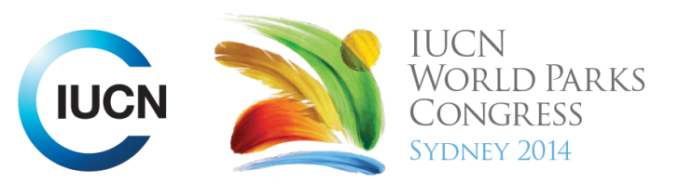

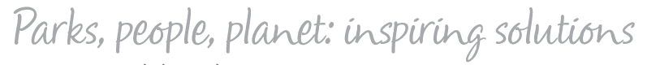

Please fill-in this word template, save it and email to:
WPCReports@iucn.org

Rapporteur’s report on session
Stream Number/WLD/Plenary:--- 7---
Repporteur’s name: --- Pilar Gomis---
Session ID:---502--- |  | Session Name: --- Sustainable partnerships: Indigenous Peoples, traditional knowledge and the private sector------
Summarize the session: Capture 1-3 main insights and findings of this session (including promising opportunities and inspiring solutions).
1. --- | The session is a dialogue between Indigenous leaders and Industry partners about good practice in building partnerships. It will discuss how respectful and sustainable partnerships are developed and sustained, and identify gaps in policy and processes, and cover some different types of partners, with case studies from different countries. Successful experiences have been showcased to set key issues on policy, practices and expectations – in particular from the Indigenous perspective. The question of how are Indigenous Peoples voices best heard and gain agency has been addressed. Also, how often diverse opinions are most appropriately considered in the planning and implementation and operation of long term development.---
2. --- | Sustainable partnerships are possible: Sustainable partnerships can work by promoting positive mutually beneficial relationships through: 1. having a jointly initiative; communicated regularly and openly; establishing equitable, transparent benefit-sharing plans; promote the sharing of knowledge and skills; managing expectations. Joint venture agreements are only successful when communities have the capacity. In that context, NGO plays a key role in supporting capacity development. Employment staff from different ethnic groups is key elements. There is a need to provide skills training to need skills training to empower the communities. Increase knowledge and raise awareness is essential. A good example is the case study: Damaraland Camp, Namibia (Africa) – Joint venture between Wilderness Safaris and the Torra Conservancy, where The Integration of Culture and Indigenous Knowledge Into Tourism in Protected Areas has been a successful practice.---
3. --- | Main points discussed in the session includes: a) Developing cultural education programmes is key, b) Joint venture agreements are only successful when communities have the capacity. In that context, NGO plays a key role in supporting capacity development. Employment staff from different ethnic groups is a key element. There is a need to provide skills training to need skills training to empower the communities. Increase knowledge and raise awareness is essential. Example: Development of the Wilderness Ethnic Charter and Codes of Conduct for Cultural Tourism. They develop cultural maps; c) Another successful case study: The Fisher Bay Area, Canada. Lesson learned – good practice; d) There is no framework for development; e) Opportunities regarding tenure security and governance. Communities want NGOs to be more sensitive and aware of the human rights; f) Environmental and social components are dissociated. Social component should be integrated into environment/nature conservation component, but how do we create a model that integrates the social component into the environmental strategies; g) Development of cumulative impact Assessment, for the Environmental and social components; h) Role of Standards in achieving sustainable development goals. A solution may be refer to Having a model where companies have a wider awareness about the risk will lead to less conflict; mitigate risks, better outcomes for industry, IP, government and nature. In that context, Nature Conservancy is leading a global program aimed at achieving sustainable conservation by incorporating and respecting Indigenous knowledge, aligning conservation practices with human rights, advancing industry and government practices reform, and providing tangible conservations benefits to people. A model of social and environmental mitigation and offsets to allow movement away from confrontation and conflict, and towards conversation, collaboration and conservation has been developed. This model can provide industry, conservation organizations and Indigenous peoples useful decision-making data to better understand the impacts and opportunities of development and conservation. And a challenge is addressed: How do you put an economic value on a cultural practice?---
Related keywords
---Reconciling Development Challenges--- | ---Capacity Development--- | ---Choose an item.---

Cross Cutting Themes
If the session was related to a Cross Cutting Theme, please give some information on what has been discussed.
---Click here to enter text.---
Related cross cutting theme
---Choose an item.---

Recommendations to the IUCN World Parks Congress
Capture any specific recommendation from this session for the Innovative Approaches documents / Promise of Sydney (along the line of policy changes, capacity development, financing, practice…)
 | It was recommended that: | Actors | Timeline
1. --- | Need of development of legal protection framework--- | ---Click here to enter text.--- | ---Click here to enter text.---
2. --- | Click here to enter text.--- | ---Click here to enter text.--- | ---Click here to enter text.---
3. --- | Click here to enter text.--- | ---Click here to enter text.--- | ---Click here to enter text.---
Related keywords
---Choose an item.--- | ---Choose an item.--- | ---Choose an item.---

Information for the Communications - Team
Note any announcements/commitments or people/items of interests to media/communications. Please ensure to include any relevant contact information.
---Click here to enter text.---

