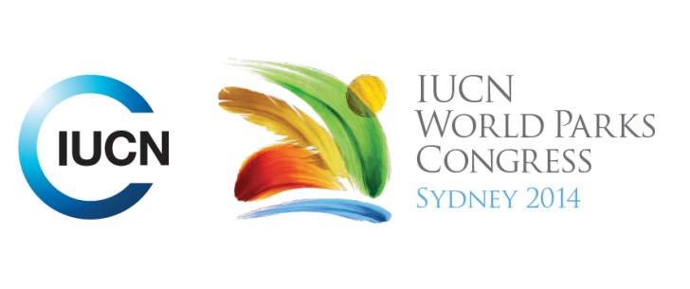

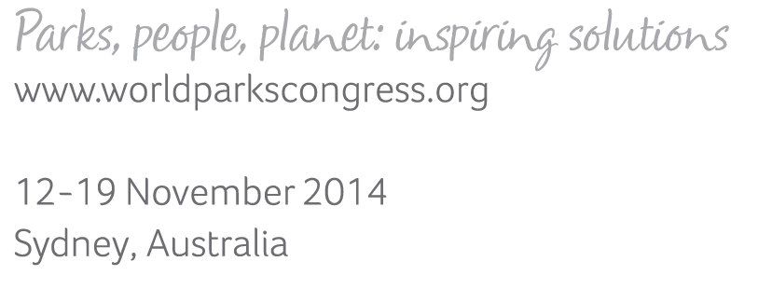

**Please fill-in this word template, save it and email to:**[**WPCReports@iucn.org**](mailto:WPCReports@iucn.org)

|  |  |  |
| --- | --- | --- |
| **Rapporteur’s report on session** | | |
| **Stream Number/WLD/Plenary:--- 7---** | | |
| **Repporteur’s name: --- Naomi Dwyer---** | | |
| **Session ID:---513---** | | **Session Name: --- Nature-Culture Linkages: Stewardship of Biocultural Landscapes for Biodiversity and People---** |
| ***Summarize the session: Capture 1-3 main insights and findings of this session (including promising opportunities and inspiring solutions).*** | | |
| 1. **---** | Indigenous and traditional knowledge and land-use practices by communities in biocultural landscapes inside and neighbouring protected areas are being recognized for their potential to assist conservation and protected areas management. Recognition of biocultural landscapes help Indigenous people to ensure and promote the protection, restoration, conservation, and sustainable use of resources from indigenous territories to ensure the full conditions for strengthening indigenous people’s quality of life and the integrity of their heritage. Key to this is intergenerational transfer. The next generation and youth need to be involved to continue the story – give culture a voice.**---** | |
| 2. **---** | Environmental or conservation management approaches designed within one community can help inform and assist other communities. **---** | |
| 3. **---** | Biocultural heritage are living traditions. If people stop using the land or change the way they use they land then they lose the diversity of the crops and the knowledge of how to manage land. It needs to be used. Indigenous communities can adapt and keep land use sustainable. Indigenous people are innovative at combining knowledge and culture and hold essential biodiversity-relevant information and lessons to be learnt that the loss of the process would be catastrophic. Adaptation and adaptive management have long been undertaken by Indigenous people and they hold lessons for survival strategies to help inform us for the next 100 years**---** | |

|  |  |  |
| --- | --- | --- |
| Related keywords | | |
| ---Choose an item.--- | ---Choose an item.--- | ---Choose an item.--- |

| **Cross Cutting Themes** |
| --- |
| ***If the session was related to a Cross Cutting Theme, please give some information on what has been discussed.*** |
| **---**Biocultural management approaches designed within one community can help inform and assist other communities. Participatory and collaborative approaches will ensure benefits for communities, regions and countries.**---** |

|  |
| --- |
| Related cross cutting theme |
| ---New Social Compact--- |

| **Recommendations to the IUCN World Parks Congress** | | | |
| --- | --- | --- | --- |
| ***Capture any specific recommendation from this session for the Innovative Approaches documents / Promise of Sydney (along the line of policy changes, capacity development, financing, practice…)*** | | | |
|  | **It was recommended that:** | **Actors** | **Timeline** |
| 1. **---** | Indigenous people are innovative at combining knowledge and culture and hold essential biodiversity-relevant information and should therefore be consulted on the management and development of their lands **---** | **---**Click here to enter text.**---** | **---**Click here to enter text.**---** |
| 2. **---** | Click here to enter text.**---** | **---**Click here to enter text.**---** | **---**Click here to enter text.**---** |
| 3. **---** | Click here to enter text.**---** | **---**Click here to enter text.**---** | **---**Click here to enter text.**---** |

|  |  |  |
| --- | --- | --- |
| Related keywords | | |
| ---Choose an item.--- | ---Choose an item.--- | ---Choose an item.--- |

| **Information for the Communications - Team** |
| --- |
| ***Note any announcements/commitments or people/items of interests to media/communications. Please ensure to include any relevant contact information.*** |
| **---**Click here to enter text.**---** |