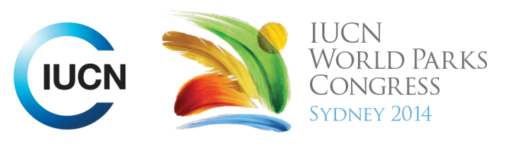

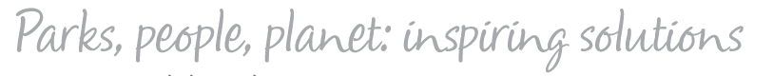

Please fill-in this word template, save it and email to:
WPCReports@iucn.org

Rapporteur’s report on session
Stream Number/WLD/Plenary:--- 7---
Repporteur’s name: --- Gen Pezzimenti---
Session ID:---518--- |  | Session Name: --- Respecting, relying on and advancing traditional knowledge, governance and management systems---
Summarize the session: Capture 1-3 main insights and findings of this session (including inspiring stories, promising opportunities and innovative solutions).
1. --- | Indigenous knowledge and traditional governance systems should be maintained and valued in protected area governance and management, as a matter of cultural responsibility. Traditional knowledge is critical for enhancing the management of land and sea in areas where it still exists. Incorporation of traditional knowledge, or a management framework founded on traditional knowledge, redeems improved protection of conservation areas greater than considering traditional, local, scientific and political knowledge systems separately.---
2. --- | The documentation and application of traditional knowledge has to take place with the free, prior and informed consent of the knowledge holders, and the ownership of knowledge will need to stay with them. The transfer of traditional knowledge should be underpinned by essential attitudes of trust, respect, reciprocity, equity and transparency.------
3. --- | Intergenerational transfer of traditional knowledge is important to propogate cultural identity and values. Traditional knowledge is transferred from elders and leaders to young people. It is important to include young people in management and decision-making processes to instil within them respect for and a deep connection to their lands, and a desire to care for and protect them. It is important to increase opportunities for young people to connect to the land through immersion in the landscape, for example through school camp programs. Such programs facilitate the transfer of traditional knowledge to younger generations and helps them to value it and their heritage.---
Related keywords
---Enhancing Diversity and Quality of Governance--- | ---Respecting Indigenous and Traditional Knowledge and Culture--- | ---Inspiring a New Generation---

Cross Cutting Themes
If the session was related to a Cross Cutting Theme, please give some information on what has been discussed.
---Indigenous knowledge and traditional governance systems should be maintained and valued in protected area governance and management, as a matter of cultural responsibility. For example, marine protected areas zoning can be based on a traditional management system, through the inclusion of sacred sites in core protection areas, with differentiation of men’s and women’s sites; and incorporation of a monitoring and evaluation program that has cultural significance through the use of an indicator species that has cultural relevance (Case study Charlotte Karibuhoye Said).---
Related cross cutting theme
---New Social Compact---

Recommendations to the IUCN World Parks Congress
Capture any specific recommendation from this session for the Innovative Approaches documents / Promise of Sydney (along the line of policy changes, capacity development, financing, practice…)
 | It was recommended that: | Actors | Timeline
1. --- | The transfer of traditional knowledge be underpinned by the following attitudes which are considered essential: trust ,respect, reciprocity, equity and transparency. Permission for the transfer of knowledge must be attained from the relevant person, and the nature of the transfer – timing, type of information and detail and mode of delivery, should be treated with sensitivity--- | ---Governments, conservation organisations, indigenous people and communities, elders--- | ---Ongoing---
2. --- | Acknowledgement and incorporation of traditional governance systems in government decision-making should occur --- | ---Governments--- | ---ongoing---
3. --- | A mindshift by governments and “developers” should occur to recognise that Indigenous knowledge systems, in combination with other knowledge systems such as political or scientific knowledge systems will enrich our knowledge of the management of protected areas overall--- | ---Governments, managers--- | ---Ongoing---
Related keywords
---New Social Compact--- | ---Enhancing Diversity and Quality of Governance--- | ---Choose an item.---

Information for the Communications - Team
Note any announcements/commitments or people/items of interests to media/communications. Please ensure to include any relevant contact information.
---Click here to enter text.---

