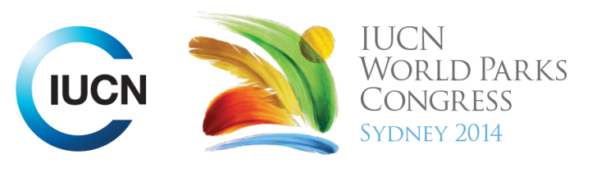

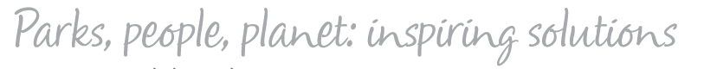

Please fill-in this word template, save it and email to:
WPCReports@iucn.org

Rapporteur’s report on session
Stream Number/WLD/Plenary:--- 7---
Repporteur’s name: --- Naomi Dwyer---
Session ID:---524--- |  | Session Name: --- Traditional management systems in achieving national and international policy goals---
Summarize the session: Capture 1-3 main insights and findings of this session (including promising opportunities and inspiring solutions).
1. --- | Indigenous people are well positioned to first identify climate change impacts at a local scale and are well positioned to address and adapt to change. The ability of indigenous communities to create innovative and integrative solutions to climate change can be better illustrated to decision makers by monitoring and assessing the impact of climate change at a local level, then synthesising this with traditional ecological knowledge and contemporary science.---
2. --- | Traditional resource management approaches and knowledge can contribute to reaching national or international goals and targets, and the rights of indigenous people to benefit sharing and knowledge ownership should be ensured where their knowledge does contribute to achieving these goals. ---
3. --- | Knowledge resides in the land, so the custodians of the land are also the custodian of the knowledge. Traditional owners are willing to share knowledge on the basis of reciprocity from those they share their knowledge with.---
Related keywords
---Responding to Climate Change--- | ---Choose an item.--- | ---Choose an item.---

Cross Cutting Themes
If the session was related to a Cross Cutting Theme, please give some information on what has been discussed.
---Discussed formalisation of intellectual property rights for traditional ecological knowledge to ensure their contribution is respected and acknowledged.---
Related cross cutting theme
---New Social Compact---

Recommendations to the IUCN World Parks Congress
Capture any specific recommendation from this session for the Innovative Approaches documents / Promise of Sydney (along the line of policy changes, capacity development, financing, practice…)
 | It was recommended that: | Actors | Timeline
1. --- | There should be a desk allocated for traditional knowledge on the climate change convention to coordinate and articulate the contribution traditional knowledge can make.--- | ---UN--- | ---Click here to enter text.---
2. --- | Click here to enter text.--- | ---Click here to enter text.--- | ---Click here to enter text.---
3. --- | Click here to enter text.--- | ---Click here to enter text.--- | ---Click here to enter text.---
Related keywords
---Choose an item.--- | ---Choose an item.--- | ---Choose an item.---

Information for the Communications - Team
Note any announcements/commitments or people/items of interests to media/communications. Please ensure to include any relevant contact information.
---Click here to enter text.---

