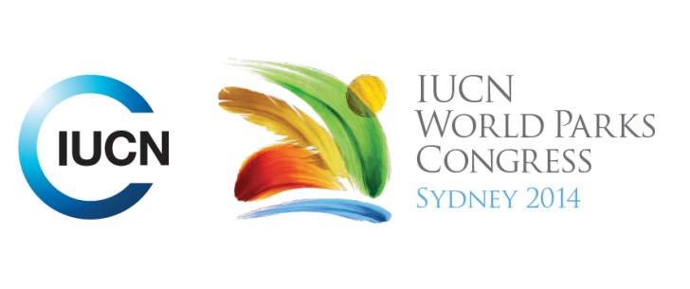

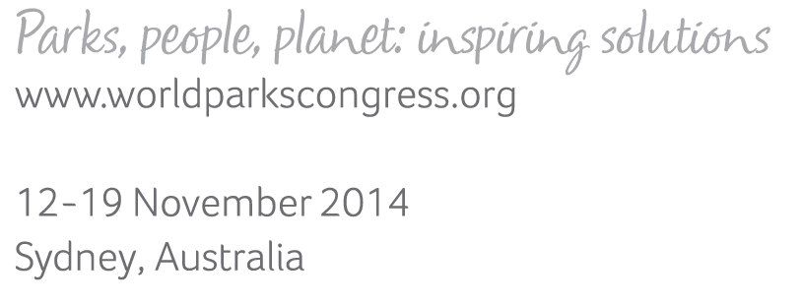

**Please fill-in this word template, save it and email to:**[**WPCReports@iucn.org**](mailto:WPCReports@iucn.org)

|  |  |  |
| --- | --- | --- |
| **Rapporteur’s report on session** | | |
| **Stream Number/WLD/Plenary:--- 7---** | | |
| **Repporteur’s name: --- Pilar Gomis---** | | |
| **Session ID:---527---** | | **Session Name: --- Implementing the UN Declaration on the Rights of Indigenous Peoples (UNDRIP) in Protected Areas---** |
| ***Summarize the session: Capture 1-3 main insights and findings of this session (including promising opportunities and inspiring solutions).*** | | |
| 1. **---** | The United Nations Declaration on the Rights of Indigenous Peoples (UNDRIP) has at least 17 articles relevant to protected areas. Given that UNDRIP is a universally agreed instrument, it should be implemented by countries in their protected areas policy and practice. UNDRIP represents an opportunity to support indigenous peoples and also to support an inclusive model of protected areas that can be more effective than exclusionary models. This session addresses the question of what mechanisms, tools and avenues are available to use to promote the realization of the Declaration.  **------** | |
| 2. **---** | Policy changes at international level such as UNDRIP are important and welcome; national legal and policy changes are fundamental to achieve change in support of indigenous peoples in the protected areas context. However many of the specific solutions to the on-the-ground problems have to be crafted locally because of the complexity of the situations, and evolve according to the socio-political context. This is demonstrated by the cases presented from different regions, such as the Indigenous Territories and Kayan Mentarang National Park, North Kalimantan, Indonesia (Asia), the Whakatane Pilot Assessment in Kahuzi-Biega, Democratic Republic of Congo (Africa) and a case of a Bolivian Protected Area (Latin America). Some other examples includes the WHAKATANE Mechanism (The Whakatane Assessment experience in Ob Luang National Park, Thailand) or the experience of the Endorois to regain their rights in Lake Bogoria, Kenya**------** | |
| 3. **---** | This session was focused on learning about the complexity and diversity that IP have to face on the ground. Different solutions and approaches have been proposed depending on the social political context. No universal recipe works globally, but working along communities at the local level may strengthen the efforts. The struggle and effort of the communities is a key driver of change. In support of that, conflict resolution and facilitation mechanisms can be very useful to address specific cases where communities have been affected by protected areas or other conservation measures. Such instruments should work directly with the communities and involve the government agencies and other players. **---** | |

|  |  |  |
| --- | --- | --- |
| Related keywords | | |
| ---Choose an item.--- | ---Choose an item.--- | ---Choose an item.--- |

| **Cross Cutting Themes** |
| --- |
| ***If the session was related to a Cross Cutting Theme, please give some information on what has been discussed.*** |
| **---**Click here to enter text.**---** |

|  |
| --- |
| Related cross cutting theme |
| ---Choose an item.--- |

| **Recommendations to the IUCN World Parks Congress** | | | |
| --- | --- | --- | --- |
| ***Capture any specific recommendation from this session for the Innovative Approaches documents / Promise of Sydney (along the line of policy changes, capacity development, financing, practice…)*** | | | |
|  | **It was recommended that:** | **Actors** | **Timeline** |
| 1. **---** | UNDRIP should be used as a framework to plan protected area developments in the lands of indigenous peoples, and also as an assessment and monitoring tool for measuring progress in implementing an inclusive model of protected areas with indigenous peoples**------** | **---**Click here to enter text.**---** | **---**Click here to enter text.**---** |
| 2. **---** | There should be a concerted effort by all to achieve changes in national legal frameworks of protected areas and other related legislation, to make them compatible with UNDRIP and to provide security to communities**------** | **---**Click here to enter text.**---** | **---**Click here to enter text.**---** |
| 3. **---** | Specific mechanisms and initiatives should be set up to strengthen customary laws and regulations of indigenous peoples because they contribute to conservation and to their livelihoods and cultures. New threats and problems require supporting communities for greater capacities to defend their rights**---** | **---**Click here to enter text.**---** | **---**Click here to enter text.**---** |

|  |  |  |
| --- | --- | --- |
| Related keywords | | |
| ---Capacity Development--- | ---Enhancing Diversity and Quality of Governance--- | ---Choose an item.--- |

| **Information for the Communications - Team** |
| --- |
| ***Note any announcements/commitments or people/items of interests to media/communications. Please ensure to include any relevant contact information.*** |
| **---**Click here to enter text.**---** |