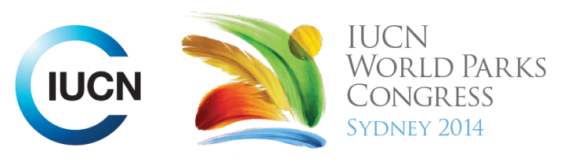



Please fill-in this word template, save it and email to:
WPCReports@iucn.org

Rapporteur’s report on session
Stream Number/WLD/Plenary:--- 7---
Repporteur’s name: --- Gen Pezzimenti---
Session ID:---537--- |  | Session Name: --- Assessing and certifying Indigenous knowledge of tracking in African conservation and protected areas---
Summarize the session: Capture 1-3 main insights and findings of this session (including promising opportunities and inspiring solutions).
1. --- | Conservation of ecological biodiversity is generally valued by governments and international non-governmental organisations over the rights of indigenous people. This western or colonial concept of conservation is a fundamental barrier to the recognition of Indigenous rights. Indigenous communities are forced out of their lands by governments when governments establish protected areas on their lands to conserve ecological biodiversity, forcing them to give up their rights. In addition to the loss of traditional knowledge , impacts include social fragmentation, specifically the degradation of respect for elders by the community due to alcohol and drug problems, loss of dignity by the elders because the practice of their identity is prohibited, as is their ability to make a livelihood from their traditional knowledge.---
2. --- | Inspiring solution: The indigenous people of Bwabwata National Park established the TEKOA Academy (Teaching Each Other Knowledge Of All/Traditional Environmental Knowledge Outreach Academy). The Academy aims to restore dignity, social cohesion and renewed pride in traditional knowledge and culture. The Academy restores these values through the establishment of the first-indigenous run certification of competence in tracking in Southern Africa with the ultimate goal to train and qualify local people for positions in conservation management. The Academy also creates opportunities to transfer traditional knowledge by getting elders involved in training younger generations in tracking and hunting methods. There are also opportunities for outsiders to learn about the indigenous communities. ---
3. --- | Click here to enter text.---
Related keywords
---Capacity Development--- | ---New Social Compact--- | ---Respecting Indigenous and Traditional Knowledge and Culture---

Cross Cutting Themes
If the session was related to a Cross Cutting Theme, please give some information on what has been discussed.
---This session is also linked to New Social Compact and Capacity Development.---
Related cross cutting theme
---World Heritage---

Recommendations to the IUCN World Parks Congress
Capture any specific recommendation from this session for the Innovative Approaches documents / Promise of Sydney (along the line of policy changes, capacity development, financing, practice…)
 | It was recommended that: | Actors | Timeline
1. --- | The concept of conservation is decolonised so that all knowledge systems including traditional are considered and valued by governments and the international community of conservationists.--- | ---Click here to enter text.--- | ---Click here to enter text.---
2. --- | Communities demonstrate with evidence (numbers and figures) to governments and scientists how their management strategies effect positive ecological conservation outcomes such as increased wildlife biodiversity as a way to garner government support for projects and the value of Indigenous peoples in general.--- | ---Click here to enter text.--- | ---Click here to enter text.---
3. --- | The social fragmentation of indigenous people caused by the lack of recognition of their rights is addressed by governments and that community-based programs are established as a way to promote rights of Indigenous peoples.--- | ---Click here to enter text.--- | ---Click here to enter text.---
Related keywords
---New Social Compact--- | ---Capacity Development--- | ---Respecting Indigenous and Traditional Knowledge and Culture---

Information for the Communications - Team
Note any announcements/commitments or people/items of interests to media/communications. Please ensure to include any relevant contact information.
---Click here to enter text.---

