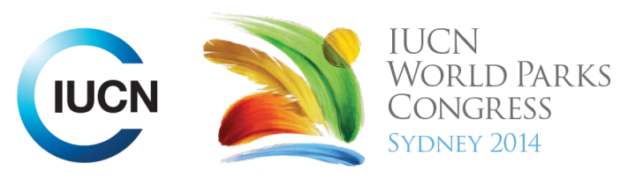

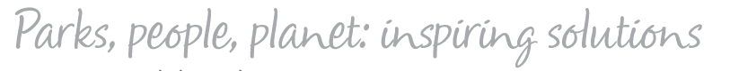

Please fill-in this word template, save it and email to:
WPCReports@iucn.org

Rapporteur’s report on session
Stream Number/WLD/Plenary:--- 8---
Repporteur’s name: --- Nicola Bryden---
Session ID:---550--- |  | Session Name: --- A new wave of nature stewards---
Summarize the session: Capture 1-3 main insights and findings of this session (including promising opportunities and inspiring solutions).
1. --- | BioBlitz is a really good way of getting kids and families engaged in the outdoors and investigating their local environment. It is a survey of a defined area to record as many species as possible. Feedback is that kids like getting dirty now, and it is very liberating, with kids adopting animals like worms. We preserve what we love, we love what we understand, we understand what we are taught. Therefore, if we are taught, we can understand, when we understand we can love, when we love, we will preserve.---
2. --- | It is important for citizen scientists to feel there is a purpose to their activity and information gathered and to be connected to something bigger – so other resources include: the Great NATURE project – which is an online platform to see it, snap it, upload it and it links to iNaturalist automatically so species identification can be verified and then used in scientific databases including the GBIF Global Biodiversity Information Facility. Having a location on information makes it data. There are also commercial activities like paying $10,000 to sail out to the Great Pacific Rubbish Patch which provide opportunities for engaging audiences and galvanising action. ---
3. --- | As children we start with a wonder and love for nature innately, but in school we learn to disconnect from nature and deal objectively with facts and figures. Society values being good at tests, rather than our relationship with nature. Our reconnection needs to be deeper than campaigns and social media. We need to form relationships with species. In disadvantaged communities, there is a need to give kids opportunities, understanding and to create leadership roles. ---
Related keywords
---Inspiring a New Generation--- | ---Capacity Development--- | ---Improving Health and Well-Being---

Cross Cutting Themes
If the session was related to a Cross Cutting Theme, please give some information on what has been discussed.
---Example of Golden Gate Conservancy’s program recruiting disadvantaged students for opportunities in parks, combined with income, university education and then leadership opportunities for them to inspire a new generation after them. ---
Related cross cutting theme
---Capacity Development---

Recommendations to the IUCN World Parks Congress
Capture any specific recommendation from this session for the Innovative Approaches documents / Promise of Sydney (along the line of policy changes, capacity development, financing, practice…)
 | It was recommended that: | Actors | Timeline
1. --- | Next WPC needs to integrate youth, not have them as a breakout.--- | ---Click here to enter text.--- | ---Click here to enter text.---
2. --- | Listen to young people. By telling them what to do and how to think all the time, it disempowers them. --- | ---Click here to enter text.--- | ---Click here to enter text.---
3. --- | Don’t forget the kids for whom parks and nature is not on the radar and recognise that when you offer a lot of experiences to disadvantaged children, they will respond by wanting opportunities to share that experience and lead others who share a similar background.--- | ---Click here to enter text.--- | ---Click here to enter text.---
Related keywords
---Inspiring a New Generation--- | ---Capacity Development--- | ---Improving Health and Well-Being---

Information for the Communications - Team
Note any announcements/commitments or people/items of interests to media/communications. Please ensure to include any relevant contact information.
---Video –US National Park Service Centennial 2016 – 2+ years extravaganza. Redefining parks. “Find your park”, TV series, iMax movie, celebrity talent in parks, etc. http://www.nps.gov/subjects/centennial/index.htm
For BioBlitz - contact Mary Ford mford@ngs.org
www.greatnatureproject.org free app for iPhone and Android to share Bioblitz style photos and link to inaturalist and GBIF.
Campaign to reduce rubbish in the sea with really great images of a person lifting a carpet of seashore to reveal rubbish - www.take3.org.au
---

