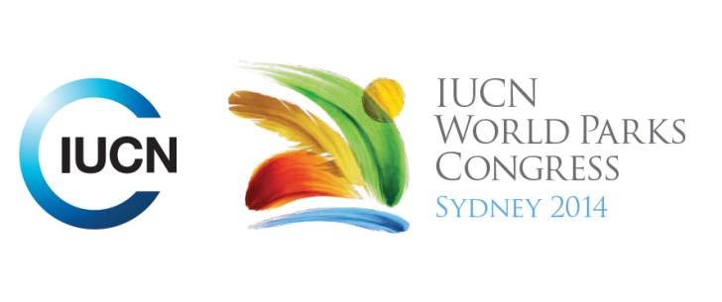

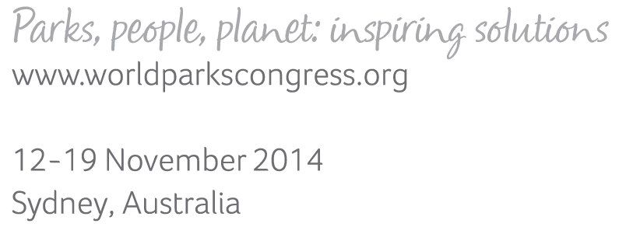

**Please fill-in this word template, save it and email to:**[**WPCReports@iucn.org**](mailto:WPCReports@iucn.org)

|  |  |  |
| --- | --- | --- |
| **Rapporteur’s report on session** | | |
| **Stream Number/WLD/Plenary:--- 8---** | | |
| **Repporteur’s name: --- Nicola Bryden---** | | |
| **Session ID:---579---** | | **Session Name: --- Intergenerational dialogues: inspiring a new generation for parks, people and planet---** |
| ***Summarize the session: Capture 1-3 main insights and findings of this session (including promising opportunities and inspiring solutions).*** | | |
| 1. **---** | What is important for initiating intergenerational learning and collaboration? Important to consider and be respectful of context (cultures, setting, differences) when starting dialogues, but also establish commonality first. Consider whether to meet in formal and informal spaces – in the Cloud/web or out on country. Focus on exploratory activities that can be explored together, rather than just on the person. **---** | |
| 2. **---** | Key qualities of intergenerational engagement: Two-way mentoring is an effective and respectful way of having dialogue. Nurture relationships by giving and receiving and listening carefully – even if you think you might have heard it all before. Allow others’ passion to inspire you too. Polish example of a two-sided document with one way for older generations and the other for younger people. **---** | |
| 3. **---** | How is future learning to be sustained? Mainstream youth in decision making, plan for succession to the next generation also, build capacity, monitor and adapt to change. Don’t complain, but explain what you think needs to be done and how you may require support and facilitation. Seek advice from older generations but don’t emulate – bring fresh perspective and dynamism to help change mindsets. Different generations working together can achieve more.**---** | |

|  |  |  |
| --- | --- | --- |
| Related keywords | | |
| ---Inspiring a New Generation--- | ---Capacity Development--- | ---Enhancing Diversity and Quality of Governance--- |

| **Cross Cutting Themes** |
| --- |
| ***If the session was related to a Cross Cutting Theme, please give some information on what has been discussed.*** |
| **---**Intergenerational dialogues were seen as a critical component of capacity building – not just of young people, but also of seniors. For example the Third-Age Universities and skilling up older generations in technology and different ways of working or seeing things. **---** |

|  |
| --- |
| Related cross cutting theme |
| ---Capacity Development--- |

| **Recommendations to the IUCN World Parks Congress** | | | |
| --- | --- | --- | --- |
| ***Capture any specific recommendation from this session for the Innovative Approaches documents / Promise of Sydney (along the line of policy changes, capacity development, financing, practice…)*** | | | |
|  | **It was recommended that:** | **Actors** | **Timeline** |
| 1. **---** | Have Global Youth Dialogues instead of Global Leaders Dialogues or ‘Interleadership’ Dialogues with both young and older leaders – need a commitment to mainstream youth and bring a certain proportion of young professionals to future congresses and events. **---** | **---**Click here to enter text.**---** | **---**Click here to enter text.**---** |
| 2. **---** | Draft Promise of Sydney is very motherhood and won’t impact on politicians. It needs to take the Young Peoples Pact on board.**---** | **---**Click here to enter text.**---** | **---**Click here to enter text.**---** |
| 3. **---** | Maintain relationships of respect with conscious and deep dialogue. **---** | **---**Click here to enter text.**---** | **---**Click here to enter text.**---** |

|  |  |  |
| --- | --- | --- |
| Related keywords | | |
| ---Inspiring a New Generation--- | ---Capacity Development--- | ---Enhancing Diversity and Quality of Governance--- |

| **Information for the Communications - Team** |
| --- |
| ***Note any announcements/commitments or people/items of interests to media/communications. Please ensure to include any relevant contact information.*** |
| **---Note session on 17 Nov 1:30pm onwards (Hall 2 North Pod) to discuss and vote on the Young People’s Pact.---** |