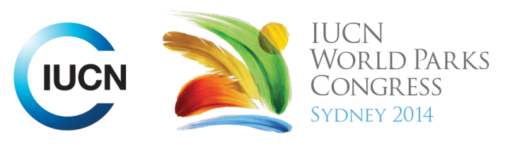

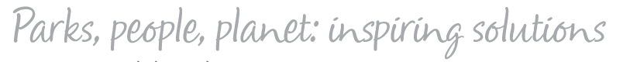

Please fill-in this word template, save it and email to:
WPCReports@iucn.org

Rapporteur’s report on session
Stream Number/WLD/Plenary:--- WLD---
Repporteur’s name: --- Robert Deves---
Session ID:---593--- |  | Session Name: --- Health, Naturally – Managing Healthy Parks for Health People---
Summarize the session: Capture 1-3 main insights and findings of this session (including promising opportunities and inspiring solutions).
1. --- | Many diseases have known links to ecological sources and we are facing health crises, such as ebola, leishmaniasis and malaria, the genesis of which are human intrusions into natural systems (e.g. zoonotic diseases or impacts of ecological disturbance). Intact ecosystems protect humans from disease and offer food security benefits (as evidenced by MPAs in the Comoros). Conservation of PA is a form of preventative healthcare (contrasted to the reactionary nature of the healthcare sector) yet the two share many common goals and benefits (whether that is recognized or not). Conservation biologists can save more lives and prevent more diseases than the healthcare sector. Other considerations include climate change, which facilitates the spread of disease vectors and contributes to declined nutritional value in crops. STREAM 3, 4---
2. --- | There is a large body of evidence linking PA and open space with improved physical, mental and spiritual health and social wellbeing. This is especially important in the context of current and future urbanization. Diseases such as type II diabetes, cardiovascular disease, mental health disorders, stress, anxiety, heat islands (and even pedestrian deaths) can be correlated to a lack of green space in urban areas. Populations living in close proximity to nature (or green space) are more active and have better health indicators and relationships. Urban natural space and other PAs are perceived as ‘nice to haves’ for leftover time, space and money, however strong sector growth during the economic downturn shows people value ‘recreation’ involving the outdoors. The presence of urban green space is particularly important for the urban poor who have less opportunity to leave the city. Natural spaces in urban landscapes are a place to build relationships and community and are very difficult to retrofit (thus requiring effective planning). STREAM 3, 4---
3. --- | Finding the commonalities between health and conservation was a key discussion point. Conservation is a form of preventative and restorative health which has many common goals to the health sector. However, healthcare funding is focused on the critical and the reactionary (e.g. ebola or hospitals). The dialogue on PA needs to be build around health, environment and development, and can help grow the preventative/restorative health share of budgets. Communication and relationships (and understanding of stakeholders) is essential to win ‘hearts and minds’ (for instance, health care sector needs clinical evidence and funding sector needs economic evidence). Corporations also have a role to play in full cost accounting of their businesses. STREAM 1, 3, 4---
Related keywords
---Choose an item.--- | ---Choose an item.--- | ---Choose an item.---

Cross Cutting Themes
If the session was related to a Cross Cutting Theme, please give some information on what has been discussed.
---Discussion was had on the early successes of the MPA system in the Comoros. The MPA system was implemented in 2010 to an amount of community disagreement (a significant proportion of whom depend on the marine environment for sustenance). Early successes include increases in both species diversity and abundance of marine life, which has flow on benefits to fishing areas where fish catches have improved. This has led to measurable decreases in levels of diabetes, hypertension and heart disease. (MARINE)---
Related cross cutting theme
---Choose an item.---

Recommendations to the IUCN World Parks Congress
Capture any specific recommendation from this session for the Innovative Approaches documents / Promise of Sydney (along the line of policy changes, capacity development, financing, practice…)
 | It was recommended that: | Actors | Timeline
1. --- | Identify the commonalities between health and conservation goals (and co-benefits). Build the body of evidence which can communicate with the relevant actors who can support PAs, such as health care (clinical evidence) and government/non-government donors (economic evidence). Build the case around health, environment and development, not parks as a luxury. STREAM 3, 4--- | ---All actors--- | ---None specified---
2. --- | The need for urgent and critical action to create and sustain urban green space was identified. Given increasing urbanization and the difficulty of retrofitting green space, ‘if our generation doesn’t do something, it is not going to happen’. STREAM 3,4 --- | ---All actors--- | ---Immediate---
3. --- | Frank Hugelmeyer encouraged IUCN to further engage business leaders in future WPCs as business has a key role to play.--- | ---IUCN--- | ---Click here to enter text.---
Related keywords
---Choose an item.--- | ---Choose an item.--- | ---Choose an item.---

Information for the Communications - Team
Note any announcements/commitments or people/items of interests to media/communications. Please ensure to include any relevant contact information.
---Click here to enter text.---

