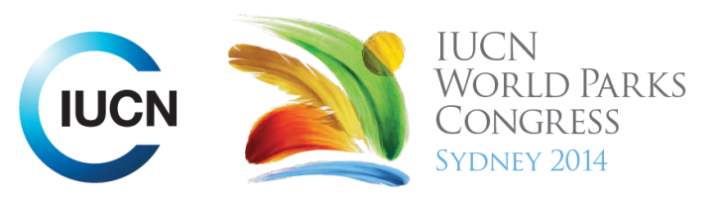



Please fill-in this word template, save it and email to:
WPCReports@iucn.org

Rapporteur’s report on session
Stream Number/WLD/Plenary:--- WLD ---
Repporteur’s name: --- Masumi Gudka---
Session ID:---594--- |  | Session Name: --- Feeding nine billion within our planetary boundaries---
Summarize the session: Capture 1-3 main insights and findings of this session (including promising opportunities and inspiring solutions).
1. --- | In Iran, the nomadic pastoral communities have adapted to the arid drylands region where they practice livestock keeping as their main livelihood which has sustained them for many generations. Recently the impacts of climate change have been having profound negative impacts on their way of life but they have adapted with limited external support. By mobilizing all the 12 neighbouring pastoral communities and forming traditional institutions they have devised strategies of collective resource management. The traditional institutions have enabled the community to build their capacity and become more empowered to take control of their natural heritage and resources and sustainably manage them through, restoring water channels, reducing grazing pressure on the rangelands by adapting grazing strategies, empowering women and diversifying their livelihoods. This has had a positive impact on their surrounding biodiversity and enabled the community to hold onto their traditional way of life which has great spiritual, cultural and livelihood value to them.---
2. --- | Food production has the greatest impact on the planet over any other activity. Forty percent of all land is used to produce food today. Fisheries have been fished beyond capacity by between 85% - 90%. We already produce enough food, but 820 million people still don’t have enough food to eat and are undernourished. This is more a matter of being efficient at what is produced and reduce wastage. Fifty percent of topsoil is already lost. Efficiency relates to what we consume and how we consume food and – reducing waste. Even between countries and within countries food production is not equal. One third of the population consume too much while 100 million people go hungry every night. In different parts of the world culture and traditions play a large role in food security down to the household level. In Mozambique for example although food production is sufficient, the culture prevents optimal use of food resources and results in malnutrition In Indonesia a programme has been established to reduce the amount of food related wastage by encouraging communities and food producers to make optimal use of products which would have otherwise been considered waste. This initiative is called the Blue Economy..---
3. --- | What is urgently needed to address challenges of food security for the planet as a whole is a shift in attitude about what we consume and how it is produced. Much of the food that is produced and food products that are creating extreme environmental degradation and biodiversity loss is not based around absolute necessity but is rather a choice we are making as a society. It deals more with our wants rather than needs and this is not a sustainable model. This attitude can be changed and lead to changes in behavior that ultimately affect our food production systems, but the question is do we have enough time to wait for these changes to occur. We need strategies that are scale and time appropriate. By the time we have the right policies and attitudes in place we may have already depleted our natural resources .---
Related keywords
---Choose an item.--- | ---Choose an item.--- | ---Choose an item.---

Cross Cutting Themes
If the session was related to a Cross Cutting Theme, please give some information on what has been discussed.
---The perception of the oceans used to be that once the land has failed us we can look to the oceans to feed the world. In reality this is not the case. We have done very well at extracting ocean life for food. 90% of the fish we have caught and consumed in markets are no longer there today. The oceanic wildlife has consistently declined. The vision of oceans producing food is more elusive that what was believed. We have selected a handful of animals and plants that provide all the sustenance for humans. In the ocean we have tended to focus on top carnivores well beyond that of lions and tigers. Will the ocean be an answer, NO! Other values of ocean wildlife have to be appreciated. We have to look at the total value of oceanic animals when we consider feeding ourselves.---
Related cross cutting theme
---Marine---

Recommendations to the IUCN World Parks Congress
Capture any specific recommendation from this session for the Innovative Approaches documents / Promise of Sydney (along the line of policy changes, capacity development, financing, practice…)
 | It was recommended that: | Actors | Timeline
1. --- | There needs to be a change in the way our food productions systems work. We need to have more efficient production systems to reduce the amount of wastage that occurs as a result and this way we will be able to feed a larger population more easily--- | ---Click here to enter text.--- | ---Click here to enter text.---
2. --- | There needs to be a shift in the way we think about what we eat and understand that for most of it us it is based on individual choices and preferences and not based on necessities. This is something we can learn to change and adapt. --- | ---Click here to enter text.--- | ---Click here to enter text.---
3. --- | Click here to enter text.--- | ---Click here to enter text.--- | ---Click here to enter text.---
Related keywords
---Choose an item.--- | ---Choose an item.--- | ---Choose an item.---

Information for the Communications - Team
Note any announcements/commitments or people/items of interests to media/communications. Please ensure to include any relevant contact information.
---Click here to enter text.---

