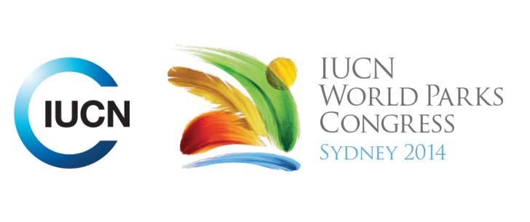

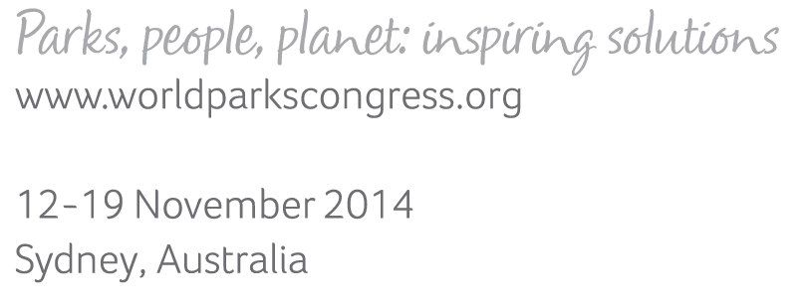

**Please fill-in this word template, save it and email to:**[**WPCReports@iucn.org**](mailto:WPCReports@iucn.org)

|  |  |  |
| --- | --- | --- |
| **Rapporteur’s report on session** | | |
| **Stream Number/WLD/Plenary:--- Stream 4---** | | |
| **Repporteur’s name: --- Anshuman Saikia---** | | |
| **Session ID:---680---** | | **Session Name: --- Nature-based solution for disasters: how can science better inform policy-making?---** |
| ***Summarize the session: Capture 1-3 main insights and findings of this session (including promising opportunities and inspiring solutions).*** | | |
| 1. **---** | A key insight from the session was on the need to bring forward the existing best practice examples and case studies on ecosystem based disaster risk reduction and also validate them further through undertaking comprehensive economic analyses. The participants recognised the gap being validation that would enable these cases to be taken to the policy level towards influencing relevant policies and processes. Even though there is recognition of ecosystem based disaster risk reduction being cost effective, having multiple functional benefits, self-maintaining, self-renewing and addressing multiple hazards there is still need to apply economic tools to value and quantify ecosystem services related to DRR looking at economic scenarios and analysis going beyond valuation to focus on incentives and disincentives and also financial mechanisms. This will enable to understand the limits of ecosystem based disaster risk reduction, understanding the tipping points for Eco-DRR and generating evidence that Eco-DRR can operate at differential spatial and temporal scales in the context of PAs**---** | |
| 2. **---** | The second important insight was on the importance of engaging communities and recognising the value of local knowledge systems including indigenous and traditional knowledge systems. There was an example provided on the use of traditional knowledge system for water harvesting and flood control that complements civil engineering measures adopted in the buffer zone of Manas National Park. The communities as expressed by a number of presenters and speakers need to be central to the process of ecosystem restoration for reducing risks to natural disasters as evident from mangrove restoration by Wetlands International in the Post Indian-Ocean Tsunami context, coral reef restoration in Taiwan, as well as other restoration efforts undertaken by Conservation International. The Government of Japan presented the currently underwat 'Post Disaster Rebuilding through Landscape Restoration' in the aftermath of the Sendai Earthquake which clearly demonstrated the need for community focused integrated approaches that are win win propostion for DRR and sustainable development. **---** | |
| 3. **---** | The third very important insight is on linking scientific research related to ecosystem based disaster risk reduction and ecosystem based adaptation to the relevant policy frameworks and policy processes. It was pointed out that traditionally researchers have been extractive which IUCN is trying to change with linking research institutions working collaboratively on Eco-DRR in Chile, Nepal and China with the relevant policy makers and decision making stakeholders related to disaster risk management in the countries. In addition, as demonstrated through PEDRR and Wetland International's partnership with the private sector, it is very important to develop collaboration with private sector and public sector involved in developing grey infrastucture to further ecosystem based approaches including by developing business cases for Eco-DRR. This would involve combining scientific research, validation through quantification studies and subsequently engaging and collaborating with the relevant stakeholders. **---** | |

|  |  |  |
| --- | --- | --- |
| Related keywords | | |
| ---Responding to Climate Change--- | ---Respecting Indigenous and Traditional Knowledge and Culture--- | ---World Heritage--- |

| **Cross Cutting Themes** |
| --- |
| ***If the session was related to a Cross Cutting Theme, please give some information on what has been discussed.*** |
| **---**One of the presentations specifically focused on a World Heritage Site, Manas National Park located in Assam, India**---** |

|  |
| --- |
| Related cross cutting theme |
| ---World Heritage--- |

| **Recommendations to the IUCN World Parks Congress** | | | |
| --- | --- | --- | --- |
| ***Capture any specific recommendation from this session for the Innovative Approaches documents / Promise of Sydney (along the line of policy changes, capacity development, financing, practice…)*** | | | |
|  | **It was recommended that:** | **Actors** | **Timeline** |
| 1. **---** | It is important to use the opportunity of working on eco-DRR to push for ownership of risk which is lacking in the developing country context**---** | **---**Click here to enter text.**---** | **---**Click here to enter text.**---** |
| 2. **---** | There is a need to communicate better the role of PA's in reducing risks to natural disasters which can be achieved with more scientific evidence that is validated through economic analyses**---** | **---**Click here to enter text.**---** | **---**Click here to enter text.**---** |
| 3. **---** | In working on Eco-DRR, there is a need to adopt a multi-disciplinary approach and cross-sectoral approach**---** | **---**Click here to enter text.**---** | **---**Click here to enter text.**---** |

|  |  |  |
| --- | --- | --- |
| Related keywords | | |
| ---Supporting Human Life--- | ---Responding to Climate Change--- | ---Choose an item.--- |

| **Information for the Communications - Team** |
| --- |
| ***Note any announcements/commitments or people/items of interests to media/communications. Please ensure to include any relevant contact information.*** |
| **---**Click here to enter text.**---** |