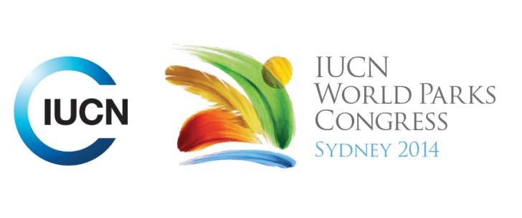

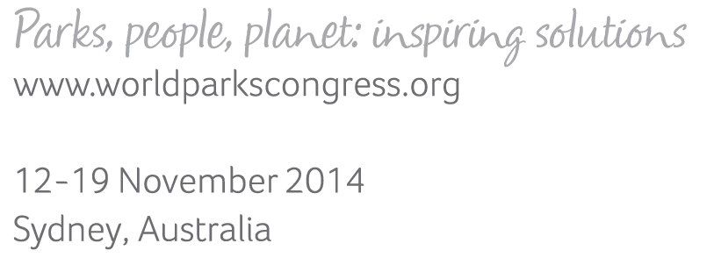

**Please fill-in this word template, save it and email to:**[**WPCReports@iucn.org**](mailto:WPCReports@iucn.org)

|  |  |  |
| --- | --- | --- |
| **Rapporteur’s report on session** | | |
| **Stream Number/WLD/Plenary:--- 7---** | | |
| **Repporteur’s name: --- Naomi Dwyer---** | | |
| **Session ID:---682---** | | **Session Name: --- Arctic dialogue---** |
| ***Summarize the session: Capture 1-3 main insights and findings of this session (including promising opportunities and inspiring solutions).*** | | |
| 1. **---** | Hubbard point in Hudson Bay, Canada is a unique environment with a diverse range of marine species including beluga whales, seals, fish as well as bears and caribou. Local Inuit are working with Oceans North to capture the natural and cultural values of their area to ensure protection for the area. **---** | |
| 2. **---** | Lancaster Sound in Canada is in negotiation for a National Marine Conservation Area. It would be the largest NMCA in Canada and the first to directly involve Inuit. The Federal Government released proposed boundaries for the MCA which are currently being negotiated with Inuit traditional owners. Government boundaries sourced on their ecological assessments and mineral and energy resource assessment. The traditional owners initiated a cultural mapping exercise, where their traditional ecological knowledge, values and cultural uses of this area were recorded and mapped. It showed that the government boundaries did not adequately capture all significant areas for the Inuit or for the species that utilise this area. This will result in a report combining the cultural and scientific knowledge to be integrated into the feasibility of the NMCA. Co-management is an aspiration for the group and the only way they want to manage the area. The federal government is required to develop an Inuit Impact and Benefit Agreement to be part of a management for the area**---** | |
| 3. **---** | Click here to enter text.**---** | |

|  |  |  |
| --- | --- | --- |
| Related keywords | | |
| ---Marine--- | ---Choose an item.--- | ---Choose an item.--- |

| **Cross Cutting Themes** |
| --- |
| ***If the session was related to a Cross Cutting Theme, please give some information on what has been discussed.*** |
| **---**The development of a National Marine Conservation Area in Lancaster Bay in Canada is currently undergoing a feasibility study and the boundaries and management are being negotiated with the local traditional owners.**---** |

|  |
| --- |
| Related cross cutting theme |
| ---Marine--- |

| **Recommendations to the IUCN World Parks Congress** | | | |
| --- | --- | --- | --- |
| ***Capture any specific recommendation from this session for the Innovative Approaches documents / Promise of Sydney (along the line of policy changes, capacity development, financing, practice…)*** | | | |
|  | **It was recommended that:** | **Actors** | **Timeline** |
| 1. **---** | That in protecting areas of natural significance that the human elements are not forgotten or negated. **---** | **---**Click here to enter text.**---** | **---**Click here to enter text.**---** |
| 2. **---** | That IUCN articles should recognise that the important natural values of world heritage areas are also part of cultural landscapes and they need protect FOR as well as protection from human activities.**---** | **---**IUCN**---** | **---**Click here to enter text.**---** |
| 3. **---** | When dealing with areas nominated for WHA protection that meet natural and cultural criteria It is important that assessment does not become overly compartmentalised.**---** | **---**IUCN**---** | **---**Click here to enter text.**---** |

|  |  |  |
| --- | --- | --- |
| Related keywords | | |
| ---Choose an item.--- | ---Choose an item.--- | ---Choose an item.--- |

| **Information for the Communications - Team** |
| --- |
| ***Note any announcements/commitments or people/items of interests to media/communications. Please ensure to include any relevant contact information.*** |
| **---**Click here to enter text.**---** |